PEM Board Review

Chapter 16: HEENT Trauma

Head
Basilar Skull Fracture – Battle sign, racoon eyes, CSF rhinorrhea, CSF leak in the ears
- Fracture can connect Brain to sinuses
- RISK of post trauma meningitis
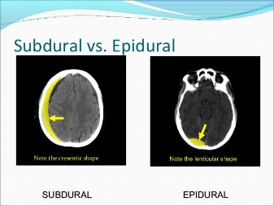
  - Also facial nerve paralysis (CN7), hearing loss (CN 8)
  - Ischemic stroke
- Diagnosis – CT head/temporal bones
- Treatment – bed rest, head elevated call NS

Cushing Triad – elevated BP - decreased HR - irregular respirations
Epidural hematoma – middle meningeal artery
- Convex shape
- Initial LOC lucid interval then inc ICP (altered mental status)

Subdural hematoma - bridging veins
- Accelerating and deceleration injuries
- Shaken baby
- Consult NS
  - hospital admission for close neurologic monitoring
  - The need for surgical intervention is determined by any progression or worsening of neurologic symptoms, increased bleeding, or evidence of mass effect on repeat neuroimaging

Elevated ICP TREATMENT:
- Elevated the head of the bed
- Mild hyperventilation – goal CO2 30-35
- Mannitol 0.25 – 1 g/kg
  - Monitor BP – risk of hypotension
- Hypertonic Saline 3% 3ml/kg
  - Drip rate 0.1 – 1ml/kg/hr
- No indication for Steroids

Traumatic Brain injury – indications for CT head:
- < 2 years – LOC > 5 seconds, non-frontal scalp hematoma, severe mechanism, palpable skull fracture, not acting normal per parents
  - If all criteria are negative NPV – 100% Sensitivity 100%
- > 2 years – prolong LOC, vomiting, severe headache
- If intermediate risk can monitor for at least 4 hours in the ED
- If Head CT negative and persistent symptoms(vomiting, lethargy, severe headache, or neurologic deficits) - Hospital admission for symptomatic treatment without neurosurgical evaluation is appropriate
Indications for MRI –
- MRI can be used for those who have focal neurologic deficits not explained by CT scan findings, those in whom nonaccidental trauma is suspected for full delineation of the extent and timing of injuries, or in follow-up for prolonged symptoms after concussion or TBI.

Skull fracture – minimally depress with out a bleed
- Admit for observation and progression
- RISK of Leptomeningeal cyst with growing fracture (children < 3 years)
  - Meninges push through fracture increase in size causes a cyst
  - enlarging skull fracture that occurs near post-traumatic encephalomalcia. The term cyst is a misnomer, as it is not a cyst, but an extension of the encephalomalacia. Hence, it is usually seen a few months post-trauma.
  - Call NS

Concussion – AMS after head trauma
- Sometimes can have posturing after trauma – benign NO need CT head as long as resolve quickly
- +/- LOC
- Treatment – rest and pain control

Second impact syndrome- a 2nd minor head trauma causes irreversible and fatal brain damage
Return to Play:
- No physical activity until all symptoms resolved then gradual stepwise return to play as tolerated
- 6 step process – each step in 24 hours – if any return of symptoms have to drop back to previous step

In deep scalp lacs, close the galea separately with 3-0 or 4-0 sutures. Failure to do this may cause the frontalis muscle (into which it inserts) to contract asymmetrically.

Ketamine and Succinylcholine are contraindicated in the setting of likely cerebral edema.

Penetrating head injury’s
- Early airway management is important in this situation because penetrating injuries to the head often lead rapidly to cerebral edema, apnea, and hypoxemia.
- Surgical interventions include debridement and control of any sites of bleeding
- Penetrating head injuries can be divided into those involving missiles (usually with high kinetic energy) and those involving impalement (lower kinetic energy).
- GSWs are the most common cause of the former injuries in the United States. In fact, the United States has the highest rate of GSW-associated head injuries in the developed world.
  - These injuries are comparatively more common in older adolescents, and the increased rate persists through young adulthood.
  - Centers for Disease Control and Prevention data show that firearm injury rates have declined in the past decade
    - Still are the second most common cause of mortality in children older than 12 years of age
- Predictors for survival: include the initial GCS score and pupillary responses.
  - mortality is 100% among patients whose GCS scores are less than 5 and who have no pupillary response.
  - survival rate is 75% among those who have GCS scores greater than 8 and pupillary response.

- It is important not to remove the object outside the operating room so as not to precipitate hemorrhage.

Neck
NEXUS Criteria – VERY FEW PATIENTS < 8 YEARS
- Alert and Orientated
- Not intoxicated
- No midline tenderness
- No neuro deficits
- No distracting injury
  - If all negative – (including no midline tendnerness) – then check for pain with ROM negative can clear clinically
- If any positive start with c spine xray – 3 view
- If positive xray or neuro symptoms needs MRI spine

SCIWORA - Spinal Cord Injury Without Radiographic Abnormality
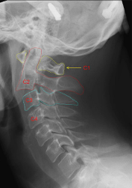
- Children have greater elasticity of ligaments – increased water in the intervettebral disc more pliable less bone injury but spine injured
- Xray negative with a history of neuro deficit
  - Numbness and tingling alone count (even if now resolved)
- Unable to get reliabel exam
- SHOULD check MRI c spine

Hangman Fracture – arch of C2
- Hyperextension injury
- Bilateral pars interarticlaris and anterior subluxation of C2 on C3
- Unstable fracture
  - BUT seldom neuro findings

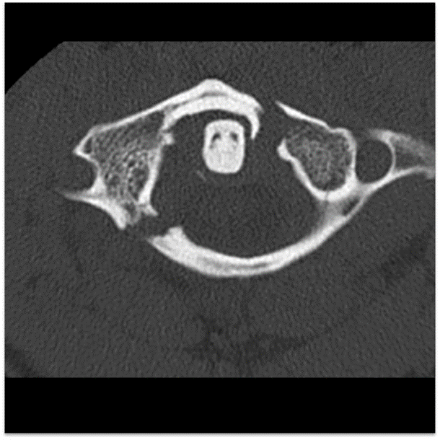
Jefferson Fracture – diving injury
- Axial compression injury
- Fracture through the anterior and posterior arches of C1
- Patient will be a football player or diver
- Treatment is a halo
- Unstable fractur
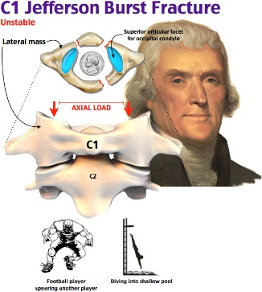

Neural Arch Fx C1
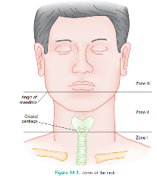
- Hyperextension injury

Neck Zones -

Horner’s Syndrome – ptosis, miosis, and anhydorsis
- Sympathetic nerve fibers in superior cervical ganglion
- Injury to the carotid artery
- If unstable go to the OR
- If Stable check CTA/CA for vascular injury

Neck Masses – if supraclavicular, hard or irregular borders or fixed risk malignancy
Thyroglossal duct cyst – midline – moves with the tongue
- Can be infected after URI
- Treat with antibiotics then excision

Cat scratch disease – bartonella Hensela
- Treatment azithro

Mycobacterium infection – chronic cervical adenitis
- Non TB mycobacterium
- NO respond to abx
- I &D will cause a sinus tract
- Dx ppd – check CXR – ENT
- Treatment – excision

Cyctic hygroma – lateral neck on the posterior triangle
- Malformation lymphatics
- Dx – CT scan
- Tx – excision

Brachial cleft cyst – lateral neck anterior to SCM
- Painless cyst or sinus tract
- Can become infected treat antibiotics and excision

Retropharyngeal abscess - < 4 years
- Group A strep
- Inc RR, drooling, decreased ROM neck
- Dx CT with IV contrast
- Tx drainage and IV abx

Paratonsilar Abscess – Adolescent
- Group A strep
- Drooling, trismus, muffled voice
- Dx clinical
- Tx – needle aspiration

Leimierre’s Syndrome – Fusobacterium necrophorum
- Complication of pharyngitis
- Septic emboli to the lungs, heart brain or kidney
- Tx – unasyn or clinda

Laryngomalacia – most common cause of stridor
- Starts at 4-6 weeks of age and resolves by 2 years
- Stridor is worse with crying or laying

Eye
The eye -
The sclera and undersurfaces of the upper and lower lids are covered with bulbar and palpebral conjunctiva, respectively.
The iris is covered by the cornea, which consists of three layers:
an outer nonkeratinized epithelial layer
a stromal layer
endothelial layer.

Eye exam must do’s –
- Evaluation of best corrected visual acuity in both eyes should be performed in most, if not all, patients who have ocular complaints. A standard chart appropriate for the child’s age, developmental level, and reading capability should be used to assess the best corrected acuity in each eye individually
- Direct ophthalmoscopy allows assessment of the posterior retina and optic disc. Viewing can be optimized by decreasing ambient light or through the use of mydriatic drops.
- Assessment of the presence and symmetry of the red reflex, symmetry of corneal light reflexion (Hirschberg test), and instillation of ophthalmic drops and ointments are other common pediatric ophthalmic procedures with minimal risks and complications.

Orbital fracture
- A comprehensive neurologic examination assesses potential associated neurosurgical injuries, which are common in younger children who have orbital fracture injuries due to their higher cranium-to-face ratio.
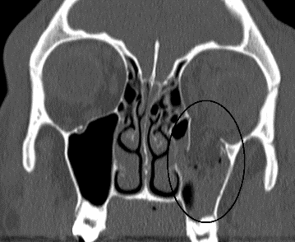
- Infants and younger children tend to demonstrate more orbital roof fractures.
  - The presumptive mechanism is believed to be their underdeveloped frontal sinuses, which fail to cushion some of the impact forces.
- Older children assume more of the adult pattern, with medial wall fractures predominating.
- “Trapdoor” fractures are a special subset of orbital floor fractures seen in young children that sometimes also are referred to as “white-eyed blowout fractures.” They occur when orbital fat and muscle is entrapped in the paranasal sinus cavities as they herniate through a medially hinged greenstick-type fracture in the orbital floor
- Pain with palpation of the orbital rim
- Decreased sensation on the cheek = infraorbital nerve injury
- Limited upward gaze = entrapment
- May have - Periorbital ecchymosis and swelling
  - Enophthalmos and proptosis may be difficult to appreciate because edema conceals their presence;
  - Hypoglobus or severe downward displacement of the eye can be seen with severe orbital floor disruption or a superior orbital subperiosteal hematoma
  - subcutaneous and intraorbital emphysema also may be seen with blowout fractures of the orbital floor.
  - Orbital emphysema
- Nausea and vomiting are common
- Diagnosis – CTG orbit
- RISK if orbital emphysema increased pressure stretching of the retinal artery decreased vision
  - Need to call optho for needle aspirate or lateral canthotomy
- Treatment call ENT and optho
  - In general, most orbital fractures are treated nonoperatively.
  - Surgical intervention is indicated for orbital fractures if there are symptoms of entrapment or CT evidence of herniation, significant orbital floor displacement or comminution (usually >50%) that would progress to cosmetically significant enophthalmos if uncorrected, or obvious early hypoglobus or enophthalmos.
Traumatic hyphema: blunt trauma to the eye
- blood in the anterior chamber between the iris and the cornea.
- Initial treatment –
  - Elevation of the head of the bed 30 degrees
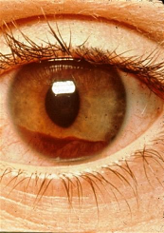
  - Eye shield
    - Shield not PATCH – patch risk of increasing IOP
  - IV morphine and Zofran – decreasing pain decreases intra-orbital pressure (IOP)
  - Call optho
  - Lateral canthotomy is indicated in cases of significant eye trauma that involve retrobulbar hemorrhage causing orbital compartment syndrome
    - such patients typically display significantly elevated intraocular pressure, proptosis, limited extraocular movements, diplopia, and an afferent pupillary defect

- Risk of spontaneous re-bleeding in the 1st 5 days
  - Bleeding disorders (even sickle cell trait) can increase this risk
- Goal to prevent re-bleeding and increase risk of IOP
  - Risk glaucoma

Ruptured Globe- Tear drop pupil
- Treatment – keep calm, elevate head of bed, IV morphine and Zofran, eye shield
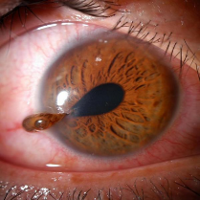
  - Call optho
- Can have a sluggish pupil can indicate ruptured globe
- Intraocular pressure should not be measures
- can get a subconjunctival hemorrhage, enophthalmos, teardrop pupil, a flattened anterior chamber
- If unsure preform fluorescence exam and look for extravasation of dye (dye becomes diluted from aqueous humor of the eye and streams from the site of rupture
Ruptured Globe
- How to evaluate the eye: use of an ocular speculum or two lid retractors is unlikely to put pressure on the globe. Lid specula are specifically designed for this purpose: the speculum is squeezed to close the two arms, one arm of the speculum is slid under both the upper and lower lid margins, and the speculum is released.
- Lid retractors are designed to retract one lid, but use of two simultaneously can allow viewing of the globe. If commercial lid retractors are not available, they can be fashioned from paper clips, but care should be taken to ascertain that no particles or fragments are present at the point of bending. Uncoated, smooth clips should be used to minimize this risk. Both specula and retractors can extend any lid lacerations further and rarely can result in corneal abrasion.
- Cotton swabs can be used to open the lids in uncooperative patients or those who have significant swelling, but they should not be used in the setting of trauma because they apply pressure to the globe
Pressure with the thumb and index finger can be used to counteract mild swelling or contraction of the orbicularis oculi in the uncooperative child. Pressure is placed over the superior and inferior boney orbital rims at the site of muscle insertion (not over the soft tissues of the lids), making contraction impossible. This technique can be used in the setting of trauma if care is taken to avoid pressure on the globe, but it is unlikely to facilitate viewing of the globe in a cooperative patient who has marked swelling.

Foreign body under the upper eyelid - Multiple vertical corneal abrasions
- Viewing and removing such a foreign body is facilitated by eversion of the upper lid.
- Urgent or emergent ophthalmology consultation should be obtained in cases of embedded foreign bodies, or foreign bodies that are incompletely removed or cannot be removed without sedation or anesthesia.
- Metallic foreign bodies also may result in a rust ring, which must be removed
- Foreign bodies under the upper lid cause conjunctival or corneal abrasions with blinking that typically are vertical and multiple.
- should be removed as early as possible to avoid epithelialization over them that may make removal more difficult
- Methods:
  - Topical anesthesia should be administered before- oral or intravenous pain medications also may be indicated
  - Irrigation with sterile saline, sterile water, or commercially prepared eye solutions better for superficial bodies.
  - A moistened cotton swab can be used for foreign bodies that appear superficial but persist after irrigation.
  - Foreign bodies on the undersurface of the upper lid can be seen and removed best after the lid is everted: A cotton-tipped swab is placed at the upper margin of the tarsal plate externally, the upper lashes are grasped, and the lid is flipped over the swab.
  - a 25- or 27-gauge needle or an eye spud can be used to scoop the foreign body gently off of the cornea or conjunctiva. Such removal can be facilitated by using a slitlamp
- If the foreign body is incompletely removed or cannot be removed, a shield should be placed and ophthalmology consulted for evaluation and treatment.
- Rust stains may persist after metallic foreign bodies have been removed and may gradually resolve with topical antibiotic ointment, but those that persist for 3 or more days require removal.

Corneal Abrasion –
- Diagnosis – fluorescein
- Treatment – topical abx ointment
- Should have a repeat fluorescein exam in 24 hours

Eyelid Lacerations – frequently associated with vascular injury
- Best closed with fast gut
- Only need abx for contaminated wounds
- Call optho for:
  - Medial to lacrimal punctate on lower or upper lid risk injury to the tear duct
  - Full thickness
  - Through the lid margin
  - Also Orbit injury

Glaucoma – bilateral tearing

Baby Eyes ----
Dacryostenosis – obstruction of the lacrimal duct
- Unilateral tearing, crusting and discharge
- Treatment – gentle massage (if also conjunctivitis can add abx ointment)
Conjunctivitis
- Gonorrhea – 5-7 days of life
  - Risk of spontaneous corneal perforation
  - Gram stain with gram positive diplococci
  - Pressure positive – treat with cefotaxome – ocular irrigation – optho consultation
- Chlamydia – 1-2 weeks of age
  - Risk of pneumonia 4-6 weeks later
  - Treatment PO erythromycin
- Herpetic – fluoroscene with dendritic pattern
  - IMMEDIATE optho
  - Steroids can cause glaucoma and cataracts

STye swelling in the upper lid
- Treat with eyelash scrubs to encourage drainage and warm soaks
- If FAIL surgical treatment with optho
- If recurrent PO abx with optho follow up

Optho chemical injury – 1st step irrigation of the eye

Retinoblastoma – lack of red reflex urgent optho
- Strabismus in 20%

Ear
Laceration - Given the avascular nature of ear cartilage, sutures can act as a nidus for infection. If sutures are necessary, use a 5-0 or 6-0 suture and closely monitor and follow-up for signs of infection.
- 5.0 absorable suture – evert edges
- Pericondrium included in sutures
- Avoid excessive tension – will tear ear cartilage
CSF otorrhea – test with Beta2 Transferin

Auricular Hematoma
- Treat with I&D followed by compression bandage
- Risk of necrosis of cartilage – cauliflower ear
- Recheck in 24 hours to see if re-accumulation

Periauricular pit with sinus tract – prone to infection with abscess – tender/red/fluctuant
- Treat Abx then excision

Otitis:
- AOM with perforation – PO abx Plus topical quinolone with steroid for comfort
- AOM with ear tubes – tx with fluoroquinolone drops 3-5 days
  - No need oral abx
- AOM with facial nerve palsy
  - Check temporal bone CT
  - Admit for IV abx and ENT myringotomy
- Malignant Otitis Externa – Osteomyeltits of the underlying bone
  - Ear pain, fever, ear discharge
  - Tender, swelling of the pinna
  - 20% with facial weakness
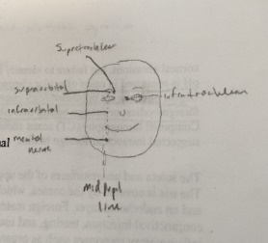
  - Typicall with history of DM or immunosuppression
  - Chest CT – abx -- ENT
Ear FB –
- No irrigation if button battery (increased risk leakage which causes liquefaction necrosis) or vegetable (can swell up)
- Insect – lidocaine ETOH or mineral oil (more effective than ETOH)
Face:
Regional ENT Nerve Blocks:
- Infraorbital block: upper lip, medial cheek, lateral nose
- Supraorbital block: forehead
- Supratrochlear block: anterior scalp
- Mental nerve block (V3): lower face, chin, lower lip
- Infratrochlear block: medial eyelid, lateral nose superior to the medial canthus, medial conjunctiva and lacrimal apparatus
- Cartilage portion of nose: V1 branch of Trigeminal Nerve (external-dorsal-nasal)
- Auriculo-temporal nerve (V3): anterior auricle, temporal scalp
- Great Auricular Nerve (C2-C3): posterior auricle, angle of jaw
  - Note: the above two are accessed with a 4 injection regional field block around the base of the ear. Direct injection into the pinna can cause tissue necrosis.

Naso-orbito-ethmoid Fracture –
- Traumatic central face fracture
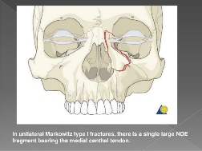
- Swelling over the nose
- Telecanthus (eye separated) - epistaxis - diplopia - CSF rhinorrhea
- Diagnosis – CT face
  - Complete separation of the nasal bone and medial orbital wall from the frontal bone
- Risk Basilar skull fracture

LeFort Fracture – 3 types
- Type 1 – maxilla to zygomatic maxillary region
  - Allows motion of the segment of aveolar bone and teeth
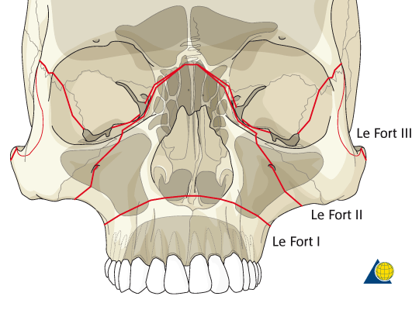

NO NG tube with midface fractures

Epidural inclusion cyst – post pubertal ketatin cyst on the face – slow growing
- Can become secondary infected require I&D and antibiotics followed by excisional removal
Multiple inclusion cysts eval for Gardner’s Syndrome (AD)
- Intestinal polyps risk for cancer

Nose
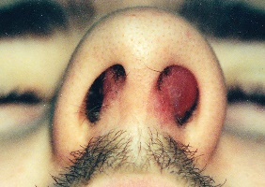
Septal hematoma
- is an uncommon yet serious complication of nasal trauma.
- Failure to recognize this entity can result in avascular necrosis of the cartilage, formation of a septal abscess, and risk of permanent nasal deformity.
- Septal hematomas are believed to occur following rupture of the perichondrial blood vessels and extravasation of blood that strips the perichondrium from the cartilage, causing a closed-space accumulation.
- Severe localized pain, tenderness to palpation of the nasal tip, and a cherrylike swelling of the nasal mucosa.
- The mass fluctuates when probed and does not change in size with vasoconstrictor application
  - Can try vasoconstricting drops – if no change in size -- hematoma
- Treatment - immediate drainage of the hematoma
  - Restore blood flow from the perichondrium is warranted.
  - Such drainage is accomplished best by prompt evacuation with otolaryngology consultation.

  - After topical anesthesia, a #11 blade is used to make an L-shaped incision in the most inferior and dependent portion of the hematoma. Using forceps or a small hemostat, the opening is expanded to allow drainage. A rubber drain is placed, followed by an anterior nasal pack for 24 to 48 hours.
- Risk – decreased blood to the cartilage destruction of the cartilage
  - Risk abscess, saddle nose deformity, chronic obstruction

Fracture of the cribriform plate - injury to the NOE complex is a, which forms the medial part of the roof of the nasal cavity.
- This fracture may result in a cerebrospinal fluid leak (presenting as clear rhinorrhea)
- Increased risk of meningitis or brain abscess.

Nasal Foreign Body – unilateral purulent drainage
- No antibiotics - vasoconstrictors may be helpful

NoseBleeds –
- 1st compression – with vasoconstrictors
- 2nd nasal packing – gauze soaked in 1:10000 Epi or phenylephrine
- MCC location Kesselbach’s plexus – anterior bleed
- Posterior bleed – required posterior packing
  - Most commonly effects splenopalatine artery
- Small bleed or a trickle can use silver nitrate

Mouth
Tongue Laceration – most heal well without repair
- Repair if:
  - Through and through - Large Flap - significant hemorrhage - larger Lateral edge - anterior edge
- Repair with 4.0 Absorbable suture – interrupted with multiple knots and inverted sutures

Dental abscess –
- Treat with PO abs then at dental follow up they will I&D with tooth extraction
- MCC strep (abx = penicillin or clinda)
- Risk of facial cellulitis - sinus thrombosis - brain abscess

Electric burn to the mouth – risk rebleeding of the labial artery
- Treatment reassurance and return if uncontrolled bleeding

