PEM|BRS: EENT/Dental/Neck

Eye -
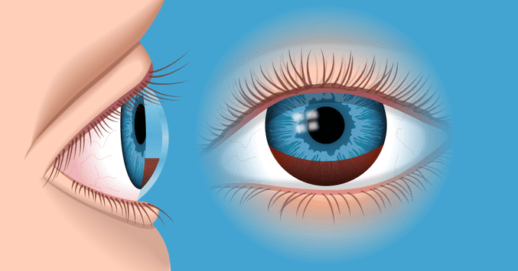
Hyphemas:
Treatment - bedrest with the head of the bed at 45 degrees.
A mydriatic agent and topical steroids are prescribed under the supervision of the ophthalmologist.
Risk - Spontaneous re-bleeding may occur within the first week—patients with sickle cell disease or bleeding disorders are at higher risk for more serious hyphemas/re-bleeding.
- Rebleeding à risk for glacoma

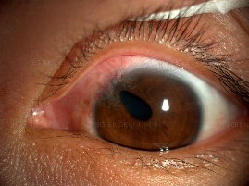
Ruptured Globe:
- Can result from a corneal or scleral laceration
- Iris or choroid migrates to plug the wound resulting in a “teardrop” shaped pupil.
- Emergent referral to an ophthalmologist
- Treatment – keep calm, eye shield, not a patch
- Severe eye trauma alone may cause vomiting, even without concomitant head injury.

Iritis: Anterior Uveitis – red congested eye
- Rapid onset; pain; photophobia; tearing;
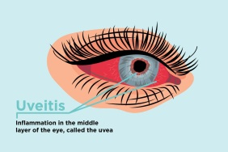
- blurred vision; --> post trauma
- Dx: slit lamp – shows cells, flare
- Tx: steroid drops and cycloplegic drops.

Uveitis – Red and Painful – cilliary flair
- Red, photophobic and irregular pupil
- Blurry vision
- Tx steroids
- Associated with Reiter’s Syndrome (See, Pee, Climb a tree)

Chemical Splash to Eye:
- Eye pain, erythema, tearing, difficulty keeping the eye open, a FB sensation, eyelid edema, and blurred vision
- Eval - examine eye to check for FB, globe rupture, penetrating injury, then check pH of conjunctival surface (checking pH should not delay irrigation…)
- Treatment - apply topical anesthetic if readily available, then immediately start copious lavage with a steady stream of NS or LR for 15-20 minutes.
  - Continue irrigation until the conjunctival pH is 7 - Measurement of the ocular pH is most helpful in guiding the response and continued need for irrigation in chemical exposures.
- Complications of irrigation include ongoing pain/discomfort associated with the procedure itself, blepharospasm, corneal injury from irrigation fluid striking the cornea directly or with excessive force, and potential worsening of the initial injury based on the pH of the irrigation solution and the type of chemical exposure.
- Although there are no absolute contraindications for ocular irrigation and decontamination, such procedures should be used cautiously if a ruptured globe is suspected.

Conjunctivitis:
Bacterial conjunctivitis more classically involves continuous discharge throughout the day that may be white, yellow, or green.
- It is described as copious and recurring within minutes of clearing the eye.
- most frequently isolated pathogen is Haemophilus influenzae, followed by Streptococcus pneumoniae and, less commonly, Branhamella catarrhalis.
- Haemophilus infection often is associated with the conjunctivitis-otitis syndrome, and older literature recommends a short course of oral therapy for a toddler suspected of having Haemophilus infection
- Treatment - erythromycin ophthalmic ointment for infants and toddlers or combination polymyxin-trimethoprim ophthalmic drops for older children.
- Failure of response within 1 to 2 days is an indication for ophthalmologic referral
Viral conjunctivitis, the discharge is less prominent throughout the day, and tearing or mucuslike discharge more common
- Treatment for presumed viral conjunctivitis is supportive, with artificial tears or lubricants providing symptomatic relief from eye irritation. T
- Children should be isolated until symptoms have resolved, especially for swimming.
- The decision to treat a child in child care is more complex; cost/benefit analysis may take into account lost time from work for the parent as well as the cost of medication. Although newer generations of topical antimicrobials, including fluoroquinolones and azithromycin, have been shown to be effective in the treatment of acute infectious conjunctivitis, they probably are not necessary and may promote the emergence of resistant organisms.
Contact lens wearers
- Fluoroquinolones are specifically indicated in the treatment of conjunctivitis in contact lens wearers,
- Rate of pseudomonal infection is high.
- Topical steroids have no role - associated with bacterial superinfection - masking serious viral infection due to herpes simplex virus, and increasing the duration of adenoviral shedding.
  - Prolonged use can lead to the development of glaucoma and cataracts

Neonatal Conjunctivitis
First 24 hours after birth = chemical conjunctivitis caused by silver nitrate ocular prophylaxis is most common
- no treatment is required.
At 3 to 5 days after birth = Neisseria gonorrhoeae becomes a serious concern.
- Sudden, severe, grossly purulent conjunctivitis.
- Always check an immediate Gram stain and culture of eye discharge.
  - Patients need FSWU
- Risk to ulceration and perforation of the globe within 24 hours if untreated.
- Treatment - Inpatient treatment with aggressive eye irrigation and systemic coverage with ceftriaxone
- Incidence of gonococcal conjunctivitis has decreased dramatically with use of ocular prophylaxis at birth.
At 1 to 2 weeks of age = Chlamydia trachomatis.
- Systemic treatment with PO erythromycin à prevents development of chlamydial pneumonia, which may become symptomatic at 4 to 6 weeks of age.

HSV conjunctivitis –
- Severe pain in a dermatomal distribution is typical for.
- characterized by a dendritic pattern on fluorescein staining of the eye.
- Immediate optho eval à optho will give antiviral and steroids

Allergic conjunctivitis
- Itchy eyes and clear discharge. Eyes may be crusted shut in the morning.
- More common in school-age children and adolescents and frequently is associated with seasonal allergies.
- Treatment – oral antihistamines if accompanied by other systemic allergic symptoms
  - Eye involvement alone may be treated with topical antihistamines, mast cell stabilizers, or nonsteroidal anti-inflammatory agents.

Lacrimal Duct Obstruction – Dacrostenosis – tearing, crusting, discharge with pressure to the sac
- Treatment – massage – if conjunctivitis also ADD topical abx
- Dacrocystitis- infected: erythematous, drainage. Tx: clinda

Stye –
Treatment – warm compress and eyelash scrubs to encourage drainage
- If no improvement in 4 weeks refer to optho

Retinoblastoma: lack of red reflex, strabismus, AD rb1 (tumor suppressor gene) – urgent optho – typically remove eye
- Most common ocular malignancy and the seventh most common pediatric cancer in the United States
- Incidence of approximately 1 in 15,000 to 30,000 live births worldwide.
- The hereditary form is autosomal dominant, although only 10% of affected patients have positive FH -
- the rb1 gene, is mapped on the long arm of chromosome 13, band 14.2 (13q14) and codes for production of tumor suppressor protein - Loss of its function at both the alleles is considered one of the major genetic abnormalities to occur before retinoblastoma formation. This cancer is a classic example of the “two-hit theory.” - the mutation in one allele is in the germinal cells (familial or sporadic), and the second allele is affected later in life (second hit).
- Most common presentation in the United States is leukocoria or white pupillary reflex (54% to 60%), followed by strabismus (19% to 25%), painful glaucoma or signs of orbital cellulitis, and fever (5% to 10%).
  - exotropia, it is almost always due to retinoblastoma.
- The presence of leukocoria indicates a large tumor.
- Diagnosis - indirect ophthalmoscopy.
- The tumor may spread beyond the eye, presenting as a protruding mass (as seen in developing countries) or as intracranial and hematogenous metastasis to the liver and bone marrow.
- Metastatic evaluation, which is only indicated if there is evidence of tumor extension beyond the globe, includes lumbar puncture, bone radionuclide scans, and bone marrow biopsy.
  - The tumor grows fast, can be locally invasive as early as after 2 months of onset, and is likely to extend beyond the eye if not diagnosed by 6 months from onset.
- Treatment includes exenteration, enucleation, photocoagulation, chemotherapy, laser photoablation, transpupillary thermotherapy, cryotherapy, brachytherapy, and radiation therapy.
- The survival rate approaches 95% in the United States.
- Poor prognostic factors include delay of 6 months in diagnosis; cataract; optic nerve, choroid, or orbital invasion; metastatic disease; and external beam radiation treatment
- Survivors should wear protective eye goggles when playing sports and, therefore, cannot participate in sports where such protection is not allowed, such as boxing.
- Second malignancies are the usual cause of death in the survivors and are seen primarily in patients who have hereditary retinoblastoma (35% to 40% at 50 years postdiagnosis), especially those who received external beam radiation or ocular computed tomography scans.
  - The second malignancies include soft-tissue sarcomas; osteogenic sarcoma; pinealoblastoma; and brain, breast, lung, and bladder cancers.

Optic Neuritis: Decreased vision (peripheral) blurring of disc margins afferent pupillary defect
- An inflammation or demyelinization of the optic nerve that results in impaired visual acuity.
- Pain on palpation or movement of the globe may be noted on examination.
- Afferent pupillary defect, decreased visual acuity, and a normal peripheral retina and macula.
- Diagnosis is confirmed with MRI that reveals at least one area of demyelination.
- Treatment with high-dose intravenous steroids improves the visual recovery and may prevent progression
- Other causes – include
  - idiopathic
  - viral infections (eg, Epstein-Barr virus, encephalitis, measles, mumps, varicella)
  - granulomatous inflammation (eg, tuberculosis, cryptococcosis, sarcoidosis, syphilis)
  - lupus
  - contiguous inflammation or infection of meninges, orbit, or sinuses
  - toxicity (eg, methanol, heavy metals, ethambutol, chloroquine, vincristine, isoniazid)
  - nutritional problems (malnutrition, vitamin B12 deficiency)
  - postinfectious, as in acute disseminated encephalomyelitis (ADEM).

Differentiating a first episode of MS from ADEM:
ADEM is a monophasic illness that usually afflicts children younger than 10 years of age.
- Patients may be febrile and have altered mentation, vomiting, seizures, ataxia, weakness, and bilateral ON.
- There is usually no family history of MS.
- CSF examination frequently shows sterile pleocytosis,
- MRI typically reveals multiple enhancing, disseminated, multifocal lesions in the basal ganglia, thalamus, brainstem, and at the cortical gray white junction, consistent with inflammation or demyelination.
MS - MRI shows T2-enhancing isolated lesions in the corpus callosum and periventricular white matter.
- The CSF in MS often contains oligoclonal bands.

Neuromyelitis optica (Devic disease) : A variant of multiple sclerosis (MS).
- Acute onset of paraplegia with sensory and sphincter impairment suggests spinal cord (transverse myelitis).
- Rapid loss of peripheral vision, afferent pupillary defect, and blurring of the optic disc margins on funduscopy suggest optic neuritis (ON).
- This constellation of neurologic findings at multiple anatomic levels is most consistent with a demyelinating process.
- MRI is the study of choice for detecting demyelination;

Wilson Disease:
- Kayser-Fleischer ring, apparent on external examination of the limbus.
- The neurologic findings are dominated by extrapyramidal symptoms of chronic duration.
- Diagnosis - Serum ceruloplasmin

Ear -
Foreign Body in Toddler:
In toddlers, the presence of one FB in the ear or nose increases the likelihood of another FB in another ear or nares.
No use of irrigation for removal if Battery or Food

Malignant Otitis Externa –
- Complication of AOE
- Osteomyelitis of the underlying bone
- MCC pseudomonas
- Clinically – worse ear pain – fever – facial weakness – foul smell from the ear
- Dx – CT temporal bone
- Tx - IV abx and ENT

AOM with ear tube – tx Fluoroquinolone topical for 3-5 days – no need PO ABX

Complications of AOM –
- Perforation of the TM
- Loss of hearing
- Cholesteatoma
- Labrinthitis
- Mastoiditis

Otitis Media with the complication of facial nerve involvement:
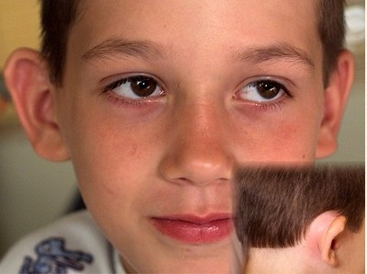
Managed with CT of the temporal bone, IV antibiotics and emergent myringotomy.

Mastoiditis:
Primarily affects children younger than 2 years of age.
The incidence ranges from 2 to 4 cases per 100,000 children in the United States.
Clinically - subperiosteal abscess - swelling over the mastoid process resulting in lateral and inferior displacement of the pinna.
Posterior auricular swelling and forward protrusion of the pinna are signs of mastoiditis.
Complications - sinus vein thrombosis, abducens nerve palsy, brain abscess, and meningitis.
- meningitis is caused by direct extension of the underlying infection, leading to irritability, variable signs of meningeal irritation, and persistent fever.
Treatment – ENT
- Uncomplicated infection usually responds to treatment with parenteral antibiotics alone.
  - ampicillin-sulbactam or the combination of ceftriaxone and clindamycin.
- If no improvement within 48 hours, surgical management, including mastoidectomy, should be considered.
Mastoiditis represents local extension of infection and, therefore, rarely involves bacteremia.

True vertigo - a sense of rotation of the patient relative to the environment or vice versa.
- It worsens with head movement, and acute events are often accompanied by nystagmus.
- Identification of the dizziness as true vertigo helps narrow the cause to a disturbance of the vestibular system, either in the central components (brainstem, cerebellum, cortex) or in the peripheral components (labyrinth).
- Central vs peripheral
  - Peripheral causes are more often associated with hearing impairment;
    - The peripheral sensory organs related to equilibrium are called the labyrinth and are composed of the semicircular canals (stimulated by rotary motion of head) and the vestibule (stimulated by gravity)
  - central causes usually spare the hearing.
  - all have nystagmus - with the fast component toward the affected side and in the direction of the perceived rotation.
Acute labyrinthitis: vertigo, nystagmus and unilateral hearing loss
- An infection of the inner ear that is seen most commonly in patients who do not (but can) have concomitant otitis media.
  - If associated with AOM – more serious disease
- This may be the result of a systemic viral infection or a viral infection that is confined to the labyrinth. There is a strong association with a recent viral respiratory infection. Specific viruses that have been associated with labyrinthitis include herpesviruses, influenza, measles, mumps, and Epstein-Barr virus.
- Inflammation of the labyrinth affects both branches of the vestibulocochlear nerve (eighth cranial nerve), resulting in both hearing changes and vertigo.
- Generally unilateral
- Children do not appear to be significantly ill.
- The symptoms are usually self-limited, with typical rapid resolution of both the vertigo and hearing loss.
- May benefit from antivertiginous medications such as meclizine or dimenhydrinate for acute or severe episodes. Benzodiazepines may also be useful.

Benign paroxysmal vertigo (BPV) : 2-4 year old – looks sick with vertigo
- Commonly accompanied by horizontal nystagmus and may be associated with concomitant auditory symptoms.
- It is a paroxysmal, non-epileptic, recurrent event characterized by subjective or objective vertigo that occurs in neurologically intact children.
- Age of onset: 2-4 years.
- Presents with a sudden episode of visible anxiety or fear followed by grasping of nearby people or objects for support.
- Children often asked to be picked up or refuse to stand.
- Older children may complain that they feel as if they will fall.
- These episodes may be associated with pallor, nausea, sweating, and unusual head postures.

Acute Cerebellar Ataxia – well appearing kid that falls
- S/p URI

Benign Paroxysmal Positional Vertigo (BPPV) : vertigo with position
- Vertigo resulting from turning the head to a particular position.
- Most commonly occurs after head injury in children due to displacement of otoconia into the posterior semicircular canal.

Meniere’s Disease: Tinnitus Plus Vertigo and decreased hearing
- Due to excessive endolymph.
- Spontaneous attacks of prolonged vertigo, fluctuating hearing loss, and tinnitus.

Ramsay Hunt Syndrome (RHS) :
- Acute facial palsy associated with a herpetic eruption on the auricle.
- It is frequently complicated by vestibulocochlear dysfunction.
- Tx: acyclovir and possibly steroids.

Tuning fork tests can help distinguish between conductive and sensorineural causes:
Weber test - a vibrating tuning fork is placed on the forehead in the midline, the sound lateralizes to the affected side with conductive hearing loss and away from the affected side with sensorineural hearing loss.
Rinne test, the vibrating tuning fork is placed against the mastoid, removed when the patient senses vibration has stopped, and held up to the ear. A positive result is demonstrated when the patient can still hear the tuning fork and indicates sensorineural hearing loss. A negative result, in which the patient cannot hear the tuning fork placed next to the ear, indicates a conductive loss. If a tuning fork is placed equidistant between both ears, the sound is louder in the unaffected ear, regardless of cause.
AOM – conductive hearing loss – weber test to the affected side – Rinn cannot hear after vibration stops….

Auricular Hematomas:
Treatment -
- Mild: cold compress and pressure dressing with recheck within 24 hours.
- Moderate to severe: should be aspirated to prevent necrosis of the cartilage and subsequent formation of a “cauliflower ear.”
  - Topical anesthetic (EMLA) can be applied prior to aspiration of the hematoma - Injection of lidocaine into the hematoma is usually not necessary
    - Use of epinephrine in the auricle is contraindicated.
  - Maintain pressure on the aspirated site for a few minutes to prevent further bleeding.
  - A pressure dressing should be applied
  - Auricle should be reexamined within 24 hours to see if there is re-accumulation of the hematoma.

Pre-auricular pit – can become infected
- Treatment – antibiotics and refer ENT for excision

Nose –
Nasal Foreign Body: unilateral foul smelling nasal discharge
- Nasal foreign bodies, typically beads, buttons, toy parts, paper, cloth, erasers, food, and button batteries, are common findings in children younger than 6 years of age.
- Nasal foreign bodies tend to be located on the floor of the nasal passage, just below the inferior turbinate, or in the upper nasal fossa anterior to the middle turbinate.
- Because multiple foreign bodies are common - a complete examination should include inspection of both ears.
- Before foreign body removal, 0.5% phenylephrine or oxymetazoline can be administered to reduce mucosal edema, and topical lidocaine may be applied to provide analgesia.
- Techniques include removal with direct viewing using forceps (alligator or Hartmann forceps), curved hooks, cerumen loops, or suction catheters (Frazier suction) and use of cyanoacrylate adhesive at the end of a blunt cotton swab. In addition, successful removal has been achieved by passing a thin, lubricated, balloon-tip catheter (5 or 6 French Foley, Fogarty, or Katz) past the foreign body, inflating the balloon, and pulling the inflated catheter balloon forward.
- Mother’s Kiss - parent can use positive-pressure ventilation to expel the foreign body by covering the child's mouth with his or her mouth, plugging the unobstructed nostril with a finger, and delivering a rapid, soft puff of air. In older and more cooperative patients, the foreign body can be expelled by asking the patient to “blow the nose” while blocking the opposite nostril. Positive pressure can also be delivered through the mouth using a bag mask or through the nose using oxygen tubing. Care should be taken to avoid barotrauma.
- Follow up with ENT if – cannot remove
- Immediate ENT if – button battery à risk of septal perforation and liquefaction necrosis, burns and nasal meatus stenosis

Septal Hematoma:
- s/p nasal trauma
- Unilateral bluish buldging of the nasal septum into the nasal cavity
  - will not shrink with nasal decongestant and
- Risk if not drained-
- Saddle nose deformity
- Septal abscess formation
- Nasal cartilage destruction
- Chronic nasal obstruction
- Treatment – drainage followed by Nasal Packing – can consider facial or plastic consult for drainage

Epistaxis: Most commonly from Little’s Area in the superior anterior nasal septum from Kisselbach’s plexus
Treatment
- local compression - compressing the lower third of the nose for 5-10 min. If bleeding continues…
- Cauterization - topical anesthetic with 2% lido combined with a local vasoconstrictor -
  - Cotton pledgets can be soaked in this solution and placed into the nose for 5 minutes.
  - Silver nitrate sticks are used to control the bleeding sites (pressure is applied to the bleeding site with the stick for 10-15 seconds.); If bleeding continues…
- Nasal packing —uncomfortable - use topical lido and possible PS&A. Can use sponges or balloons or traditionally, petroleum soaked gauze.
  - After placement, check for blood trickling down oropharynx if so packing is inadequate or the bleeding is posterior. If bleeding continues…
- Do posterior packing with a balloon—requires admission with cardiopulmonary monitoring and sedation—leave packing in place for 48-72 hours.
Antibiotics should be used when packing is in place. When packing is ineffective, ENT should be consulted for surgical intervention—nasal endoscopy and electrocautery. The sphenopalatine artery can also be identified and clipped.

Any abnormal neurologic finding in a child with sinusitis: Warrants a brain CT.

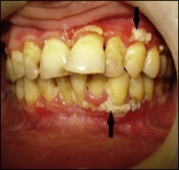
Mouth -
ANUG (acute necrotizing ulcerative gingivitis) :“trench mouth” or “Vincent’s angina”
- Acute infection caused by oral spirochetes – fusiform bacteria
- Painful gingivitis
- Adolescents with poor oral hygiene – linked to stress and poor hygiene
- Treatment is good oral hygiene, mouth rinses with dilute chlorhexidine, and oral antibiotics like PCN or clinda;
- Refer to dental for debridement of necrotic gingival tissues – once acute phase resolved
- If tx delayed, infection may spread to face—called “noma” or “cancrum oris” and has a high mortality rate.

Electrical Burn of lips: when a child bites on live electrical cords.
- low-voltage injuries can be managed as an outpatient provided the child can tolerate oral fluids and a soft diet.
- Meticulous attention to pain management, hydration, and local oral hygiene are important
- Patients may need to use an intraoral or extraoral device to separate the lower and upper lip segments during healing.
- Anticipatory guidance should include that bleeding of the labial artery may occur during the 5th-8th day.

Mandibular Dislocation - s/p extreme mouth opening
- Treatment – reduction – down and backwards pressure – often require sedation
- Dc home with decreased mouth activity

Mandibular Fracture – admission for IV hydration and pain contril
- Open fracture need IV abx

Dental –
Permanent tooth eruption –
- Central incisors – 7-8 years
- Laterl incisors – 8-9 years
- Cuspids 11-12 years
- 1st molar – 6-7 years
- 2nd molar – 12-13 years
- 3rd molar – 17-21 years

Tooth avulsion:
Permanent - A true dental emergency.
- Prognosis is best if dental re-implantation and splinting is instituted within 30-60 minutes.
- may GENTLY rinse the tooth, and then reinsert it into the empty socket (in the cooperative child
- Tooth may be preserved in a medium such as Viaspan, Save-a-tooth, or whole milk.
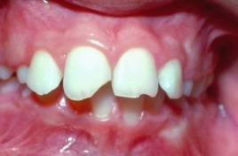
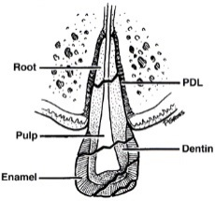
Primary – follow up with dental

Tooth Subluxation –
Permanent tooth- need dental immediately for splint
Primary – if stable can follow as outpatient for tooth removal

Management of Dental Fractures:
Permanent teeth
- Ellis Class 1, enamel alone: chip/ragged edge; no increased sensitivity
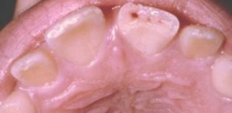
- Ellis Class 2, enamel + dentin: yellow exposed—sensitivity to touch, temp or air.
  - Referred to the dentist within 48 hours for tooth insulation with calcium hydroxide or glass ionomer to protect against pulpal necrosis; children under 12 years are at higher risk of extension of infection into pulp since their dentin layer is thinner.
- Ellis Class 3, enamel, dentin, and pulp; sensitive to touch, fluid, temp, and air; exposed pulp may be bleeding or red in the middle)
  - need to see a dentist immediately to institute pulpal therapy.

Early interventions can improve cosmetic results, prevent tooth loss, and decrease the risk of infection, so every attempt should be made to initiate care in the emergency department. Intraoral dental radiographs and panoramic views should be obtained. Trauma to the teeth may be associated with injury to supporting structures such as the alveolar bone and periodontium.
Primary teeth – All fractures need referral to dentist within 24 hours
Dietary advice (soft diet), and outpatient follow-up with dentistry (within 24 to 48 hours) are recommended for all patients.

Pericoronitis – local infection surrounding erupting tooth (wisdom tooth)
- Treatment good oral hygiene – resolves when tooth erupted
- If facial swelling – PO abx

Dento-alveolar abscess:
Treatment – PO abx – Augmentin, penicillin or clinda
Complication - Facial cellulitis and cavernous sinus thrombosis, sepsis, brain abscess
- Complications need admission for IV abx

Dry Socket – (alveolar osteilis) s/p tooth extraction
- Disintegrating blood clot causes pain and swelling
- Treat pain control and debridement – pack tooth and socket

Hutchinson’s Teeth: Are pointed lateral incisors and notched central incisors--characteristic of syphilis.

Neck -
Lemierre’s Syndrome: A rare complication of untreated bacterial pharyngitis. (septic emboli after strep pharyngitis)
- caused by Fusobacterium necrophorum, a normal inhabitant of the oropharynx
- bacteria invade the internal jugular vein producing phlebitis and thrombosis à Septic emboli then travel to other parts of the body including the lungs, heart, brain, and kidneys, and can result in MSOF.
- The bacteria are susceptible to beta-lactam antibiotics, metronidazole, and clindamycin or unasyn
- Should suspect in a patient with sore throat, neck swelling, persistent fever, and multi-organ involvement (particularly chest pain or dyspnea).

Cervical lymphadenitis - enlarged, tender, inflamed lymph nodes in the neck.
- Most cases involving the submandibular or deep cervical chains that drain most of the head and neck region.
- Most common cause of cervical lymphadenitis is viral infections of the head and neck, with common pathogens including enterovirus, adenovirus, influenza viruses, and rhinovirus.
  - Viral infections typically cause acute bilateral lymphadenitis, with mildly tender nodes that usually are 1 to 2 cm in diameter persisting for several weeks before resolution.
  - Bacterial head and neck infections, including impetigo, pharyngitis, otitis, cellulitis of the face or scalp, and periodontal infections, also can progress to cervical lymphadenitis.
  - Typical bacterial causes of cervical lymphadenitis are Streptococcus pyogenes and Staphylococcus aureus (>80% of cases). Group B Streptococcus is a frequent cause in neonates. Lymphadenitis as a result of dental infection may be caused by oral anaerobic bacteria.
  - Bacterial infection most commonly is associated with acute unilateral lymphadenitis.

Cat-scratch Disease - Infection by Bartonella henselae
- Regional lymphadenitis proximal to the site of inoculation.
- Exposure to kittens or dogs, with a scratch leading to the development of pustules or papules at the site.
- This is followed within days to weeks by the development of lymphadenitis.
- Fever, malaise, and other systemic symptoms are common.
- Diagnosis – Clinical – check titers -
  - Nodes that have evidence of acute suppuration or abscess formation should undergo aspiration or incision and drainage for diagnosis and management.
- Treatment - azithromycin, trimethoprim-sulfamethoxazole, rifampin, or gentamicin, although most cases are self-limited and resolve without treatment.
- Complications – encephalitis and neuroretinitis (blindness), pneumonia, endocarditis

A child with a submandibular neck mass for several weeks: NTB Mycoplasma
- Unresponsive to multiple courses of antibiotics, mildly tender and has a violaceous hue is most likely atypical mycobacteria (NTB nontubercular mycobacterium infection)
- you should place a PPD, get a CXR, and an ENT consult.
- Treatment - Excisional biopsy is the way to diagnose and definitively treat

Histoplasmosis Lymphadenitis: The most common fungal cause of lymphadenitis in the pediatric population.
- central US and Ohio River Valley
- Infection occurs from inhalation of spores from bat or bird dropping.
- Pulmonary infection is common.
- Fever, pneumonia, hepatosplenomegaly, DIC and FTT are possible.
- Dx: culture of nodal tissue;
- Tx: excision and Ampho B.

Toxoplasmosis Lymphadenitis: The most common parasitic cause of lymphadenitis
- Presents as cervical lymphadenitis;
- Exposure to cats, cat litter, uncooked meat, or unpasteurized milk.
- If immunocompromisede at higher risk; if not, no tx required.

Branchial cleft anomalies: Lateral neck mass or drainage – can become infected – anterior to SCM
- Painless sinus or cyst along the anterior border of the sternocleidomastoid muscle.
- Clear mucous discharge from the skin opening may be present.
- Can become infected.
- After a course of antibiotics, the entire sinus tract and cyst should be excised to prevent recurrence.

Thyroglossal duct anomalies: Midline – can become infected – Abx then remove
- midline in location.
- Often enlarge following URI’s
- Move with protrusion of the tongue and/or on swallowing.
- Opening of the cyst may be located at the base of the tongue, antibiotics that cover the mouth flora are indicated when superinfected.
- After a course of antibiotics, the cyst should be surgically excised.

Cystic Hygroma: Lateral – no change since birth – trans-illuminates – can become infected
- Malformations of the lymphatic system—occur in areas where the lymphatic duct drains into the venous system
- Neonate with a neck mass- noticed shortly after delivery and remain unchanged.
- A soft, compressible mass in the posterior triangle - non-tender, flesh colored, and transilluminates with light.
- Dx- CT scan.
- Treatment - Complete surgical excision (ENT removal)

Retropharyngeal Abscesses:
- less than 6 years of age
- MCC group A strep
- Infections that spread from the paranasal sinuses, middle ear, and nasopharynx.
- Dx: First do lateral neck radiograph with neck in extension during inspiration. The width of the retropharyngeal space is normally < 50% the width of C2 and a retropharyngeal space greater than 14 mm is abnormal.
  - CT will define cellulitis vs. abscess.;
- Tx: admit all for IV abx and ENT consult for I&D

Peri-tonsillar Abscess
- Adolescents
- MCC group A strep
- 1 tonsil bigger with uvula deviation
- Trismus, difficulty speaking, muffled voice and drooling
- Treat – drain and PO abx

Palpable lymph nodes in a neonate are not normal.

Airway compression -
Laryngomalacia: The most common cause of congenital stridor.
- Inspiratory stridor is usually noticed at 4-6 weeks of age and resolves by 2 years of age.
- Worse in the supine position or when the infant is crying and improves when the infant is placed prone.
- Have a normal cry as opposed to infants with vocal cord paralysis who have a weak cry.

Extrinsic compression of the trachea due to vascular slings or rings:
- Can present with stridor or wheezing
- Don’t improve with positioning.

Infants with hemangiomas or papillomas of the larynx are hoarse.

Torticollis:
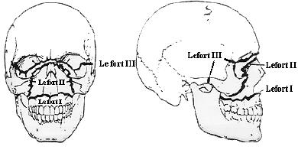
Treatment - PT, including massage, and range of motion and stretching exercises

Face -
MIDFACE INJURY: Midface fractures can be classified as Le Fort I, II, or III.

Le Forte I - fracture separating the palate and alveolus from the rest of the maxilla – occurs above the roots of the teeth. This mobile maxillary segment moves like a “loose denture.”
Le Fort II separates the midface from the skull, creating a free-floating pyramidal segment. Also includes a mobile palate.
Le Fort III involves a complete separation of the face from the cranial base. The mobile segment includes the maxilla, palate, zygoma, and ethmoid bones. It is a “craniofacial separation”.
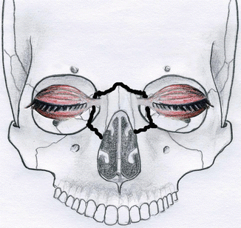

Naso-Orbital Ethmoid Fracture – separation of the eyes on exam
- Nose coming off the face

Sinusitis
- MC complication is orbital cellulitis
- Diagnosis – nasal discharge and congestion for at least 10 days
  - Fevers with purulent rhinorrhea for 3 days
  - Worsening congestion and fever after 3-4 days of initial symptoms
  - Clinical diagnosis – no need imaging
- Treatment – high dose amox- for strep susceptibility
  - Antihistamine and decongestants have toxic effect and not recomended

Ludwig’s Angina:
- Rapidly expanding infection involving the submental and submandibular areas of the oral cavity.
- Presents with fever, dysphagia, trismus.
- Can progress to mediastinitis.
- Airway emergency and emergent intubation is required along with surgical drainage.
- Elective awake tracheostomy is the best option for airway protection when time allows.
- Broad-spectrum IV antibiotics with coverage against anaerobes, Strep, and Staph should be initiated.

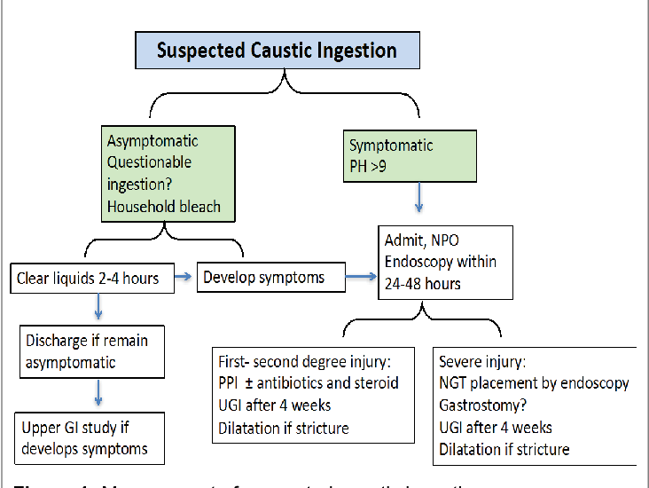
Caustic ingestions:
- Can cause burns anywhere in the oropharyngeal tract.
- Injury may appear as localized areas of ulceration, blebs or redness.
- The absence of oral or pharyngeal burns does not rule out an esophageal injury.
- Patients with symptoms have higher risk of esophageal injuries
- Should be admitted with a consultation for esophagoscopy as soon as possible.

