PEM Board Review Notes

EMS & Transport

Enhanced 911: automatically display the caller's phone number and the address from which the call is being made
- allows dispatchers to call back if they become disconnect and to direct the response team to the location from which the call is being made.
- Cell phones can now be tracked to at least the general area of the call.
Emergency Medical Dispatchers (EMD’s): trained to use protocols based on chief complaint and an algorithmic series of questions to identify critical conditions.
- Also have training to provide the caller with prearrival instructions can start interventions prior to EMS arrival
“Reverse 911” capability: allows the dispatch center to call a specific group of people or households within a community to warn of a specific danger (eg, a major gas leak)
Rank Causes of death in childhood in the USA:
Trauma (most common)—2/3 of these deaths involve MVC’s (highest mortality teens); homicide; suicide; drowning; fire

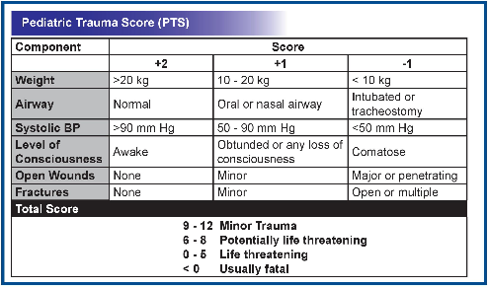
PTS – Pediatric Trauma Score predicts severity of injury and potential mortality
- Direct relation with injury severity
- Indirect relation with patient mortality
- 6 components -
  - Size – airway – consciousness – SBP – Fracture – cutaneous injuries

Categorization of Hospitals:
- Inclusive System: all hospitals participate in providing care to all patients
- Exclusive System: seriously ill/injured patients are triaged to designated centers

Medical Direction
What does Off-line (indirect) medical control include?
- Equipment lists
- Treatment protocols
- Dispatch criteria
- QA programs
What does On-line (direct) medical control include?
- Real-time communication between EMS care providers and base station

Transport
Emergency Medical Services for Children (EMSC): not a separate EMS system, but is the integration of the special needs of children into the existing EMS system.

Primary transport: the movement of a patient from the out-of-hospital location of an injury or illness to a hospital ED.
Secondary transport: the patient is moved from the ED or hospital ward to a specialty center.

Pediatric Transport & EMS Statistics:
- Children are mostly transported by their caregivers to ED’s.
- Children account for approximately 1/3 of all ED visits nationally (85% of those children seen in general ED’s)
- Children account for 10% of all ambulance runs
- 2/3 of pediatric 911 calls are managed by first responders and EMT’s and 1/3 are managed by paramedics.
- 10% of ped. transports (or 1% of all transports) are seriously ill/injured children
- Children transported to ED’s by EMS are 3-4 times more likely to require admission than are those who arrive by other methods.

Helicopter flight: generally about 1/3 of ground transport time.
- Only for distances < 150 miles
- Fly at < 1500 feet
Fixed Wing (plane) –
- Better for > 150 miles
- Plane budget less $
- Plane cannot get cabin pressure to sea level < 7,000 – 8,000 feet
Transport team – is conditions unsafe – need to wait for transport

The National Highway Traffic Safety Administration (NHTSA) established the National Standard Curriculum (NSC) for training EMT’s and defined 4 levels of EMS Providers:
- First Responders (police and fire fighters): basic first aid, CPR, basic airway management, AED (>1yo)
  - Training 40 hours

- EMT Basic (EMT-B): O2 delivery with bag/mask, splinting, spine immobilization, extrication and transport, assist patient to use their own: albuterol nebulizer, epi pen, nitro tablets
  - Training 110 hours

- EMT Intermediate (EMT-I): basic ECG and pulse ox monitoring, vascular access, nasal/oral intubation, needle thoracotomy, manual cardioversion/defibrillation/pacing, and administration of resuscitation drugs

- Paramedic (EMT-P): trained in use and interpretation of 12-lead ECG, RSI/medication-enhanced intubation, and needle/surgical cricothyrotomy
  - Need PALS training
Note: the specific scope of practice for all pre-hospital providers will be dictated by state law and the system’s medical director.
Providers should never go outside their levels – even if given ok by MD
EMT on duty is NOT covered by the good Samaritan laws

There are 2 levels of ambulance service:
- Basic Life Support (BLS) units are staffed with EMT-B’s
  - Carry oral airways, self-inflating resuscitation bags and masks, nonrebreathing masks, stethoscopes, backboards, C-collars, blood pressure cuffs, suction and suction catheters, extremity splints, obstetric supplies, thermal blankets, lubricant, and AED’s.
- Advanced Life Support (ALS) units are staffed with paramedics
  - Carry IV catheters, IO needles, nebulizers, resuscitation drugs, IV fluids, ET tubes and laryngoscopes, NG tubes, transport monitors, and manual defibrillators
  - Drugs albuterol – antidotes - amiodorone – Atropine – Becarb – Diazapam – Dopamine – Epi – Lidocaine - Morphine
Transport to trauma center:
- GCS <13 - hypotension - tachypnea
- Injuries - Penetrating injuries (prox elbow and knee), Chest wall deformity, 2 or more long bone fractures, Crush injury, Amputation wrist to ankle, Pelvic fracture, Open or depressed skull fracture, Paralysis
- Mechanism fall > 10 feet, intrusion, ejection, death in same compartment, auto vs ped, > 20 mph
- Other considerations h/o bleeding disorder, burns, pregnant > 20 weeks

EMS can transport without parental consent if:
Emergency condition – will cause a delay in treatment – unreliable guardian –
- If life threatening can go against parents’ wishes

Mass Causality
Disaster triage vs. ED triage:
ED Triage: give the most resources to the most critically ill patients.
Disaster triage: patients with little or no chance of survival are not resuscitated “do the most good for the most people.”
The disaster triage categories are:
- green (nonurgent, walking wounded, third priority): “everyone who can hear and who needs medical attention and who can move should move to the area with the green flag”
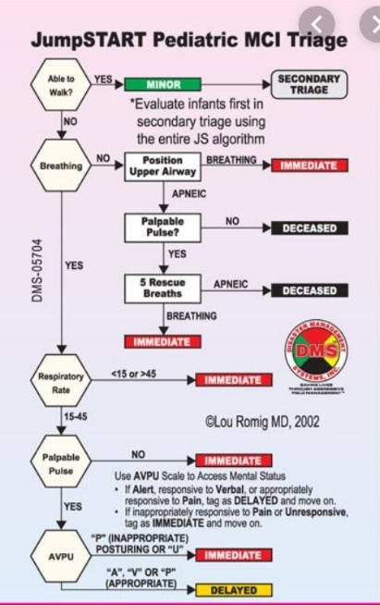
- yellow (delayed, urgent, second priority): Can tolerate an hour wait; Ask those who remain after clearing the walking wounded to “raise a hand or leg if they need help” (open fractures, deep lacs with pulses, alert abdominal or head injuries) (i.e. a penetrating abdominal or spinal wound with stable vitals)
- red (most urgent, first priority): have immediate threat to life or limb, but if given immediate care will probably survive; Go to those who remain after you’ve moved the greens and noted the yellows. Do Airway issues, then Breathing, then Circulation…(The goal is to first sort immediate from catastrophic.)
- black (dead, expectant, catastrophic): not breathing even after airway positioning and a few rescue breaths.

START (Simple Triage and Rapid Treatment): An adult-based triage system identifying
- 4 categories of patients.
- Green – get up and walk
- Red – breathing
- Yellow – RPM – RR<30 – Perfusion < 2 – good Mental status
- Black – apnea after opening the airway

JumpSTART - The pediatric version (for patients younger than 9 years)
- Green – walking
- Black – apnea after 5 rescue breathing
- Yellow - RR 15-45 - Palpable Pulse – normal perfusion
- Red -

Mass Casualty Events (MCE’s) vs. Multiple Casualty Incidents (MCI’s):
- MCE’s: overwhelms resources of involved EMS systems; rare
- MCI’s: involves 5+ patients, strains involved EMS resources, more common

Poisonings - Regional poison control centers (PCCs)
- They provide telephone advice and recommendations to the general public, first responders (including EMS, fire, and police personnel), and medical clinicians.
- PCCs are not involved in local EMS and hospital protocols related to appropriate destination facilities and are not designed to provide on-scene response.
- Although hazardous materials incidents may benefit from PCC consultation, most calls involve individual accidental or intentional poisonings
- Many EMS services include consultation with the PCC in their protocols for the management of any potential medication overdose, chemical exposure, hazardous materials incidents, or potential chemical terrorism events.
- Consultation can result in a reduction in unnecessary hospital transports and cost savings.
Prevention
Haddon’s Matrix: a tool used to develop or evaluate injury prevention programs, analyzing injuries based on:
- Host factors (person being injured)
- Agent factors (what causes the injury)
- Environmental factors
Each of these factors is evaluated in the pre-event, event, and post-event environment.
Example: Prevention of injuries due to MVC’s
- Pre-event (primary prevention) prevents the crash from occurring, (highway design, signals at intersections, improving driver education)
- Event (secondary prevention) lessens injury severity (seat belt/car seat)
- Post-event (tertiary prevention) improves the treatment of injuries (EMS, funding trauma centers)

Car seats -
Rear-facing until 2 years of age
Front facing until 40 lbs (as long as possible until outgrow requirement on seat… most 40 lbs)
Booster seat until 4 feet 9 inches
All children under 13 should ride in the back seat

Transport in car seat?
- Yes can transport in carseat via EMS IF NO damage to seat and NO obvious injuries

How can a minor become emancipated? (some states offer additional options)
- Marriage
- Joining the military
- Declaration of the court
- Economic self serving

Mature Minor –
- >14 years old and declared mature by state supreme court

Consent laws in NYS:
- >18 years
- If have a child can consent for that child
  - BUT NOT emancipated minor
- Pregnant can give consent to prenatal care
- Married or in the military
- >16 years and self-sufficient source of money
Children < 18 can consent to own STD care, family planning, drug treatment or mental health treatment

Sources:
Fleisher GR, Ludwig S, et al., eds. Textbook of Pediatric Emergency Medicine. 6th ed. Philadelphia, PA: Lippincott Williams & Wilkins; 2010

Baren JM, Rothrock SG, Brennan JA, Brown L, eds. Pediatric Emergency Medicine. Philadelphia, PA: Saunders Elsevier; 2008

Avner J, Baker D, Wilde J, eds. PREP E-Med. American Academy of Pediatrics. www.prepemed.aap.org

Wang VJ, Sharma S, Flood RG, eds. Pediatric Emergency Medicine Question Review Book 2009. www.lulu.com

