PEM|BRS: Heme/Onc & Allergy/Immunology

Immunology –
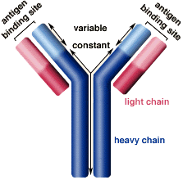
Immunology –
CD8 cells recognize HLA class I Ag (CD8 cytotoxic)
CD4 Tcells recognize HLA class II Ag
Class II à professional antigen presenting cell
  - monocytes – macrophages – B cells

B cells- check Ig’s and response to vaccines
Compliment – check CH50 and C3 C4
T cells – check number of T cells and cytometry
Phagocytes – neurophil oxidation

Compliment – Three pathways - classical, lectin, and alternative pathways
- Independently activated to form C3 convertase.
- The activation of this cascade culminates in the formation of membrane attack complex (MAC).
  - Composed of C5b, C6, C7, C8, and multiple copies of C9 that generate lytic pores in cellular membranes
- Also generates various fragments derived from complement proteins à acts as potent mediators of inflammation by binding to their receptors on the cell surface
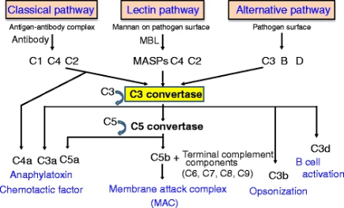
Antibodies –
IgM – first produced
IgA – secreted
IgE – allergic
IgG – 4 subclasses – main Ab in breast milk

Compliment Deficiencies –
C3 deficiency à risk infection with encapsulated organisms
C5-C9 deficiency à recurrent Neisseria meningitis
- Diagnosis CH50

Immune deficiencies (Bcell)–
SCID – x linked
- Presents at months of life
- FTT - eczema - diarrhea - lung infections
- CXR – no thymus
- Decreased lymphocyte count
- Treatment – BMT
  - No live vaccinations
  - Given irradiated blood

X linked – Burtons – lack of all Ig types
- Presents at 4-6 months
- Lack of btk gene – tyrosine kinase
- Bacteria infections - small lymphnodes - small tonsils - encapsulated organisms
  - Meningitis – giardia
  - Treatment – IVIG

Common Variable – at least 2 subclasses of Ig
- Encapsulated bacteria PLUS autoimmune disease
- Sprue like illness - diarrhea - hepatosplenomegaly - inc risk lymphoma -
- Non-caseating granulomas - liver – spleen – lungs – skin
- Treatment – IVIG

Hyper IgM – x linked – no conversion IgM à IgG
- PCP pneumonia - giardias - ascending cholangitis with crypto
- Treat – IVIG and Bactrim

DiGeorge Syndrome – chromosome 22 - defect in FISH
- CATCH 22 à cardiac – abnormal face – no thymus – cleft palate – hypoparathyroid
  - Decreased Ca
  - Cardiac à interrupted aortic arch – tetralogy – transposition – double outlet RV
  - Face à Low ears – microganthia – short philtrum
- Early in infancy with mucocutaneous candidiasis

Wiskott Aldrich – X linked - Elevated IgE
- Eczema - decreased Platelets (small platelets) - immunodeficiency (encapsulated organisms)

Ataxia telangiectasia– ataxia - oculocutaneous telangiectasia- immunodef
- < 5 years – ataxia then > 5 years of age telangiectasia
- Sinopulmonary infections - increased lymph
- Diagnosis à elevated alpha 1 fetoprotein

Neutrophil diseases –
Cyclic neutropenia – fever about every 21 +/- 3 dyas
- ANC <200
- Fever – apthous stomatitis – lymphadenitis – rectal/vaginal lesions
- Treat – G-csf

Congenital Leukocyte Adhesive defect- 1 (LAD-1) - Lack fo CD 18 à does not enter tissue
- Delayed separation of the umbilical cord - Cigarette paper skin scaring
- Skin infections – pneumonia – gingivitis
- Diagnosis – Flow cytometry
- Treatment – BMT

Hyperimmunoglobin E (job)
- Increased IgE - increased eosinophils
- Eczema - cold abscess - delay dental - hyperextensibility - scoliosis
- Treatment – Bactrim

Chediak Higashi – Giant granules in neutrophils and eosinophils
- Albinism - silver hair
- Frequent skin and sino/pulmonary infections

Chronic Granulomatous Disease – defect in respiratory burst
- Skin abscess - liver abscess - osteomyelitis
- Diagnosis – NBT dye à yellow does not turn blue
- Treatment – sulfa and interferon - BMT

Vaccinations
- Measles vaccine, DTP, and Hep B are the most commonly identified vaccine-related causes of anaphylaxis.
- Egg Protein à
  - Measles vaccine - derived from chick embryo fibroblast tissue and contain egg protein
    - But the risk is exceedingly small.
  - Influenza vaccine contains a greater amount of egg protein and places children at such a great risk for allergic reactions
    - Recommendation - This vaccine be withheld from children with egg allergies.
- Neomycin
  - IPV contains trace amounts of neomycin streptomycin, and polymyxin B
  - MMR and Varicella vaccines contain trace amounts of neomycin and gelatin
- Yeast –
  - Present in Hep B - children with yeast allergies can have reactions to this vaccine.
- Rashes
  - Varicella and MMR most commonly related with rashes
    - Varicella vaccine rashes appear 9-16 days post immunization.
    - The MMR rash and fever appears 7-10 days post immunization
- Fever occurs within 2 days for Hep B, Influenza, Hib, and pneumococcal vaccines.
- Joint symptoms like arthralgias and arthritis are associated with the rubella component of MMR.
- Thrombocytopenia – Seen with MMR – typically within 2-6 weeks

Tetanus –
- Increased risk if: contaminated (with dirt, feces, soil, or saliva), puncture wounds, avulsions, wounds resulting from missiles, crush injuries, burns, frostbite, and those with neurovascular compromise.
- IF PATIENT WITHOUT 3 PRIOR DOSES of vaccine
  - ALSO give TIG

Rabies
- Risk: Bites from raccoons, skunks, bats, foxes, bobcats, coyotes, woodchucks, beavers, and mongooses are considered high-risk for rabies transmission.
  - Low risk - Domestic animal bites (dogs, cats, ferrets, and livestock)
    - Also include mice, squirrels, rabbits, chipmunks, rats, hamsters, gerbils, guinea pigs.
- Raccoons are the most commonly encountered rabid wild animal—then skunks, bats, and foxes.
- The majority of rabies cases in the USA are due to bats -
  - Need to treat if a bat is found in the room of an individual who is incapable of attesting to absence of direct contact
    - Sleeping and awakes to find a bat in the room
    - Bat found in the room of an unattended child/mentally/physically disabled/intoxicated
    - The only exception is when the bat is captured and immediate brain testing is available.
- You can also get it from inhaling large amounts of bat guano in a bat cave.
- Treatment/prophylaxis after exposure
  - BOTH RIG and Rabies vaccine.
    - Rabies vaccine is given on days 0, 3, 7, 14
      - 1 ml given in deltoid
    - RIG given on day 1
      - Injected around the bite – with rest in thigh or butt
  - People already been vaccinated and are exposed à only vaccine on days 0 and 3 (no need RIG)
  - Observe domestic animals for 10 days - defer immunization (unless animal rabid while in captivity).

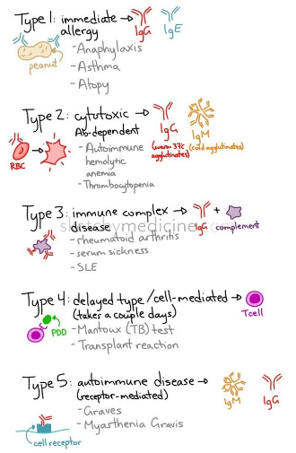
Immunocompromised – 2mg/kg steroids given daily for > 14 days
- Need to be off steroids for 4 weeks prior to giving vacinations
  - NO à OPV – LIVE FLU – MMR - varicella - BCG
  - NOT for contacts à OPV - Live Flu - Smallpox
- HIV can have all vaccines except OPV à should get MMR and Varicella

Hypersensitivity Reactions –
Type 1 – IgE – anaphylactic
- Mast cells – Histamine
- Need previous exposure
- Late phase à 3-12 hours – eosinophil response
Type II – Antoantibodies
- Hemolytic anemia, SLE, good pasture, Myastenia
Type III – Ab + Ag complex deposits in tissue
- Vasculitis – serum sickness
Type IV – Delayed T cell
- ppd

Anaphylaxis – multisystem – skin, resp, vascular, GI
- Immunoglobulin E (IgE)-mediated, immediate hypersensitivity reaction to a protein antigen.
- Approximately 1% to 2% of anaphylactic reactions are fatal à Nuts cause death more often
- Diagnosis – clinical à 2 or more body systems
  - Symptoms typically develop rapidly (within minutes to a few hours) after exposure.
    - Cardiovascular (eg, dysrhythmias, hypotension)
    - Cutaneous (eg, angioedema, urticaria)
    - Gastrointestinal (eg, cramps, vomiting)
    - Neurologic (eg, diminished mental status, seizure)
    - Respiratory (eg, stridor, wheezing)
- A minority of patients experience biphasic reactions (a recurrence of symptoms after apparent initial resolution), generally within 72 hours of onset.
- Most common allergens – penicillin, latex, peanuts, tree-nuts, shellfish and eggs also insects stings (eg, Hymenoptera)
- Initial exposure to the antigen is required to generate allergen-specific antibodies
  - anaphylaxis follows a subsequent re-exposure to the allergen.
- Treatment- IM Epi 1:1000 thigh – 0.01mg/kg - maximum of 0.5 mg/dose
  - PLUS – Benadryl - albuterol – ranitidine – steroids
    - Continue treatments of at least 48 hours following discharge
  - Consider admission if experience upper airway obstruction or shock
  - Refer to allergist
    - May be able to identify the specific allergen with skin testing or serum antibody tests.
  - If on a betablocker à poor response to Epi à treat with Glucogon

Anaphylactoid reactions
- NOT IgE-mediated.
- Complement activation à C3 C4 C5 à release granules
  - Causes
    - Blood products - Immune complexes
    - Radiocontract dye - probable complement activation
    - Aspirin and NSAIDS - abnormal leukotriene metabolism
    - Exercise and Morphine - direct release of mediators by physical factors
  - May occur on initial exposure to the agent

Allergies
Food allergies – MC à peanut
Also common à eggs, wheat, seafood

Insect allergies – yellow jackets
- If anaphylaxis – need referral to allergist for immunotherapy
- If large local reaction – no further workup needed
Latex –
- Cross reacts with avocado – banana – chestnut
  - Also tomato – potato - papaya - Kiwi

Asthma –
- Well controlled – less than or equal to 2 episodes/day/wk
  - Less than or equal to 2 episodes/night/month
  - Less than or equal to 2 ER visits per year
- Sever exacerbation - Epi (in addition to albuterol) first-line treatment
- Intubating Asthmatics: only in extreme cases
  - Ketamine at 1-2 mg/kg - ideal induction agent bronchodilatory effects.
  - Mechanical ventilation of asthmatics places them at high-risk for barotraumas
    - Allow permissive hypercapnia - short I/E ratio to allow expiration - minimize sedation
    - Reduce this risk of barotrauma

Nasal Polyps –
- Younger children à CF
- Older kids à allergic

Mastocytosis –mast cell infiltration of skin or other tissues and organs.
- Symptoms - mainly from mediator release
  - Puritus, flushing, and dyspepsia due to gastric hypersecretion.
- Cutaneous à Darier sign = wheal with gentle stroking
- Should stay away from heat, cold, ETOH, ASA, opiates
- Diagnosis is by skin or bone marrow biopsy or both.
- Treatment is with antihistamines and control of any underlying disorder.

Hereditary Angioedema – defect in C1 inhibitor
- Low plasma protein C1 inhibitor
- Swelling – painful - but not itchs no uritcaria
- Abdominal pain – typically starts with abdominal pain
- Diagnosis – decreased C4
- Treatment – C1 esterase inhibitor
  - Danazol – anabolic steroid

Serum Sickness – type III hypersensitivity reaction
- Immune complex mediated activation of the complement pathway due to injection of foreign serum proteins.
- Signs and symptoms - fever, arthralgia, skin eruptions, GI symptoms, lymphadenopathy, nephritis, and neuritis.
  - Skin – target lesions
- A latent period of 7-14 days is expected between antigen exposure and the onset of the reactions.
  - Can be more rapid if previously exposed (1-4 days)
- Antibiotics are the most common medications to cause serum sickness-like reactions
  - Cefaclor, and prior sensitization is not necessary
- Treatment – self resolves in 7-10 days - Stop inciting protein if possible.
  - NSAIDS - for fevers and myalgias
  - Antihistamines – for pruitis, urticaria, or angioedema
  - Steroids - for severe cases or those refractory to more conservative measures.

Serum Sickness like reaction –
- Signs and symptoms - fever and lymphadenopathy, but are otherwise confined to the skin and joints.
- Unlike serum sickness - serum sickness-like reactions are not associated with circulating immune complexes.
- Will not have à palpable purpura, nephritis, edema, and neuritis

HIV – low CD4
- CD 4 count – monitors immune function
- HIV RNA – monitors amount of virus in blood
- Risk of PCP pneumonia – may be asymptomatic
  - Wheezing, tachypnea, pneumonia
  - CXR – bilateral alveolar infiltrates – ground glass
  - Elevated A-a gradient - elevated LDH

- A well-appearing febrile child with HIV and low viral load à can be treated like normal child
  - Work-up - CBC, blood culture, and U/A, UCx.
  - CXR and pulse ox measurements - if the WBC is elevated or a left shift is present.

- HIV medications
  - Didanosine, amivudine, and stauvidine – side effects à Acute pancreatitis

- Pneumocystis Carinii Pneumonia (PCP)
  - ages 2-6 months
  - Symptoms of fever, wheezing, tachypnea, and decreased breath sounds.
  - CXR shows diffuse bilateral infiltrates.
  - A high A-a gradient on ABG and elevated LDH (above 500) are typical lab findings.

HEME
Epistaxis - Most children have “benign” epistaxis that requires no further evaluation.
- Benign epistaxis typically from anterior nasal septal mucosa à Kiesselbach plexus.
  - This highly vascular area is within reach of a child’s finger during nose picking or rubbing.
- Concern if - > 20 minutes – multiple episodes –
  - Check CBC with diff and coags
  - If normal can refer to Heme for eval for vWD
- Treatment - controlled pressure, ice, or topical instillation of vasoconstrictor medications - Phenylephrine.
  - Pressure is applied to the outside of the nose in a forward leaning position.
  - Or pinch the nostrils and compress the upper lip, which occludes the labial artery.
  - Nasal packing
- If consistently unilateral à ENT à look for foreign body, abnormal vessel, polyp, or rarely, a neoplastic lesion such as angiofibroma.
- Vascular disorders such as hypertension or hereditary hemorrhagic telangiectasia (Rendu-Osler-Weber disease) are among the nonhematologic disorders that can result in epistaxis.

ITP – bruising and low platelet count
- Proposed mechanisms - autoimmunity against glycoproteins on the surfaces of platelets.
  - Autoantibodies coat the platelets that then are destroyed by the spleen and other organs of the reticuloendothelial system.
  - Antibodies are believed to arise from the immune response to a mild bacterial or viral infection
- Well-appearing - no other signs of chronic illness – with increased bruising or bleeding
  - Bleeding from mucosal surfaces, mouth, vagina, and GI tract
  - No lymphedema or hepatosplenomegaly
- Normal other cell lines and smear
  - Smear – decreased number of platelets - which are normal, or larger than normal in size
    - Normal white blood cell and red blood cell morphologies.
    - Platelets in ITP are typically large, reflecting fresh platelets
- Treatment à only after malignancy excluded
  - Intravenous immune globulin – steroids – Anti-Rho antibody (for Rh+ patients)
    - Typically in patients with platelet count <20
    - Rhogam à no longer used – risk of anemia, renal failure, DIC
  - For most children ITP resolves within 6 months without any treatment
  - No platelet transfusion à anti platelet antibodies from ITP would destroy them
- Head bleed à need IVIG, platelets AND steroids
- No LP unless Platelets > 50,000
- A minority of children progress to chronic ITP.
  - More common in older children.
  - Occasionally children resistant to pharmacologic treatments (including rituximab) à splenectomy.

Von Willebrand’s Disease – most common bleeding disorder
- VW protein - helps platelets bind to the vessel wall and serves as a carrier protein for factor VIII
- Most common presenting symptom – menorrhagia
- Normal PT, PTT – elevated bleeding time (in severe cases – prolong PT and PTT)
- Decreased - Platelet Function Analyzer (PFA) has replaced bleeding time as the test of choice
- Treatment à DDAVP = desmopressin
  - fluid restriction is recommended during and immediately following DDAVP due to the risk of hyponatremic seizures.
  - If severe also give Factor VIII

Thormbocytosis – Platelets > 500,000
- Not associated with bleeding or thrombosis
- Cause – Kawasaki disease – infection – iron anemia
- If well appearing no treatment needed
- Mod/severe – follow CBC’s

DIC – associated with septic shock
- Petechiae – purpura
- Decreased platelets - elevated PT and PTT +fibrinogen +d dimes
- Treatment à treat underlying cause
  - Give platelets, Cryo and FFP

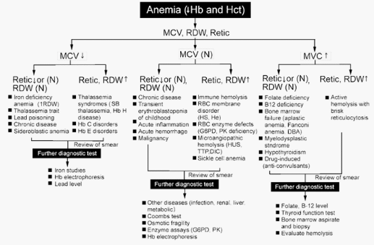
Hemophilia A – factor VIII deficiency
- X linked
- Decreased factor VIII – elevated PTT – normal PT
- If bleeding give factor 1st then get imaging
- Treatment – DDAVP à causes release of vWF and factor VIII
- Inhibitors – give VIIa and activated prothrombin complex
  - May respond to high dose factor VIII
  - Plasmapheresis

Hemophilia B – factor IX deficiency
- Treat with recombinant factor IX
- Prolong aPTT - PT normal

E-aminocaproce acid = amicar
Cryo = fibrinogen
FFP = plasma with clotters

Anemia’s
Physiologic Anemia of Infancy - Hgb 9-11
- 6 wk à Resolves by 3-4 months
- Normocytic
- At birth – increase in PaP2 à decrease in EPO production à anemia
- Preterm infants with nadir as low as 7 around 3-6 weeks of age

Transient erythroblastopenia of childhood (TEC)
- Most common cause of acquired isolated RBC aplasia in children.
- Occurs between 6 months and 3 years of age,
- Nonspecific viral illness à transient immunologic suppression of erythropoiesis à severe anemia.
- Decreased Retic - Normal MCV - normal RBC adenosine deaminase (ADA)
- Treat with transfusion if Hgb <5

Diamond-Blackfan anemia (DBA) also known as congenital RBC aplasia. (congenital defects + elevated ADA)
- Severe anemia, reticulocytopenia, macrocytosis,
- Normal white blood cell count, and normal platelet count
- Congenital skeletal abnormalities the hypoplastic thumb – abnormal radi – FACIES – cardiac – cleft palate
- Elevated ADA
- Treat – steroids and BMT

Iron Deficiency – microcytic – hypochromic
- Age 9-24 months
- Decreased MCV – retic 1-2% - RDW >14
- Drinking large amounts of cows milk (> 20-24 ounces/day) à Associated with cognitive defects
- Treatment – decrease milk intake
  - Iron supplementation – 3-6 mg/kg/day
  - Will see increase in retic count in 3-5 days
- Also associated with menstrual loss

Mentzer Index = MCV/RBC
- >12 = Iron deficiency
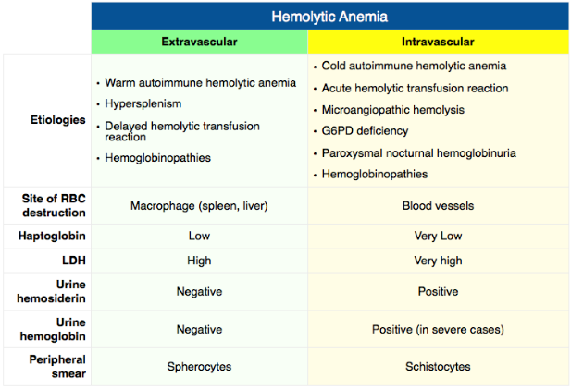
- < 11 thalassemia
RDW – elevated in Fe def - normal in thalassemia

Thalassemia
- B minor – target cells - HgA2 >3.5%
- B major –
  - 6-12 months with pallor – decrease growth hepatosplenomegaly
  - Thalassemia faces – osteopenia
  - Heinz Body
  - Elevated Hg F

Folate – goat milk
- Megoblastic anemia with hypersegmented neutrophils

B12 def – vegan diet
- Neuro symptoms- paresthesia – decrease proprioception – decreased vibration - dementia
Direct coombs – IgG on RBC - Indirect – serum has Abs
- Intrinsic factor produced in parietal cell – B12 absorbed in the terminal ileum
  - Pernicious anemia – decreased intrinsic factor or Antibody to intrinsic factor
- Causes – tapeworm – Diphyllobothrium latan - enteritis – bacterial overgrowth
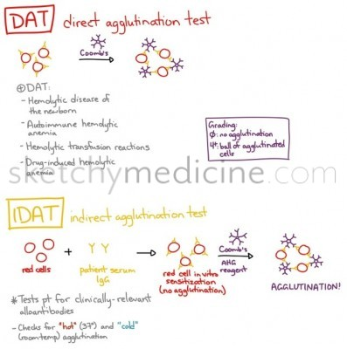
Hemolytic anemia – anemia – jaundice
- Dark urine - splenomegaly
- Positive direct coombs
- Treat – steroids +/- transfusion
Spherocytosis – cells destroyed in the spleen
- Hemolytic anemia - jaundice
- Elevated retic
- Diagnosis – osmotic fragility test
- Risk – aplastic anemia with parva B19 and bilirubin gallstones

G6PD – X linked - decreased glutathione
- Stress/infection/dapsone/primaquine à lead to hemolysis
- Diagnosis – check G6PD level

HUS
- nonimmune microangiopathic hemolytic anemia (circulating RBC fragments, hemoglobinemia, and hemoglobinuria)
- consumptive thrombocytopenia
- Renal insufficiency or failure.
- Children from 7mo-5 years old.
- 2-14 days after an acute infectious hemorrhagic colitis caused by EColi

Sickle Cell –
Vaso-occlusive pain
- Typically first episode in infants and toddlers à acute swelling of the hands and feet (dactylitis).
  - Hand-foot syndrome symmetric - involving the metacarpals and/or metatarsals.
  - If fever is present, osteomyelitis may be difficult to exclude and may require a bone scan or MRI.
- Pain control à morphine is preferred
  - Meperidine (Demerol) (metabolite (normeperidine)) can causes seizures and is poorly metabolized

Sickle Cell Disease and Fever:
- If ill appearing or < 6 months à IV abx and admission
- Well-appearing > 6 months who meet specific criteria, may be treated as outpatients with close follow-up.
  - Criteria:
- Normal mental status
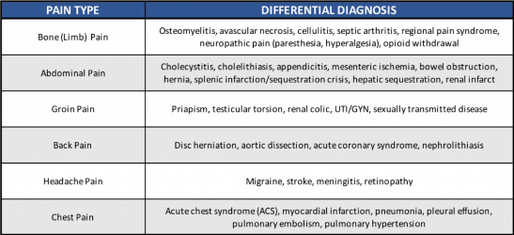
- Normal vitals and cap refill
- Temp under 40 (104)
- No prior pneumococcal sepsis
- Mild pain only
- No evidence of pneumonia
- WBC 5-30K
- Hemoglobin > 5
- Platelets > 100,000
- No allergy to ceftriaxone (able to administer)
- Reliable 24 hour follow-up

Acute Chest –
- Fever - chest pain - respiratory distress - cough/hemoptysis
- Infiltrate on CXR
- Most common cause – chlamydia, mycoplasma and RSV
- Treatment - O2, IVF, analgesics, and Cef +/- Azithro
  - Overly aggressive hydration is contraindicated - risk of edema from pulmonary vessel permeability.
  - Severe: multilobar disease, rapidly progressive disease, marked respiratory distress, PO2 < 70 or a fall of 25% in baseline PO2
    - consider à Steroids, macrolides, and exchange transfusion
    - Transfusion – if Hg < 5 - hypoxemia - r apid progression

Aplastic Crisis -Typically from parvovirus B19
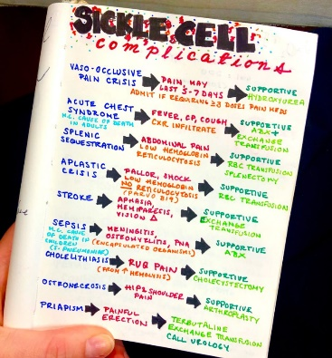
- s/p UTI à Progressive pallor without jaundice - tachycardia
- RBC’s in HbSS last only 30 days opposed to the normal 120 days – greater risk of aplastic crisis
- Decreased Hgb AND decreased retic count also decreased bili, no splenomegaly
- Encapsulated organisms – S. pneumo - N. meningitidis - H. flu
- Treatment – if symptomatic children - small volumes of transfused PRBC’s.

Splenic Sequestration – children 6 months to 2 years
- Fever - pallor - enlarged spleen - associated with viral illness/URI
- Precipitous drop in Hgb (> 2 from baseline) - retic normal/elevated
- Can have signs of circulatory collapse, requiring prompt intervention to reverse hypovolemic shock
- Treat à IVF - transfusion

Priapism
- Treatment à hydration and pain control
  - Aspiration of the corpora and instillation of an epinephrine-type solution (> 2 hours)
  - Transfusion –
    - Exchange transfusion - if the Hgb >10
    - Transfusion if Hgb <10
  - If no improvement in 72 hours à a shunting procedure is considered.
- Risk – impotence and decreased sexual function

Strokes
- Occur in 10% of patients with Hb SS by the age of 20 years.
- Treatment - expeditious exchange transfusion.
  - The goal is to limit further sickling by acutely decreasing the proportion of Hb S to < 30%.
  - Avoid hyperviscosity by keeping the Hct around 35%. Treat seizures as per normal.

Biliary cholic and acute cholecystitis
- Always possible etiologies for Sickle Cell patients with abdominal pain.
- Chronic hemolysis à hyperbilirubinemia à formation of bilirubin containing gallstones.

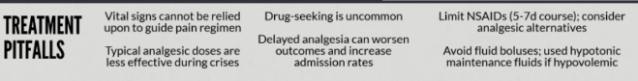
Pitfall: DO NOT attribute tachycardia to baseline anemia à they have compensated and have a normal heart rate.

Sickle Cell Trait – can have gross hematuria
- Decreased ability to concentrate urine à renal papillary necrosis à gross hematuria
- Reported complications in children who have sickle cell trait - renal medullary carcinoma, hematuria, hyposthenuria (loss of urinary concentrating ability), renal papillary necrosis, splenic infarction, rhabdomyolysis, and unexpected exercise-related sudden death.
- There may be a relationship with venous thromboembolic events, pregnancy-related complications, hyphema, retinopathy, acute chest syndrome, and asymptomatic bacteriuria.

Fanconi Anemia – aplastic anemia – all cell lines down
- Age 8-9 years
- Short thumbs – radi abnormal – dark pigmentation – café au late spots
- Treatment BMT
- Increased risk of malignancy

Methemoglobinemia (MHb) – normal PaO2 but a low pulse ox following the ingestion of a sulfa-containing antibiotic
- Acquired - when the iron oxidized from the ferrous (Fe²⁺) to the ferric (Fe³⁺) state.
  - Hemoglobin is unable to bind oxygen
  - Hemoglobin dissociation curve is shifted to the left à unable to release oxygen molecules
  - Leading to impaired oxygen transport and tissue hypoxia.
- MHBb is produced normally in the body and accounts for about 1% - 1.5% of child's total hemoglobin.
  - Most is reduced back to the ferrous state by the actions of cytochrome b5 or MHb reductase.
  - In the first few postnatal months, infants are relatively lacking in this enzyme
  - Multiple causes of oxidant stress can precipitate an episode of methemoglobinemia in infants.
- Exogenous sources of oxidants often are related to the ingestion of nitrites or nitrate-containing compounds that may be converted to nitrites in the gastrointestinal tract of infants by normal gut flora.
  - Well water that contains high concentrations of nitrites or nitrates (often due to agricultural runoff)
  - Foods (including carrot juice)
  - Medications - local topical anesthetics, benzocaine (teething gels).
    - Others - dapsone, metoclopramide, quinones, and sulfonamides.
- In very young infants, especially low weight for their age - may occur during diarrheal illnesses.
  - The exact mechanism of this development is not completely understood.
  - Acidosis à may be enough of an oxidant stress to cause oxidation of hemoglobin to the ferric state.
  - Changes in gut flora during the illness may lead to an increased production of nitrites à increased production of MHb.
    - Escherichia coli and Campylobacter jejunii have been implicated in some case series.
- Diagnosis - Considered whenever cyanosis in a child does not respond to oxygen
  - Pulse oximetry readings are inaccurate - may be normal
- Treatment - 1 to 2 mg/kg of intravenous methylene blue for symptomatic patients or concentrations > 30%.
  - Methylene blue should not be administered to patients who have glucose–6–phosphate dehydrogenase (G6PD) deficiency because it can precipitate acute hemolysis.
  - Exchange transfusion or hyperbaric oxygen therapy may be useful in patients who have G6PD disease or in those who do not respond to methylene blue.
- Failure to recognize can lead to continued hypoxia, worsening acidosis, seizures, coma, and even death
Transfusion Reactions
Acute Transfusion à STOP transfusion – reassess donor and patient blood
- Fever Hemolytic reaction à uticaria, dysphagia – wheeze
  - Hypersentivitiy to plasma
  - Minimized wth washed RBCs
  - Treat IVF and Tylenol
- Fever non-hemolytic reaction à fever - chills – pulmonary infiltrates
  - HLA on WBC
  - Minimized with leukoreduction
  - Treat with Tylenol
- Allergic –
  - Treat with epi, steroids and antihistamine
- Anaphylactois
  - Treat with steroid and epi
Delayed transfusion reaction - new AB against a RBC
- 3-14 days after repeat transfusion
  - patients having previously received matched blood that had undetectable incompatible antigens
- Pallor, severe anemia – less often with end organ failure
- Coombs + à The direct antiglobulin test will be positive
Antibody now be discernable in the cross-match à transfusion of compatibility tested RBC’s safe.

Pulmonary Embolism/DVT –
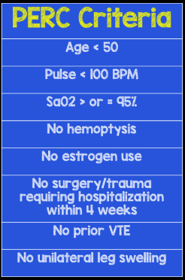
- Risk factors – underlying illness (SLE, sickle cell, nephrotic syndrome, congenital heart) – obesity – steroids – OCPs – trauma – central line catheter – prolong immobilization – malignancy - and thrombophilic disorders such as Factor V Leiden mutation and Protein C or S deficiency.
- Clinical presentation – often
  - Dyspnea and pleuritic chest pain are the most common presenting symptoms
  - hemoptysis, syncope, unexplained tachypnea or tachycardia, clinical signs of deep vein thrombosis
  - Sudden increase in oxygen requirements in those receiving mechanical ventilation.
- The D-dimer - high sensitivity (~95%) but is not specific.
    - breakdown product of cross-linked fibrin
    - may be elevated in other conditions such as disseminated intravascular coagulation, sepsis, postsurgical state, or cancer.
  - Chest radiographs in PE usually appear normal.
    - Westermark sign - abrupt localized cutoff of central pulmonary vasculature (massive PE)
  - EKG - Nonspecific ST-T wave changes are the most common
    - Right ventricular strain - S1Q3T3 pattern on ECG
- PERC – can rule out in low risk
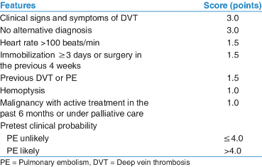
  - If PERC negative can stop there
  - If PERC not negative – move to Wells
- Wells criteria
  - If wells unlikely à get d dimer
  - If wells likely à get imaging
- Imaging à CTA
    - Non invasive readily available
  - A V-Q scan - rapid
    - Results are clearly normal or show “high” probability of PE.
    - The presence of prior lung disease or congenital heart disease with differential pulmonary blood flow can lead to false-positive results on the perfusion scan.
  - PA - invasive and expensive – still called the GOLD STANDARD
  - Magnetic resonance angiography does not involve radiation
    - Not readily available - takes longer to accomplish – may require sedation or anesthesia.
- Treatment à anticoagulation with intravenous heparin or subcutaneous low-molecular weight heparin
  - Massive PE in an unstable patient or when anticoagulation is contraindicated à open surgical or transcatheter embolectomy may be considered.

DVT – 90% of PE originates from thrombi in proximal deep veins of the pelvis and lower extremity
- Deep vein thrombosis is detected in 20% to 50% of cases of PE
- Incidence - estimated at 4.9 per 100,000 children per year.
- DVT is more common in African Americans and children younger than 2 years and older than 15 years of age
- Pathogenesis for thrombus formation can be explained by the Virchow triad of hypercoagulability, stasis, and endothelial injury.
- Risk factors known to induce one or more of the Virchow conditions are:
  - Immobilization for longer than 3 days - Trauma - Vasculitis (systemic lupus erythematosus) - Intravenous drug use - Presence of indwelling catheters - Pregnancy - Major surgery in the past 4 weeks - Sepsis - Use of oral contraceptives - Hypercoagulable states (inherited prothrombotic disorders or acquired prothrombotic states such as nephrotic syndrome)
  - Oral contraceptives - increase incidence of DVT by a factor of 10 due
    - Alteration of procoagulant and fibrinolytic systems.
- Presentation – classic à local swelling, edema, erythema, pain on forced dorsiflexion of the foot (Homans' sign), fever, and discoloration of the extremity
- Diagnosis - Doppler ultrasonography of the lower extremities the test of choice.
  - Inability to compress the vein walls when pressure is applied to the overlying skin
  - Contrast venography is the gold standard for diagnosis
- Treatment - Primary goals reduce morbidity à prevent further clot formation, acute PE, recurrence of thrombosis.
  - Anticoagulation is initiated with low-molecular weight heparin.
  - Low-molecular weight heparin - better bioavailability
    - Single daily subcutaneous dosing
    - No necessity for laboratory monitoring
    - Lower risk of heparin-induced thrombocytopenia.
  - Heparin administration is discontinued in a few days
- Late complications à postphlebitic syndrome and chronic thromboembolic pulmonary hypertension
ONCOLOGY
Neuroblastoma – abd mass and racoon eyes *most common malignancy of infants*
- Children less than 5 years of age
- Arise in the adrenal glands (40%), abdominal (25%) or thoracic (20%) sympathetic ganglia
- Non-tender abdominal mass – large – can potentially cause respiratory distress
- Racoon eyes - metastatic lesions to the orbits
  - Can also metastasis to the bones, bone marrow, or lymph nodes
- opsoclonus– jerking and random eye movements
- May compress the spinal cord, causing paraplegia
- Tumors involving the cervical sympathetic chain may produce Horner’s Syndrome (miosis, ptosis, enophthalmos, and anhydrosis).
- Diagnosis - 90% of tumors produce HVA or VMA – check in the urine
- Treatment – surgery +/- chemo
- Good prognosis à 4S: < 1yearliver and skin met
- Risk of Spinal cord compression - True neurosurgical emergency.
  - Back pain, radicular pain, difficulty with urination, paresis, or paralysis.
  - Diagnosis - MRI with gadolinium is the most appropriate test for confirmation
    - CT – if MRI not available
  - Treatment - dexamethasone can decrease acute inflammation.
    - Emergent chemotherapy for neuroblastoma

Wilms –
- Associated with Urinary tract malformations and Beckwith-Wiedemann Syndrome
  - Beckwith Wiedermann Syn à neonatal hypoglycemia, ophalocele, macroglossia, and visceromegaly
  - WAGR – Wilms - Aniridia - GU abnormalities - MR +/- hemihypertrophy
- Most children are less than 8 years old
- Asymptomatic abdominal mass or acute abdominal pain – constipation -
- Hematuria - anemia
- HTN in 25%
  - Due to renal ischemia (elevated renin)
- Lung mets occur in 15% of cases
- Diagnosis – 1st test in ED if thinking of à abd ultrasound
  - Followed by CT scan
- Treatment – resection – nephrectomy -90% of children are cured with surgery + chemotherapy

Liver Tumors-
Hepatoblastoma
- Children under 2 years of age
- Association with Beckwith-Wiedemann Syndrome or extreme prematurity.
- Present with a large abdominal mass. Lungs are a common metastatic site.
- Diagnosis à Most tumors produce alpha fetoprotein
- Treatment à Chemo followed by tumor resection cures most patients

Hepatocellular carcinoma - > 3 years
- Solid mass
- +/- alpha feto protein
- Associated with hepatitis B

Hemangioendothelioma – benign
- < 6 months
- Multiple lesions
- Negative alpha feto protein

Adenoma – Adolescent on OCP’s

Bone Tumors -
Osteosarcoma
- Most common bone cancer.
- Peaks between 10-18 years of age – adolescents – growth spurts
- Most tumors occur near the knee and some in the humerus, metaphyseal region
- Typical presentations include localized pain with or without physical findings and pathologic fractures.
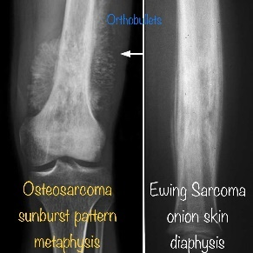
- Xray - Sunburst
  - Poorly defined tumor margins - bone destruction -periosteal reaction - calcification
- Other imaging - MRI of the entire extremity to exclude skip lesions, bone scan to detect mets, and Chest CT to detect lung mets.
- Diagnosis à open biopsy.
- Treatment à preoperative chemo followed by surgery (en bloc tumor resection and endoprosthesis placement).

Ewing’s Sarcoma (PNET): small round cell tumors of neuronal origin.
- < 10 years
- Arises in the diaphyses of long or flat bones and in soft tissues – ribs/pelvis
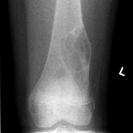
- Also can have systemic findings – fever – decreased weight
- Xray – onion skin
- T11:22 translocation

Fibrous Cortical defect – non ossifying fibroma
- Painless
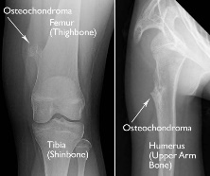
- Xray with sharp demarked lucency
- Treatment – none needed

Osteochondroma – benign
- Ages 5-15 years
- Distal femur or prox humerus
- Xray – stalks or projections from bone and cartilage cap
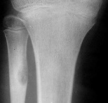
Osteoid Osteoma –
- Painful
- Round lucency
- Treatment à remove

Brain tumors –
- Early morning headache that is relieved by vomiting is a sign of increased intracranial pressure
- Cushing Triad - hypertension, bradycardia, and irregular respiratory patterns à increased intracranial pressure
  - Requires emergent interventions - osmotic agents, high-dose corticosteroids, relative fluid restriction, head elevation, controlled hyperventilation, and possible neurosurgical intervention
- Presentation
  - Infants – irritable – anorexia – vomiting – bulging fontanelle
    - Impaired upwards gaze (sunsetting)
  - Infratentorial – CN’s – ataxia
  - Supratentorial – headaches – seizure – vomiting – motor weakness – visual field defects (if involve optic chiasm) - endocrine abnormalities (hypothalamic or pituitary tumors)
- MCC – medulloblastoma
  - Headaches – vomiting -ataxia
- MC posterior Fossa à Astrocytoma
  - Clumsiness – unsteady arms and legs
- Craniopharyngioma à benign
  - Change in vision with endo changes à short, polydipsia
  - Complication post surgery à DI
- Diagnosis - magnetic resonance imaging (MRI) with and without contrast is the diagnostic test of choice
  - CT may be more realistic….
    - CT scan does not demonstrate posterior fossa pathology as well as MRI
  - Fluid–attenuated inversion recovery (FLAIR) sequences often are useful in determining tumor infiltration or peritumor edema.
  - Diffusion-weighted imaging can differentiate cysts from solid tumors and identify areas of necrosis

ALL – all cell lines decreased
- Replacement of normal hematopoiesis by malignant cells à neurotpenia
- Labs - depressed platelet count - markedly elevated white blood cell count - severe neutropenia
  - Blasts on peripheral smear – confirmed by hematologist microscopy eval
  - LDH, Uric acid, blood type and screen, PT, and PTT
  - A widened mediastinum on CXR due to enlarged lymph nodes may be noted in some T-cell ALLs.
- Risk of sepsis with severe neutropenia - increased with absolute neutrophil counts < 0.5x10³/mcL (0.5x10⁹/L).
  - Gram-negative organisms that colonize the skin, mouth, and gastrointestinal tract
  - Treat with broad-spectrum antimicrobial agents effective against gram-positive and gram-negative pathogens - methicillin-resistant Staphylococcus aureus (MRSA) and Pseudomonas aeruginosa.
    - Vancomycin and ceftazidime
- Treatment in the ED - D5 1/2NS OR D51/4NS + 30 mEq/L NaHCO3 at twice maintenance
  - Fever à antibiotics
  - Hb <8 à PRBC transfusion
  - Platelets < 20,000 à Platelet transfusion
  - Allopurinol OR Rasburicase
- Hyperleukocytosis – WBC >100,000
  - Risk sludging – respiratory distress – AMS
  - Treat – IVF
    - Then leukophoresis à later allopurinol
- Poor Prognosis à age < 1 year and > 10 years – Philadelphia chromosome (t9:22) – WBC > 50,000 – mature B cells – T cell
  - 95% with standard risk go into remission after induction
  - 25% relapse – MC site = Bone Marrow
    - Treatment for relapse – BM transplant

AML – cells with Auer rods
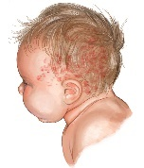
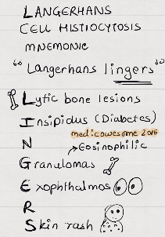
- Associated with Downs
- > 25% myeloblasts
- Treatment – Chemo alone all typically needed in Downs
  - Rest need BMT
  - Except M3 – chemo and retonic acid

CML – t9:22 Philadelphia chromosome --- brc:abl
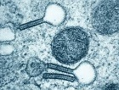
Langerhans Cell Histocytosis – Birbeck granules
- CD1a surface marker
- Scaling dermatitis
- Rash (around the ears) – DI – skull lesions
Mediastinal Masses
- HD and NHL are the most common malignancies presenting with mediastinal masses.
- Indolent presentation of chronic cough or
  - 10% of HD patients - have night sweats, weight loss and intractable pruitus.

Hodgkin’s Lymphoma
- Painless cervical, supraclavicular, or mediastinal lymphadenopathy
- “B” symptoms – night sweats – fever – weight loss
- CXR – anterior mediastinal mass à check CT chest
- Reed-sternberg cell – OWL EYES
- Tx: chemo +/- Rad
- Don’t sedate these patients – if mass compressing trachea – will be difficult to manage

Non-Hodgkin’s Lymphoma
- MCC Burkitt Lumphoma
- GI tract – peyers patches à abdominal pain
- Have abd mass – n/v
- Enlarged mediastinum

Ovarian Masses
- < 6 mm – simple mass = observation à Typically gone in 4-8 weeks
- Septation – multiloculated – echos – calcifications à check CT or MRI and tumor markers
Germinoma – malignant – markers negative
Yolk sac – MC germ cell tumor + aFP
Choriocarcinoma – syncytiotrophoblast tissue +Bhcg
Gonadoblastoma – dysgenic gonads 46 X4
- 80% female markers negative
- Leydig – androgens
- Sertoli cells - estrogen

Chemo Side effects –
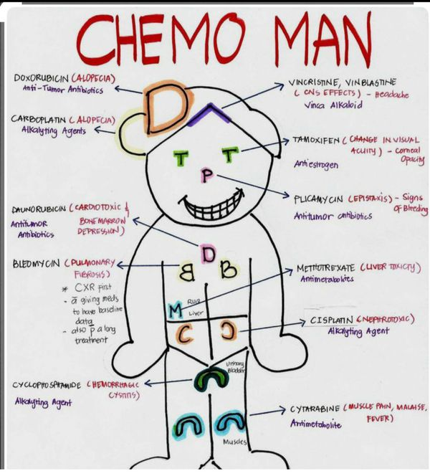
Cyclophosphamide – hemorrhagic cycstitis
Doxorubicin – Cardiomyopathy
Bleomycin – pulmonary fibrosis
Vincristine – peripheral neuropathy
Vinblastin – leukopenia
L-asp – pancreatitis and hyperglycemia
Cisplatin – nephrotoxic – ototoxic

Anthracyclines (adriamycin, idarubicin, daunomycin) - cardiotoxic effects
- Acute or delayed rhythm disturbances
- carditis-pericarditis syndrome
- cardiomyopathy
- Cardiac failure.
- Patients who present in fluid-refractory shock without evidence of sepsis à afterload reduction and inotropics
  - dobutamine or amrinone.

Chemo + pallor = anemia
- Transfuse if Hg < 7
- Given 3-5ml/kg over 4 hours
  - Risk of heart failure if too much fluid or too rapid
Chemo + fever = infection
- Antibiotics
Chemo + low platelets
- Transfusion if < 20,000
Chemo + Varicella exposure = VZIG
- VZIG given within 72 hours may prevent or lessen the severity of illness.
- If signs of disease à VZIG PLUS acyclovir (mild= oral, moderate= IV)
- The varicella vaccine is a live vaccine - contraindicated in immunosuppressed individual

Tumor Lysis Syndrome –
- Risk – elevated K – elevated phos – elevated uric acid - elevated LD - decreased Ca
  - Phos and LD à deposit in kidney à kidney injury
  - Elevate K à EKG changes
- DO NOT give K in IVF
- Treatment - IVF – D5 ½ NS with NaCO3 AND Allopurinol à decreases the production of uric acid
  - If peak T waves (elevated K) à no Ca – risk of CaPhos crystals
    - Albuterol, Sodium bicarbonate, and insulin/dextrose faster ways to redistribute K
    - furosemide and sodium polystyrene sulfonate enemas – longer term ways to reduce K
  - Aluminum hydroxide lowers serum phosphate levels
  - Allopurinol reduces uric acid.

Splenectomy + Fever = risk encapusulated organisms
- S. pneumo - H. inf - N. meningitis

Typhlitis
- Necrotizing enterocolitis
- In neutropenic patients with leukemia or lymphoma.
- Presenting signs and symptoms include abdominal pain and tenderness to palpation, diarrhea, and fever.
- Xray - paucity of air, ileus, thickened bowel, and air in the bowel wall. (follow with serial abd xrays)
- CT may show an intraluminal abscess.
- Treatment - Fluids and broad spectrum
  - Including anaerobic coverage (zosyn or cefepime/ metronidazole)
  - Do not use: anti-diarrheals, anti-cholinergics, opiates

Transplant Emergencies
Autograftà from one part of body to another in same person
Allograftà from non-identical donor of same species
Xenograftà diff species
Infections
<1 mo out: hep C, hpe B, varicella, surgical site
1-6 mo: opportunistic
- PCP pna: b/l infiltrate on CXR, fever/ cough/ dyspnea, dx PCR
- CMV: fever/ malaise, leukopenia w/ lymphcytosis and inc in LFTs, Clinical dx +PCR, tx valganciclovir
- EBV: atypical lymphocytosis, Dx PCR, Tx reduction of immunosuppression
- BK virus: nephropathy/ pyuria/ hematuria, Dx PCR, Tx reduce immunosuppression
- Toxo: Flu like/ brain abscess, cardiomyopathy
>6 mo: community acquired, food borne (unpasteurized, raw), dental
Rejection
Acute: cell mediated, lymphocytes and worsen organ function
Tx: pulse steroids
Chronic: long term loss of function of the graft. Tx: inc immune suppression
GVHD
- Skin, liver, bone marrow, GI
- Tx: steroids
PTLD
- Lymphoproliperation in immunosuppression
- Rituximab, reduction in immunosuppression, chemo/ radiation

Juvenile rheumatoid arthritis - juvenile idiopathic arthritis [JIA
  - Younger than 16 years of age
  - Arthritis in one or more joints
  - Duration of 6 weeks or longer
  - Absence of any other cause of arthritis.
- The cause of JIA is unknown - both genetic and environmental factors are believed to play roles.
- JIA is subdivided based on the type of disease present during the first 6 months of illness.
  - Oligoarthritis (pauciarticular JIA) (50% of cases) - fewer than five joints, as in this child.
    - Mild-to-moderate pain and joint inflammation.
    - Early onset (before 5 years of age)
      - Female predominance - positive antinuclear antibody (ANA) titer in up to 60% of cases - rare hip or sacroiliac joint involvement - association with chronic iridocyclitis in nearly 50% of cases.
    - Late onset (5 years or older).
      - Male predominance - negative ANA titer - frequent involvement of the hip and sacroiliac joints - occasional association with uveitis.
    - The joint involvement in pauciarticular disease frequently is asymmetric.

  - Polyarticular JIA (35% of cases) - five or more joints within the first 6 months of symptoms
    - Rheumatoid factor (RF)-positive
      - a female predominance, generally occurs after 8 years of age, is associated with a positive ANA in up to 75% of patients, is not associated with uveitis, but is associated with severe and destructive arthritis.
      - Subcutaneous rheumatoid nodules, particularly over extensor surfaces such as the elbows, are seen frequently
    - RF-negative disease.
      - female predominance, typically presents before 8 years of age, is associated with a positive ANA in only 25% of patients, rarely is associated with uveitis, and progresses to severe arthritis in approximately 10% of patients
    - Associated with fever, rash, and other systemic symptoms
    - The joint involvement in polyarticular JIA is typically symmetric
    - And more severe than that seen in pauciarticular disease.

- Systemic JIA (15% of cases) (also know as Still disease)
  - Spiking fevers (often twice daily), an evanescent salmon-pink rash, hepatosplenomegaly, myalgias, and serositis.
  - Cardiac involvement, including pericarditis or myocarditis, is most common in the systemic form of the disease.
  - More frequently are male, typically present before the age of 5 years
    - Negative ANA and RF status
    - Do not develop uveitis, and develop severe arthritis in approximately 25% of cases.
  - A feared and potentially fatal complication of systemic JIA is macrophage activation syndrome, which can present with unrelenting fevers, hepatosplenomegaly, pancytopenia, hepatic dysfunction, elevated ferritin values, and disseminated intravascular coagulation.

