PEM|BRS: Signs & Symptoms & Dermatology

Dermatology
Erythema Multiforme (EM) and Stevens-Johnson syndrome (SJS) are hypersensitivity syndromes caused by infections, drugs, vaccinations, malignancy, and connective tissue disorders.

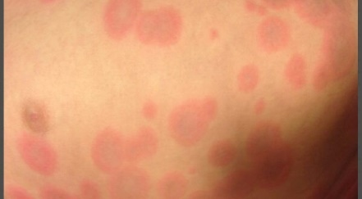
Erythema Multiforme (EM)
- “target” skin lesions and may have involvement of one mucous membrane, usually the oral mucosa
- Most cases of EM (60%) are associated with herpes simplex infection.
  - Others have been associated with viral or mycoplasma infections.
- May have prodromal symptoms
- Crops of lesions develop over a few days in the acral regions, especially the palms and dorsa of the hands, wrists, feet, and extensor surfaces of elbows and knees
  - may manifest Koebner’s phenomenon (target lesions appearing within areas of cutaneous trauma from scratching).
- Resolves in 1-2 weeks but may last 4 weeks.
- Tx: withdrawal of suspected drug cause, tx with Benadryl/maalox
- Frequently misdiagnosed as urticaria—but urticaria involves transient and migratory lesions with a clear central zone instead of the dusky, hemorrhagic center of EM lesions
  - urticarial lesions will respond to Epi and EM lesions will not.

Stevens-Johnson Syndrome (SJS):
- At least 2 mucous membranes are affected in addition to the “target” skin lesions;
- Ophthalmologic consult is required for ocular mucosa involvement
- SJS is usually preceded by a prodromal viral type syndrome for 1-2 weeks.
- Toxicity and generalized lymphadenopathy are common, hepatosplenomegaly occasionally occur.
- After 1-14 days, the rash starts suddenly and occurs in face, trunk, and limbs.
- Mucous membranes of the oral, conjunctival, vulvovaginal, rectal, and urethral areas may be involved.
- Epidermis may separate from the basal layer as a result of minor friction (Nikolsky’s sign)
- Management - immediate withdrawal of the offending agent and supportive care.
  - Should be managed like a “burn,”
  - aggressive fluid resuscitation
  - infection control measures
  - nutrition support.
  - Requires hospitalization in PICU or burn unit
- Medications commonly implicated - sulfonamides, antiepileptic drugs such as phenytoin, and nonsteroidal anti-inflammatory drugs such as ibuprofen.
- Estimated mortality ranges from 5% to 15%.
- SJS may evolve to become TEN.
  - The primary difference between the two is the extent of body surface involved:
    - less than 10% for SJS
    - more than 30% for TEN.
- Life-threatening complications (eg, sepsis and fluid loss) are related to sloughing of the skin and the resultant loss of the protective cutaneous barrier.

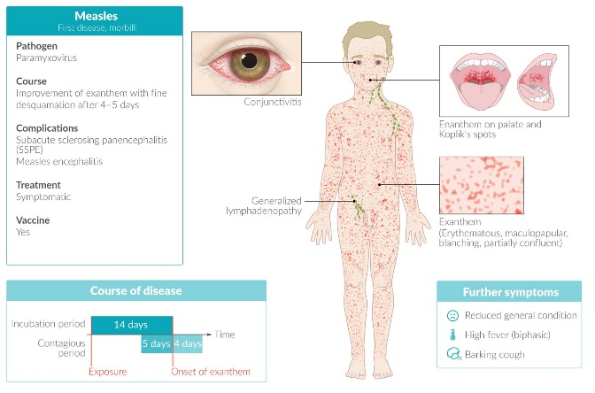
Measles (Rubeola, First Disease): -
- a prodrome of fever, cough, coryza, conjunctivitis, and Koplik’s spots child appears ill
- Caused by RNA virus, paramyxovirus
- exanthem begins at the hairline and spreads downward to become an intensely erythematous and at tim es purpuric rash -- Rash fades by day 10
- Leukocytosis common
- Severe pneumonia and encephalitis are primary causes of death
- Using Vitamin A doses on 2 consecutive days decreases mortality.
- PEP: includes the measles vaccine if given within 72 hours or IgG, which can be given up to 6 days following exposure in infants or the immune compromised

Rubella (German Measles, Third Disease):
- A RNA virus, Rubivirus,
- maculopapular rash and enlargement of the occipitocervical lymph nodes
  - Forschheimer spots on the soft palate may be present
- Rash occurs 1-5 days after onset of symptoms - faint rose-pink, macular or papular - starts on the face and spreads downward resolved by the 3rd day (“3 day measles”)
- Monoarticular arthritis or arthralgia may be present.
- Leukopenia common.
- In first trimester congenital infection “blueberry muffin” spots, sensorineural hearing loss, heart defects, glaucoma, cataracts, thrombocytopenia; No treatment

Roseola Infantum (Exanthem Subitum, Sixth Disease):
- Occurs in infants 6mo-3years with peak at 6-7 months
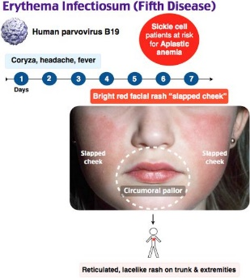
- 2-3 days of high fever in well-appearing infant followed by resolution of fever and pink morbilliform rash appears for a few days
- caused by HHV-6, a DNA virus
- seizure with the onset of fever is noted in 25-36% of cases;
- Nagayama’s spots may appear on the uvula or soft palate.
- No treatment

Erythema Infectiosum (Fifth Disease);
- Parvovirus B19
- slapped check appearance of rash on the face
- School aged children
- rash may wax/wane for 4 months
- Purpuric gloves and socks syndrome may occur
- symmetric arthritis in joints may occur
- Risk of aplastic crisis in children with hereditary hemolytic anemias
- No Treatment

Atopic dermatitis—
Infantile phase: up to age 2 years
- Eruption begins on cheeks, forehead, scalp, and lateral aspects of extensor surfaces of the legs (symmetric), spares the tip of the nose and the perioral and periorbital regions
Childhood phase: from age 2 years to puberty
- Eruption in flexural areas (mostly antecubital and popliteal fossae), and wrists; may have nummular (coin-shaped) patches.
- Risk of HSV superinfection called eczema herpeticum. Also at risk for bacterial superinfection (impetigo)
- Mild-to-moderate exacerbations are characterized by itching, erythema, excoriations, papules, and lichenification.
- Severe flares present with “weeping” of excoriated lesions and extensive lichenification
- Treatment topical steroids:
- Low potency: Hydrocortisone 1% or 2.5% ointment (BID-QID)
- Medium potency: Hydrocortisone valerate 0.2% ointment (QD-QID)
- High potency: Mometasone 0.1% ointment (QD)
- topical immunomodulator agents - Tacrolimus ointment in children over 2 years of age
side effects are stinging, burning, and erythema on application; does not cause skin atrophy so may be used for long periods on the face and intertriginous areasDiaper dermatitis
- if present for 3 or more days, think of candidal superinfection treat with nystatin ointment

  - Excellent skin care Emollients and moisturizers that are free of dyes and fragrances at least twice daily after any topical pharmacologic therapy.
  - Avoidance of known triggers
  - Antipruritic agents such as hydroxyzine and diphenhydramine (can improve sleep)
  - Bathing is controversial.
    - Bathing promotes skin hydration, cleansing of the skin, and penetration of topical agents.
    - Potential drawbacks are drying of the skin and disruption of the stratum corneum barrier.
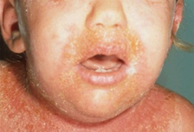
    - Can be minimized by the “soak and seal” strategy, which involves bathing for several minutes in lukewarm water, patting excess moisture from the skin, and promptly applying liberal quantities of emollients before the skin dries completely.

- Bacterial superinfection- Topical mupirocin and parenteral clindamycin
  - Honey-colored crusting, folliculitis, pyoderma, and cellulitis
  - Recurrent furuncles concern for deficiency in humoral immunity(hyper-immunoglobulin E syndrome)

Eczema herpeticum, ( Kaposi varicelliform)
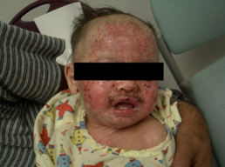
- Incubation period of 5 to 12 days
- multiple pruritic vesiculopustular, disseminated lesions and painful “punched-out” superficial ulcerations
- Treatment with acyclovir
- Herpes infection should be documented via culture of a skin scraping or direct fluorescent antibody testing.
- local defects in T-cell function.

Seborrheic dermatitis
- Yellow greasy scaly, crusting eruption on the scalp, face, eyebrows, postauricular areas, and intertriginous folds
- Bimodal peak - 1 and 6 months of age and during teenage years.
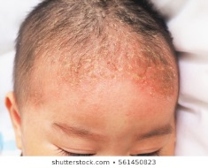
- Malassezia furfur
- The skin lesions typically are salmon-pink scaling patches on the face and scalp
  - Pruritus is not a dominant feature
- Treatment - Ketoconazole- 2% shampoo

  - No shampoos with salicylic acid in children - irritating and can cause absorption problems of salicylism
  - Adolescents can use selenium sulfide shampoo
  - Other therapeutic agents that are helpful in severe cases include 1% to 2.5% hydrocortisone cream, 1% pimecrolimus, and 0.03% to 0.1% tacrolimus ointment.
- The natural course of both infantile and adolescent SD is disappearance with age.
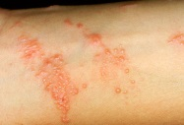
Allergic contact dermatitis (nickel dermatitis, poison ivy, rubber)
- Type IV hypersensitivity reaction
- Erythema and edema, usually about 48 hours after exposure to the offending agent
- Development of exudative vesicular or bullous lesions may follow
  - unremitting pruritus, which leads to the excoriation, lichenification, and crusting of lesions
- Kobner’s phenomenon in poison ivy—linear vesicular pattern
- Treatment is Topical or oral steroids oatmeal baths, calamine lotion, antihistamines

Scabies - intense pruitis
- Linear maculopapules and Burrows
- Failure to find mites on microscopic examination does not rule out scabies
- most common complication is secondary bacterial infection with staph aureus
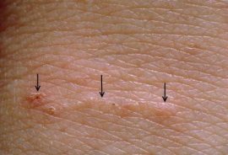
- Treat with 5% permethrin (Elimite) cream
  - may use in neonates, pregnant patients, and those who are breast feeding;
  - Apply to entire body including face and scalp and wash off in 12 hours.
  - Repeat treatment in 1 week
  - 1% gamma benzene hexachloride (lindane, Kwell) - is absorbed and concentrated in the CNS
    - can cause seizures and death.
  - All family members and close contacts should be treated.
  - Normal laundering or dry cleaning cleans clothing
    - all other fomites should be sealed in plastic bags for 1 week
  - For crusted scabies, crusts must first be removed before Elimite applied
    - Can use Oral Ivermectin.

Tick bite - Empiric treatment after bite is not recommended
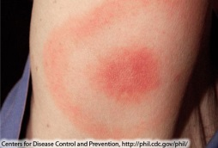
Lyme Disease
- Spirochete Borrelia burgdorferi from the deer tick (Ixodes dammini or Ixodes scapularis)
- Tick needs to be presents for more than 24 hours for transmission to occur
- Erythema Migrans (EM)
- Lyme arthritis is often monoarticular mostly involving the knee
- Treat with doxycycline (any age as long as <21days), or cefuroxime, or azirtho

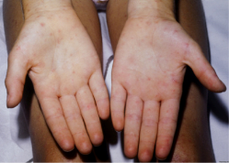
Rocky Mountain Spotted Fever
- tick exposure with fever, headache, myalgias, and rash
- Caused by the obligate intracellular bacteria Rickettsia rickettsia
- Rash occurs 1-4 days after the onset of symptoms - start in ankles and feet and spreads to wrists and hands and then centripetally to head and trunk.
  - Rash starts macular and eventually becomes petechial
- Treatment: Doxycycline
- In pregnant patients, give chloramphenicol but if given close to delivery will cause “Gray baby Syndrome”.

Head lice
- Uncommon in African Americans because they have oval-shaped hair shafts that are harder for lice to grasp.
- Nits fluoresce a pale blue color under a Woods Lamp
- Treatment is Permethrin lotion to the scalp after showering—leave on for 10 minutes then wash off
  - Repeat in 1 week
  - Use warm damp towels soaked in white vinegar which loosens nits from hair prior to mechanical removal with a fine-toothed comb
  - Seal fomites in plastic bags for 2 weeks.
- Body lice treat from head to toe with 5% permethrin cream for 12 hours, wash off, then repeat in 1 week.
- Treat pubic lice like head lice.
- Eyelash lice use Vaseline ointment 3-5 times/day

Tinea capitis - most common cause of hair loss in children
- Can develop purulent inflamed lesion mistaken for abscess
- Hairs break off and appear to be black dots
- Treatment – Griseofulvin 15-20 mg/kg/day divided BID PLUS selenium shampoo

Scarlet fever - Treated with PCN to prevent complications and the development of ARF

Chicken pox – vesicles at multiple stages, fever, fussy
- Rose petal on dew drop
- Complications- MC bacterial superinfection (group A strep)
- Also – encephalitis, transverse myelitis, purpura fulminans, arthritis

Kawasaki Disease: “ELF ROP”
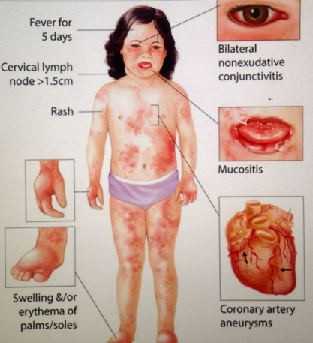
- Eye: painless bulbar conjunctival injection, non-purulent, with sparing of limbus
- Lymph Nodes: swelling of cervical lymph nodes > 1.5cm
- Fever: FUO for > 5 days; high spiking and remitting
- Rash
- Oral: dryness, redness, fissuring, peeling, cracking, and bleeding of lips, or strawberry tongue, diffuse oral mucosa erythema
- Peripheral extremity: reddening of palms and soles, indurative edema, desquamation and fissuring at tips of fingers, palms and soles
- Also
  - Thrombocytosis from 500,000 to > 1,000,000 occurs during week 2
- ECG changes: prolonged PR interval or QT interval and ST and T wave changes
- Tx: 2 g/kg of IVIG over 12 hours and ASA 100mg/kg QID
  - After defervescence, ASA 4mg/kg QID
  - ASA d/c’d if no coronary artery abnormalities seen by 6 weeks after onset.
  - Suspect diagnosis in a child with FUO > 5 days without a source.

Staphylococcal Toxic Shock Syndrome – Menstruating female with high fever, generalized erythroderma and hypotension.
- Other causes - nasal packing, wound infections, sinusitis, primary bacteremia, burns, pneumonia, and osteomyelitis
- Caused by exotoxin TSST-1 Staphylococcus aureus or exotoxins A, B, C, and F produced by Streptococcus pyogenes. (staph and group A strep)
  - TSST-1 toxins are produced selectively in an environment of neutral pH, high Pco₂, and aerobic Po₂ (conditions present in the vagina with tampon use during menstruation)
  - The toxins in TSS interact with major histocompatibility class II proteins and activate T cells leads to polyclonal activation and a massive release of the cytokines tumor necrosis factor-alpha and interleukin-6.
  - These substances are responsible for multiorgan involvement and shock.
- High fever, a diffuse erythematous rash (sunburn appearance or scarlatiniform), desquamation of skin, hypotension, and involvement of three or more organ systems.
  - Alteration of consciousness, oliguria, shock, and disseminated intravascular coagulation.
  - Acute respiratory distress syndrome, myocardial dysfunction, and renal failure.
- Blood cultures often are negative
  - throat cultures and nasopharyngeal cultures may reveal the presence of S aureus.
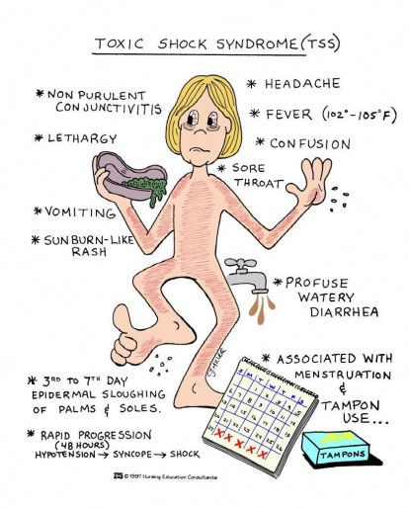
Criteria for Staphylococcal Toxic Shock Syndrome
- Fever of ( ≥102°F) ≥38.9°C
- Presence of diffuse macular erythroderma ("sunburn" appearance)
- Desquamation 1 to 2 wk after onset of illness, esp of the palms and soles
- Hypotension
- Involvement of three or more of the following organ systems:
  - Gastrointestinal: vomiting or diarrhea at the onset of illness
  - Muscular: elevated CPK or severe myalgia
  - Mucous membrane: nonpurulent conjunctivitis, oropharyngeal hyperemia, or vaginal hyperemia or discharge
  - Renal: abnormal results of renal function tests or urinalysis
  - Hepatic: elevated serum transaminase and bilirubin levels
  - Hematologic: thrombocytopenia
  - Central nervous system: disorientation or alteration in consciousness without focal neurologic signs and in the absence of hypotension or fever
- Normal results: Blood, throat, cerebrospinal fluid cultures (blood culture may be positive for Staphylococcus aureus
- Toxic shock syndrome is probable with at least four of the five criteria

- 40% to 50% of nonmenstrual TSS and 5% to 10% of menstrual TSS isolates do not produce TSST-1 a role for other exo- or endotoxins has been proposed.
- Treatment - aggressive resuscitation with fluids and appropriate inotropes.
  - Antibiotic therapy consists Vanco (a beta-lactamase–resistant antistaphylococcal antibiotic )PLUS clinda(a protein synthesis-inhibiting antimicrobial)
    - Systemic corticosteroid and intravenous immunoglobulin may be helpful in severe cases.
Staphylococcal scalded skin syndrome –
- diffuse, tender, erythematous rash
  - peeling starts on the face
- positive Nikolsky sign
- hemodynamic stability AND no mucus membrane involvement
- caused by toxin from Staph
- Risk dehydration – pain – sepsis
- Diagnosis – cannot culture lesion – clinical diagnosis
  - Can biopsy skin
- Treatment vanco and Clinda

Diaper dermatitis
- Erythematous rash over the convex skin surfaces within the diaper area that spares the intertriginous areas.
- Moisture, friction, elevated pH, and digestive stool enzymes are believed to play key roles
- Occlusion of the skin under a diaper allows these factors to cause over-hydration, maceration, and subsequent irritation and inflammation of the exposed skin.
- The inflamed skin is more susceptible to secondary infection with yeast, bacteria, or less commonly, viruses.
- Treatment – decrease causative factors.
  - keeping the infant or child out of diapers as much as possible
  - Increasing the frequency of diaper changes
  - Use of ultra-absorbent disposable diapers, which contain polymers in their cores to pull liquid away from the skin, significantly reduces the incidence and severity
  - Barrier creams and ointments that contain such active ingredients as zinc oxide, dimethicone, or petrolatum should be applied to shield the skin from irritants
    - The cream should be applied to dry skin for optimal results.
  - For more severs cases low-potency topical steroids can be used for a short course
    - mid- and high-potency steroids can cuase skin atrophy, tachyphylaxis, and systemic absorption with secondary adrenal suppression should be avoide
- if present for 3 or more days, think of candidal superinfection treat with nystatin ointment
  - involvement of the skin creases, satellite lesions
  - Recent or frequent antibiotic exposure also increases the likelihood of yeast infection.
  - Treatment Topical antifungal cream or ointment
- Strep Bacterial skin infection,- Staphylococcus aureus or group A Streptococcus
  - Suspect if bullae, skin erosion, or crusting is present.
  - Treatment - Topical or systemic antibiotic therapy. – (mupirocin)
Diffuse Purpuric rash - check complete blood count (CBC), including platelet count
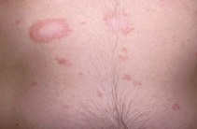
- Other labs depend on the patient's presentation prothrombin time (PT), partial thromboplastin time (PTT), fibrinogen, fibrin degradation products, blood gas analysis for acidemia, C–reactive protein (CRP), lactate, electrolytes, blood urea nitrogen, creatinine, lactate dehydrogenase, uric acid, and urinalysis. CRP values have been shown to be elevated in patients who have meningococcemia, including those in whom this diagnosis was not suspected at initial evaluation.
Pityriasis rosea (PR) –
- PR is a common, generally benign, inflammatory skin disorder
- Typically is seen in adolescents but can occur in young children and adults.
- More common in the spring
- beginning with a round papulosquamous solitary lesion (herald patch) typically on trunk or lower abdomen
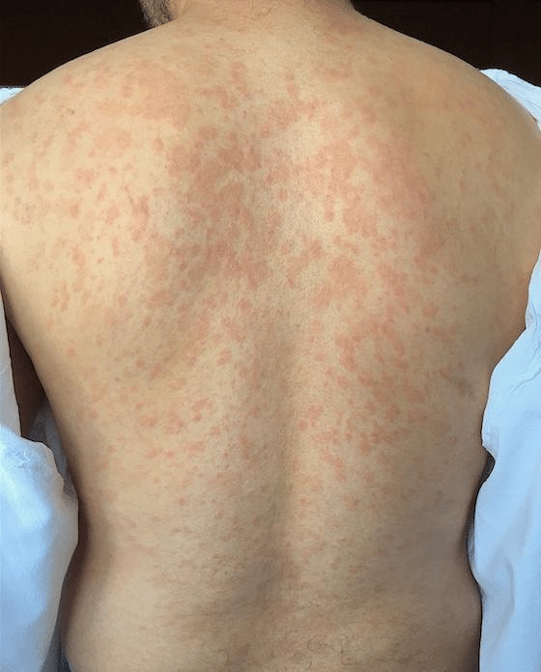
  - Multiple patches are seen in 5% of patients
- Progressing to a secondary eruption of similar but smaller lesions on the face and neck
  - oval papulosquamous lesions appears in crops over 1 to 2 weeks.
  - occur in a “Christmas tree” distribution, such that the long axis of the oval lesion lies along the skin cleavage lines (Langer's lines).
- The name comes from the Greek word pityriasis (meaning scaly) and the Latin word rosea (meaning pink).
- The prodromal illness, seasonal variation, and clustering of cases has led to the impression that PR has a viral etiology.
  - Human herpesviruses 6 and 7 have been implicated as causative, but agreement is not yet definitive.
- The rash of PR typically lasts 6 to 8 weeks and resolves spontaneously.
- Diagnosis – clinical
- Treatment – self resolves – hydrocortisone for itch
  - moisturizers and oral antihistamines and mild steroid cream (eg, 1% hydrocortisone)
  - Severe- course of oral steroid treatment.
  - Some reports suggest improvement of PR with ultraviolet B phototherapy or natural ultraviolet light.
“Inverse” PR, the most common variant areas typically spared in the classic presentation (face, arms, axillae, inguinal region) are involved.
Thus, the skin distribution is opposite, or inverse, to the classic presentation.
PR in African Americans often consisting primarily of papules (follicular PR) and few, if any, macules
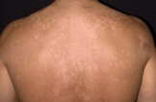
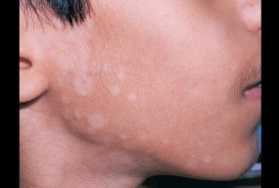
Tinea Versicolor –
- Malassezia furfur
- Scaly hyper/hypo pigmented patches
- Fluorescence under woods lamp
- Diagnosis – KOH – spaghetti and meatballs – budding yeast and hyphae
- Treatment – selenium sulfide PLUS clotrimazole

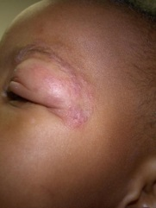
Tinea incognito,
- Dermatophyte infection modified and even exacerbated by the long-term use of topical corticosteroids.
- The immunosuppressive effect of topical corticosteroids that can alleviate the initial erythema and pruritus likely is responsible for the atypical transformation and spread of the dermatophyte infection.
- Characteristic circular, well-defined, scaling edge of tinea corporis can assume a variety of appearances: psoriasislike, eczemalike, or licheniform, with follicular, pustular, or papular characteristics.

- In general, most infectious dermatologic conditions are aggravated by topical corticosteroid use.
- In contrast, topical corticosteroids are common therapies for several dermatologic conditions
  - Such conditions tend to be noninfectious and include allergic contact dermatitis, atopic dermatitis/eczema, psoriasis, and seborrheic dermatitis.

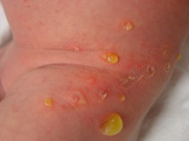
Bullus Impetigo – flaccid bullae and painful erosion
- Diagnosis – culture lesion
- Treatment – bactorban +/- PO staph antibiotics

Erythema nodosum – associated with inflammatory bowel disease
- Painful nodules on the skin – lower legs
- Treatment – treat underlying conditions
  - Supportive - NSAIDS

Langerhans cell histiocytosis (LCH)
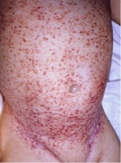
- Severe and recalcitrant intertriginous dermatitis may be a symptom of a more serious condition such,
- Well-demarcated, with scaly macules, papules, and plaques and some purpuric areas.
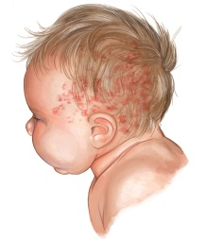
- Discrete reddish-brown papules, petechiae, and erosions may be seen in LCH.
- Scalp lesions
- Anemia
- Bone lesions - head
- Hepatomegaly
- Check CBC
- Diagnosis - biopsy
Infantile LCH (formerly called Letterer Siwe disease)
- an aggressive form
- Hepatosplenomegaly, anemia, and thrombocytopenia
- Definitive diagnosis is established with a skin biopsy—see picture below:

Zinc deficiency –
- Zinc deficiency (<50 mcg/dL [7.7 mcmol/L]) usually
- Associated with periorificial involvement
- chronic diarrhea
- alopecia
- Irritability
- malnutrition.

Signs and Symptoms -
Ortho
Signs of neurovascular compromise decreased sensation, numbness, pulselessness, decreased capillary refill, abnormal skin color, or cool skin temperature\
- Fracture of reduction as quickly as possible and should not be delayed by obtaining radiographic studies.

Dislocation of the patella:
- Knee in flexed position with the patella displaced laterally.
- Reduction - extending the knee with simultaneous pressure of the patella medially to reposition it.
  - This can be done prior to radiographs.
  - Post reduction films should be performed to rule out an avulsion fx.

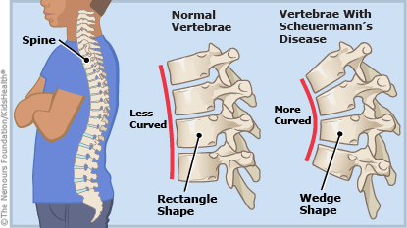
Scheuermann’s kyphosis children just prior to the major growth spurt of puberty around 10-13 years.
- Etiology is unclear.
- Primarily a cosmetic problem due to the wedging of the anterior bodies of the thoracic vertebrae.
  - Severe cases spinal cord compression can occur requiring surgical repair.
- The main treatment modality is use of a Milwaukee brace.

Sever’s Disease - apophysitis of the calcaneus in males 6-10 years old.
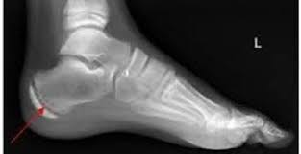
- Overuse and injury of the calcaneus at the Achilles tendon insertion.
- X-rays may be normal or show increased fragmentation of the apophysis.
- Treatment consists of limitation of activities, heel cord stretching excercises and oral analgesics.
  - Arch supports, heel supports or elevation of the heel may be helpful.

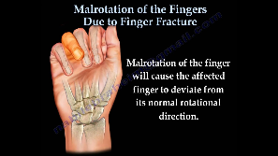
Phalanx fractures –
Scissoring – fingers overlap sign of malrotation
Ham finger = Mallet finger hyperflexion at DIP joint
Swan Neck hyper flex at DIP and hypertext at DIP
Boutonniere def hyper ext at DIP and Flex and PIP
Dupuytren’s contracture painless flexion contracture of the hand = flexion of fingers- usually 4th and 5th
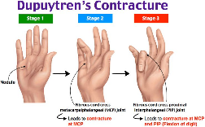
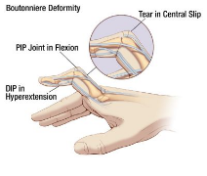
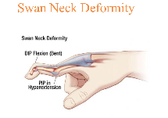
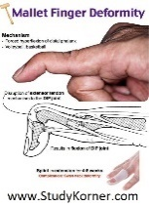

Tox -
Oil of wintergreen - commonly used in aromatherapy massage blends for joint and muscle pain.
- Methyl salicylate is the ingredient of most concern for toxicity.
- Intoxicated patients will have hyperpnea: salicylates trigger resp center in medulla
- Tinnitus, vomiting, confusion, coma, and bleeding are other common manifestations.

Benzocaine toxicity - to bradydysthrthmias, seizures, and methemoglobinemia

Eucalyptus oil toxicity - altered mental status, respiratory distress, ataxia, muscle weakness, and dysphagia. Woody scent

Menthol - low toxicity and ill effects are extremely rare.

Capsaicin (from chili peppers) is an irritant and causes a burning sensation.

Jimson weed – hallucinatory properties
- Common in adolescents
- Anticholinergic effects (mad as a hatter, dry as a bone, red as a beet, blind as a bat and hot as a hare) due to the scopolamine components of the plant.

Poppy seeds can produce a urine test positive for opiates.

Morning glory - hallucinogenic properties due to LSD.

Ma Huang - contains ephedra
- both a stimulant and thermogenic

TCA’s
- Variety of mechanisms.
  - Inhibition of myocyte fast sodium channels leads to prolonged QRS and QT intervals. T
  - he alpha- adrenergic blockade properties can lead to hypotension.
  - GABA inhibition, you can see seizure, delirium, and coma.
  - Alkinazation Sodium bicarb enhances protein binding of TCA’s, which results in a decrease in the QRS interval, stabilizing arrhythmias, and increasing BP.
    - This alkinization can also be stimulated by hyperventilation.

Digitalis toxicity - bradycardia, visual aberrations (color distortions) and syncope.

Calcium channel toxicity - bradycardia with various degrees of heart block, hypotension, and altered mental status.

Phenothiazine OD - depressed mental status, NMS, and extrapyramidal signs such as dystonic reactions.

Organophosphate poisoning - “DUMB ELFS” through a cholinergic crisis: diarrhea, urination, miosis, bronchorrhea, bronchospasm, emesis, lacrimation, fasciculations, and salivation.

Breast lesions –
Mastitis – unilateral – warm – swollen
- Systemic symptoms are rare
- Neonates need FSWU with IV abx
- Eval for abscess with US
Mastitis in older children – warm compress with oral abx – clinda/Bactrim +/- drainage (check US)
Neonatal breast hypertrophy – enlarged by no erythema
- 1st week of life – due to maternal hormones
- May have white nipple discharge
Premature Thelarche – typically in female age 6-8
- No other signs of puberty
- Benign
Precocious puberty – females age 6-8 * with other signs of puberty*
- Requires evaluation

Female neonate with vaginal discharge Physiologic leukorrhea
- Common occurring between the 2nd and 3rd week of life
- Result of maternal estrogen, the desquamation of epithelial cells presents as a clear or white odorless mucoid discharge.
- No treatment is necessary.

Fibromatosis colli (sternocleidomastoid tumor of infancy) - bleeding into the sternomastoid muscle from birth trauma.
- This may not be present at birth but may develop up to 3 weeks later as a painless smooth mass.
- Torticollis may result from shortening of the muscle
  - Chin pointing away from the affected side and the head tilted towards the mass.
- Treatment involves stretching, range of motion exercises and massage therapy.

Neck –
Rotary subluxation of the first two cervical vertebrae needs to be differentiated from torticollis (wry neck).
- Chin points to the same side as the muscle spasm.
- Occur spontaneously or after a URI.
- If suspected, obtain a cervical CT scan to reveal the rotary subluxation of C1 around the dens.
Torticollis spasm of the sternocleidomastoid (newborns may feel a mas in the SCM)
- Chin of the patient to point to the opposite shoulder.
- Treatment – stretching and ROM exercises

Neck masses a Contrast CT should be performed prior to any operative procedure.

Straw or pencil injury to the throat
- Lateral and in soft pallet check CTA
- Or pharyngeal laceration resulting in a retropharyngeal emphysema.
  - Risk for retropharyngeal infection
    - Group A Strep, other Gram positive and anaerobic bacteria.
    - Prophylactic antibiotics (IV cephazolin) and emergent ENT consult are indicated.

Trauma -
GCS of 13-14 = mild brain injury
GCS of 9-12 = moderate brain injury
GSC of 8 or less = severe brain injury (automatically intubate)

Orbit --
A retro-orbital tumor or vascular malformation may cause proptosis, which may limit eye movements similar to an entrapment of extraocular muscles in an orbital blowout fracture.
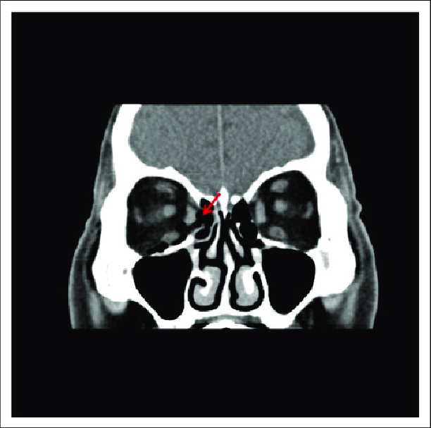
A subacute orbital fracture will have enophthalmos instead of exophthalmos.

Lamina Papyracen Fracture
- Orbital emphysema AFTER sneeze
- Direct communication with ethmoid sinus
- Treatment – abx and follow up ENT

ENT –
Epistaxis – consider PO abx if packing will be left in place for prolong time (Keflex/augmentin)
- To decrease risk of toxic shock

Cauliflower ear - Auricular hematoma from repeated direct trauma
- Blood under the perichondrium decreases blood supply to cartilage
- Needs I & D’d AND by placement of a compression bandage
- To prevent asymmetrical cartilage growth (“cauliflower ear”).

Nasal Septal Hematoma – budging of the nasal septum s/p trauma decreased blood supply to cartilage
- Risk septal abscess or saddle nose deformity
- Treatment – I&D with packing

Facial hemangioma in beard area increased risk of airway hemangioma. Racemic/ dex/ ENT

GI
False Positive Melena –
Black licorice, blueberries, spinach, beets, and bismuth and iron preparations.
False positive heme test – (not melena)
Foods containing plant peroxidases such as horseradish, tomatoes, turnips, and fresh red cherries.

Barium esophagogram - assess the patency of the esophagus in a patient with TE fistula that has been repaired and is now complicated by a stricture.

Renal
Hematuria – 1st check UA
- UTI send culture
- Glomerular – casts and tubular cells will be present on UA
  - > 2 protein
  - Recent pharyngitis or impetigo check ASO and antiDNase B
  - Concern SLE C3 and C4
    - SLE decrease C3 and C4 vs Post strep dec C3 and nl C4
  - Renal and bladder ultrasound
- Non-glomerular – may have clots –
  - No protein normal RBS
  - Trauma – CT with IV contrast
  - Stone – CT without IV contrast
- Sickle trait – can check heme electrophoresis
- Most will have no etiology if asymptomatic can dc home with renal follow up

Glomerulonephritis
- Edema, hypertension, and hematuria, often accompanied by acute renal failure.

Henoch-Schonlein Purpura (HSP) or anaphylactoid purpura - vasculitis
- Occurs between 3-10 years of age
- Due to deposition of IgA on the basement membranes;
- rash may be on face or upper extremities in children less than 2 years old
- Tetrad: symmetrical palpable petechiae or purpura rash on the buttocks and lower extremities, colicky abdominal pain, arthritis/arthralgia, and hematuria
- Severe, colicky abdominal pain must exclude intussusception.
- Major morbidity is due to renal involvement ALL patients need UA
  - Nephritis seen in 40-50% of patients (hypertension, proteinuria and hematuria)
  - Refer to renal if UA abnormal
  - Hospitalize if renal disease and hypertension found
- Treatment is supportive with NSAID’s, and occasionally steroids or cytotoxic drugs.
Infantile HSP (acute hemorrhagic edema of infancy).
- Well appearing with facial purpura and edema
  - Relative sparing of other sites (eg, kidney and gastrointestinal sites).
  - Renal involvement is less common in infants still check a UA
  - Treatment involves symptomatic care and good follow–up.

Hypertension - > 95th percentile
- Systolic (90+ (3 x age)) - Diastolic (50 + (1.5 x age)) - adolescent > 120/80 – prehypertension
- Emergency if end organ damage
- Causes –
  - Infants – renal disease - coarctation
  - Children – glomerular disease - CAH - inc thyroid - neurofibromatosis - Wilms - neuroblastoma - pheo - renal vein thrombosis -methamphetamine/cocain
- Check electrolytes (BUN and Cr) UA
- Treatment –
  - Labatelol – no in asthma of CHF
  - Nicardipine – no in inc ICP
  - Nifedipine – can be given sublingual

Hyperkalemia- mild = (5.5 to 6.0 mEq/L - moderate (6.1 to 7.0 mEq/L, severe (>7.0 mEq/
- Medical emergency that requires immediate myocardial membrane-stabilizing
- First calcium gluconate as it will rapidly compete with potassium in the myocardium and antagonize its effect.
- Sodium bicarbonate, insulin and glucose, and albuterol after the calcium gluconate.
- Sodium polystyrene (kayexylate) is an exchange resin given rectally.
- If all those don’t help, dialysis is indicated.

Neuro
Neonates with seizures - refractory to anticonvulsants should be considered to have pyridoxine dependent seizures. - - --
- almost exclusively in infants younger than 3 months inherited as an AR trait.
- Algorithm for seizure in < 3 months
  - Ativan (0.1 mg/kg) x2
  - Phenobarb load (20mg/kg)
  - Pyridoxine 100mg IV if still seizing (also check d-stick and lytes)

Acute Cerebellar ataxia – unsteady gait – tremor – incoordination
- Proceding URI – most common etiology Varicela
- Patients are well appearing

Spinal epidural hematoma is a rare and dangerous cause of back pain.
- May occur spontaneously, especially in patients with bleeding disorders or who are treated with anticoagulants.

AVM bleeding or rupture - sudden onset of severe headache, vomiting, nuchal rigidity, hemiparesis, focal seizures or sudden arrest.

Infectious Diseases-
Cat Scratch Disease - Regional and painful lympadenopathy proximal to an inoculation site from a cat
- Primarily involves the axillary nodes but may also affect the cervical and inguinal areas.
- May have constitutional symptoms of fever, malaise, anorexia, and fatigue.
- Treatment for the lympadenopathy associated with CSD beyond analgesics and warm compresses is unnecessary.
  - For those who are immune compromised, give rifampin, Bactrim, or azithromycin.
  - If the node is tender and fluctuant, needle aspiration may help relieve the pain.

Septic Joint –
- Kocher criteria – 1. ESR > 40 2. WBC >12 3. Nonweight bearing 4. Fever
- If ¾ 93% 4/4 99% likely to be septic joint
- Treatment – arthrocentesis

Transient Synovitis – most common cause of limp in 3-10 years
- Labs negative and xray negative
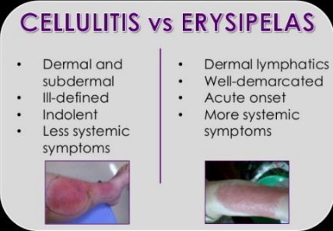
- Treatment – ibuprofen will resolve in 1-2 days

Cellulitis: infection of connective tissue in subcutaneous space; epidermis spared
- erythema, edema, warmth, and tenderness with a gradual, tapered edge
- caused by staph or strep
Erysipelas: infection of the epidermis, with abrupt, well-demarcated edges
- involved skin has an orange peel appearance and is intensely red, warm, and very painful
- Can have rapid spread and blistering; patients are commonly febrile and ill appearing.
- Caused by Group A Streptococcus; in neonates, can be due to GBS
- Tx: PCN + Clindamycin
Abscesses – if no surrounding cellulitis do not require ABX, just an I & D.
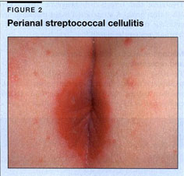
Perianal Cellulitis presents with rectal pain with sitting or defecation and has intense edema and erythema of perirectal tissue
- looks like erysipelas but child is well-appearing
- almost always due to Group A Strep.

Infections of earlobe - usually due to staph treated with local care and antistaph oral abx

Infections of cartilage from piercing due to Pseudomonas, staph, or strep, are treated more aggressively with Cefepime, piperacillin/tazobactam, or ceftaxidime

Necrotizing fasciitis:
- Risk factors - malnutrition, neoplasia, recent surgery, omphalitis, breast abscesses, balanitis associated w/ circs
- Symptoms begin with pain followed by induration, edema, and erythema within 1-2 days.
- Pain extends beyond the area of suspected inflammation—signs of necrosis such as purple skin, ecchymosis, and blisters are seen later.
- Paresthesia or anesthesia is an ominous sign of underlying necrosis
- Tissue crepitance is a specific indicator
- Toxic appearance, thrombocytopenia, generalized rash;
- Dx: tissue biopsy
- Tx: prompt surgical intervention
- Varicella is the most associated factor with necrotizing fasciitis in children
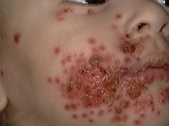
  - Increases risk for invasive Group A Strep infection (NSAID’s increase the risk of invasive Group A strep disease as well).

Eczema herpeticum - treated with IV acyclovir

Folliculitis staph
- tx with topical antiseptics (chlorhexidine, hexachlorophene, or clindamycin)

Hot tube folliculitis pseudomonas
- begin, self-limited condition that resolves in 1-2 weeks, may also treat with oral quinolone

Infantile Botulism – Floppy Baby
- weak and fatigue - decreased PO - decreased stools
- ptosis - hypotonia
- normal reflexes
- diagnosis – ID toxin in the stool
- Treatment – Baby BIG IV
  - Proven to decrease length of hospital stay, dec length of ICU stay, dec length of intubation
  - Antibiotic release toxin – make it worse

Respiratory
Asthma - If child with RAD is wheezing and doesn’t respond to 3 nebs, a chest x-ray should be obtained.

Laryngomalacia - The most common cause of stridor in infants
- Presents at birth or within first 6 weeks
- infants have high pitched inspiratory stridor that increases with crying and when supine
  - stridor is relieved when prone and calm
- usually resolves on its own by 2 years of age.

Vocal cord paralysis: 2nd most common cause of neonatal stridor
- diagnosed within the first 12 hours of life with weak or absent cry

Croup - Bacterial tracheitis is a life-threatening complication of croup
- Expiratory stridor
- Most often from 6 mo-3yrs old; males 2:1,
- Most commonly due to parainfluenza type 1 late fall-early winter
- Cyanosis is a late ominous sign;
- If stridor at rest give racemic epi. (Dose = 0.25 to 1 cc of a 2.25% solution in 3 cc of NS given via Neb) Observe at least 3 hrs post administration of racemic epi if any problems or need for redosing, patient should be admitted.
- Give Dexamethasone 0.6 mg/kg IM, IV, or po as well
- Try heliox in order to prevent need for intubation
- If ETT needed, use one at least 1 mm smaller than predicted.

Epiglottitis - supraglottic obstruction cause inspiratory stridor
- Radiologic findings: epiglottic width to 3rd cervical width > 0.5
- Epiglottitis has an abrupt, explosive onset of symptoms
- Child is toxic appearing, tripods, drooling, mouth open, chin up, leaning forward, marked retractions
- Lateral neck x-ray reveals: swollen epiglottis (“thumbprint sign”), thickened aryepiglottic folds, obliteration of the vallecula, and dilation of the hypopharynx
- Tx with ceftriaxone to cover H flu
  - Prophylaxes with Rifampin for close contacts under 4 years of age.

Retropharyngeal abscesses are most common under 4 years of age
- Can cause stridor
- Retropharyngeal nodes disappear by 5 years of age
- eak in 6-12 months of age group
- Group A Strep and S. aureus
- may have toxic appearance, fever, neck pain, dysphagia, torticollis, “hot potato” voice or voice sounding like a duck quack “cri du canard”
- Positive tracheal rock sign (pain elicited when moving the larynx and trachea from side to side gently); may have meningismus, from irritation of paravertebral ligaments
- May see widened prevertebral space on extended lateral neck x-ray.
- CT of neck is imaging modality of choice.
- TX: CFTX + Clindamycin

Bacterial Tracheitis (Membranous laryngotracheobronchitis; Pseudomembranous Croup)
- Caused by a bacterial infection of the subglottic area that complicates patients with croup.
- Average age is 3 years
- Has copious purulent secretions and pseudomembrane formation in the airway
- Primary organism is S aureus
- Usually starts as a URI for 1-2 weeks followed by a croup like illness for 1-2 days, followed by a rapid deterioration over several hours at that point, the child will clinically look like a child with epiglottitis (toxic, febrile, etc.)
- May see pseudomembrane within the tracheal lumen on X-ray (shaggy)
- Definitive diagnosis is from laryngotracheobronchoscopy showing purulent tracheal secretions.
- Tx: emergent intubation (hopefully in OR) using a ETT 1.0 mm smaller than expected
  - Ceftriaxone + Clindamycin; Use Chloramphenicol if PCN or CFTX allergic.

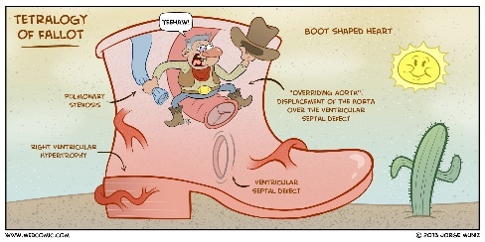
Cardio –
Tet Spell – cyanosis followed by syncope
- A classic hypoxemic “tet spell” results in decreased pulmonary blood flow.
- Risk of death—therefore these must be immediately recognized and treated
- OVEN –
- CXR with boot shaped heart, dec vascular lung markings
- Tuck knees/squat increased systemic vascular resistance)
- Other treatment Morphine – phenylephrine – 100% O2
- Long term they are on propanol

Prostaglandin E1 - The most common side effects are apnea, followed by hypotension.

Heme/Onc
Hemolytic anemia - falling hemoglobin, normal MCV, increased reticulocyte count
- Hereditary (G6PD deficiency, hereditary spherocytosis, sickle cell anemia)
- Acquired (immune disorders, toxic chemicals and drugs, physical damage, or infections).

Osmotic fragility is abnormal in patients with hereditary spherocytosis or thalassemia
- both of which are hemolytic diseases in which the Coombs test would be normal (unlike in autoimmune hemolytic anemia, where it is positive).

G6PD is an x-linked disorder usually affecting males, except in populations with a high incidence of disease.

Dental –
Avulsion – Secondary teeth - should be re-implanted within 30 minutes
- First rinse teeth under sterile water and don’t scrub or touch root or crown.
- Patient should bite down on a piece of gauze to hold the teeth in place while awaiting the dentist.
- If immediate re-implantation is not possible place in milk, viaspan, or hank’s balanced salt solution to preserve the periodontal ligaments of the root surface.

Dental pain transmitted along the fifth cranial nerve is a common source of ear pain.
- Oral analgesics are given for the pain of an erupting tooth.

