PEM|BRS: Toxicology
Basics
ABCDE D= Dstick, E= ECG
Toddlers -- MC = Tylenol MC fatal = iron
Adolescents – MC = Tylenol MC fatal = cardiac
- Acetaminophen is the most common co-ingestant in polydrug overdoses
- Always check a level - there is an antidote

Assume that the child has consumed the maximum available amount of the substance.
When 2 children have co-ingested a substance, assume each has taken allof the substance.

Exam -- Toxic pupillary findings:
- Miosis: “COPS”
  - C = cholinergics, clonidine - P = Phenothiazines, pilocarpine, pontine bleed
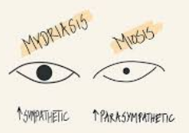
  - O = opiates, organophosphates - S = Sedative hypnotics
- Mydriasis: “AAAS”
  - A = antihistamines - A = anticholinergics
  - A = antidepressants - S = sympathomimetics
- Toxic Skin Signs:
- Diaphoretic skin: “SOAP”
  - S = sympathomimetics - A = ASA
  - O = organophosphates - P = PCP
- Red Skin: CO, Boric acid
- Blue Skin: Cyanosis, methemoglobinemia

Initial labs àif presenting with altered mental status à bedside glucose, serum lytes, Osmolal Gap, U/A, Beta HCG, ECG, calculation of an anion gap, and VBG.
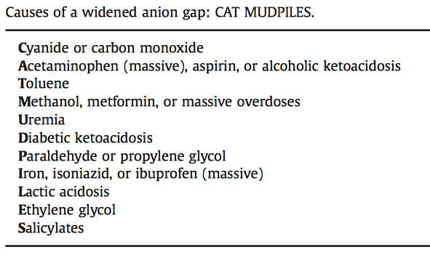
- Drugs where a level is important to obtain: “SAAD”
- Salicylates - Anticonvulsants
- Acetaminophen - Digoxin
- U/A may give helpful clues—calcium oxalate crystals are pathognomonic for ethylene glycol poisoning.

Anion gap = Na - (Cl +HCO3)

Osm gap = 2Na = gluc/18 + BUN/2.8
- Normal serum osmolality is 285-295 mOsm/L.
- The measured osmolality should not exceed the predicted by more than 10 mOsm/L.
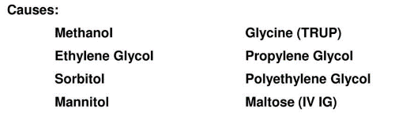
- A difference of more than 10 mOsm/L is considered an osmolal gap.
- The propylene glycol in lorazepam may cause hyperosmolarity and sometimes hyperosmolar coma in some patients, particularly when the lorazepam is used as a continuous infusion.

Corrosive eye injuries – Flush eye with saline until the pH is above 7 (and consult ophtho)
Dermal and inhalational exposures - remove all clothing and
- Organophosphates are lipophilic - can be absorbed through the skin causing corrosive injuries similar to burns.
- Neoprene gloves must be used with organophosphate exposure because organophosphates can penetrate latex gloves.

General Toxicology Themes:
- GABA is your friend—use benzo’s to treat most things
- Fosphenytoin doesn’t help in tox related seizures because it doesn’t have effects on the GABA system
- Do not induce emesis - increases the risk of aspiration.
- A drug or toxin is ideally dialyzable if it has low protein binding, the volume of distribution is less than or equal to 1 L/kg and it has a molecular weight of 500 Daltons or less. A patient who is normotensive is a better candidate for dialysis than someone who is hypotensive; continuous veno-venous hemofiltration can be considered in the hypotensive patient
- Giving AC via NG in an unprotected airway is not a good idea due to aspiration
- Narcan won’t work in a barbiturate OD (only opiate or clonidine)

GI decontamination:
- Activated charcoal may be given if administered within 1 hour of ingestion—1g/kg
Substances not absorbed by activated charcoal: “PHAILS”
- P = pesticides, potassium
- H = hydrocarbons
- A = acids, alkalis (caustics), alcohols
- I = iron, heavy metals
- L = lithium
- S = solvents
  - Do not do to someone who doesn’t have a protected airway
- Gastric lavage – OG tube with repetitive instillation and aspiration of small aliquots of fluid “stomach pumped”
  - Not routinely used
- Whole bowel irrigation is useful for metals, drug packers, and sustained release meds.
  - Use go-lytely at 0.5 L/hr under 6 years of age, 1L/hr 6-12 years; 1.5L/hr > 12 years.
- Hemodialysis à methanol – ethylene glycol – salicylates - lithium
***All intentional overdoses require a psychiatric consult

1 pill can kill – below 1 or 2 pills could kill a 10 kg toddler
- Opiates beta blockers calcium channel blockers TCA
- Antiarrhythmics à procainamide – Flecaimide - quinidine –
- Anti-depressents à thioridazine, chlorpromazine
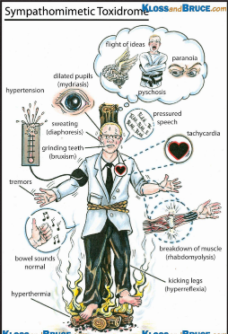
- Anti-mallarials à chloroquine, hydrochloroquine
Poison control - invaluable sources of clinical toxicologic advice.
- In the continental United States, Alaska, Hawaii, and Puerto Rico, the universal PCC telephone number is 1-800-222-1222.
Toxidromes:
Sympathomimetics: (ex. Amphetamines, methamphetamine, methylphenidate, cocaine, MDMA, pseudoephedrine, caffeine, albuterol, theophylline)
- skin pale, cool, and diaphoretic, pupils dilated and reactive; no diminished bowel sounds
- Mydriasis
“MATH High Dose Drug”
- Anxiousness
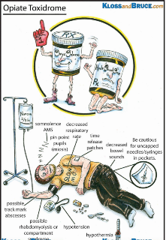
- Tachycardia
- Hypertension
- Hyperthermia
- Diaphoresis/Delirium (angry delirium)
Tx: Benzo

Opiods: (ex. Opiates, clonidine, imidazolines)
- Miosis
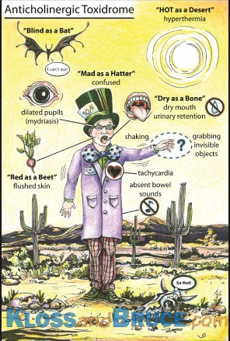
- Respiratory Failure
- Coma
Tx: Narcan

Anticholinergics:; ex. Atropine, antihistamines, antipsychotics, antispasmodics, cyclic antidepressants, jimsonweed, hyoscyamine, angel’s trumpet, nutmeg
- skin flushed, warm, dry, pupils dilated and non-reactive; diminished bowel sounds
- “Red as a beet” (flushing)
“Alice in Wonderland in a TUrRet”
- “Dry as a bone” (dry skin/mucosa)
- “Hot as a hare” (hyperthermia)
- “Mad as a hatter” (delirium/ hallucinations); often of “bugs crawling on skin”
- “Blind as a bat” (mydriasis)
- Tachycardia
- Urinary Retention
tx; benzo followed by physostigmine

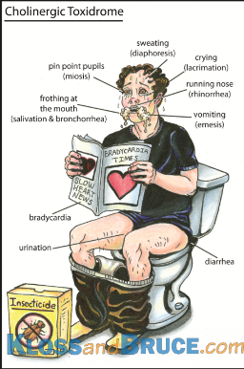
Cholinergics: ex. organophos. pesticides & nerve agents—sarin, soman (muscarinic cholinergic receptors—gives DUMBEL Sx’s)—carbamate insecticides (nicotinic cholinergic receptors—gives the fasciculations), nicotine
- Drippy and twitchy - miosis
- Diarrhea/diaphoresis, Urination, Miosis
“DUMB ELFS”
- Bronchorrhea/bronchospasm/bradycardia (KILLER B’s)
- Emesis, Lacrimation, Fasciculations, Salivation
tx: decon!
- then Atropine (an anti-muscarinic only, double every 5 min until atropinization is achieved—end point is drying of secretions without regard to pupils or HR)
- then Pralidoxime (2-PAM) which regenerates AChE—give as early as possible to prevent OP aging (permanent covalent bonding);

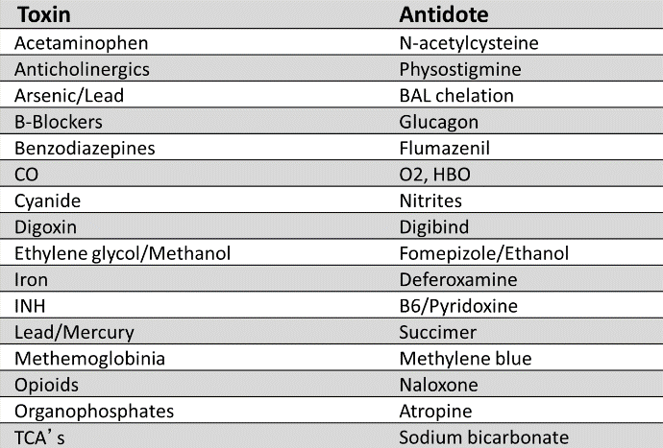

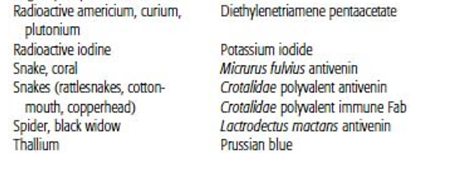

Opiates – altered mental status, respiratory depression, and pinpoint pupils
ECG changes – need cardiac monitoring
- Methadone can prolong the QTc interval leading to torsades de pointes.
- Propoxyphene can widen the QRS complex leading to ventricular arrhythmias such as VT and VF.
CXR - bilateral airspace disease with a normal cardiac silhouette à consistent with noncardiogenic pulmonary edema (NCPE) - due to opiate toxicity.
Near drowning• Oxygen therapy • Transfusion or Trauma (fat embolism) • Central nervous system disorder (neurogenic pulmonary edema)• Allergic alveolitis • Renal failure or Re-expansion or negative pressure pulmonary edema • Drugs (such as opiates [heroin, cocaine], aspirin, chemotherapeutic agents) • Inhaled toxins (ammonia, chlorine, smoke inhalation)• Aspiration or Acute respiratory distress syndrome or Altitude sickness • Contusion
  - NCPE related to opiate overdose manifests as extensive patchy, bilateral airspace consolidations; indistinct vessels; and peribronchial cuffing.
  - The exact mechanism of opiate-induced NCPE is unclear.
  - It frequently occurs after reversal with naloxone. A list of causes of NCPE can be recalled using the
  - mnemonic “NOT CARDIAC”
Treatment – Supportive O2
Naloxone -Counteracts the effects of narcotic-induced respiratory
- Rapid – Transient - improvement in vital signs and mental status.
- Multiple doses of naloxone may be administered at frequent intervals over the first 24 hours.
- Dose à 0.1 mg/kg to a maximum dose of 2 mg.
  - Repeated every 2 to 3 minutes, if needed
  - Ingestions of certain agents - buprenorphine - might require higher doses.
  - Continuous infusion à initial hourly dose based on the effective intermittent dose used and duration of adequate response seen.
- Patients should be observed and monitored closely for 4 hours after naloxone administration for potential deterioration as the effect of the drug abates.
- most direct route of administration is intravenous (onset of action within 2 minutes)
  - endotracheal, intramuscular, subcutaneous, and mucosal routes of administration are also effective
- The duration of effect is usually between 20 and 60 minutes
- Can precipitate withdrawal
  - Agitation, diarrhea, vomiting, diaphoresis, tachycardia, hypertension, pulmonary edema, arrhythmia, and seizures.

Suboxone = given to heroin addicts trying to get off Methadone.
- A combo drug of Naloxone and Buprenorphine—causes Opioid toxidrome
- Treat with Narcan.

NSAID - minimal morbidity and mortality.
- Most common complications - GI bleeds
- Seizures, coma, and renal failure are possible with the more toxic agents ( oxyphenbutazone, phenylbutazone, mefenamic acid, and piroxicam, or with massive ibuprofen or fenoprofen OD’s)
- activated charcoal is used for decontamination
- Treatment supportive care is all that is required
- Full recovery is expected within 6-24 hr

Acetaminophen
- Acetaminophen ingestion accounts for more overdoses and overdose deaths than any other medication
- The drug is everywhere and kids can get into it
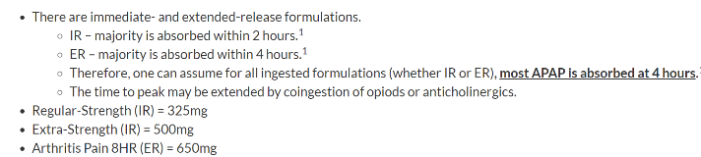
Pathophysiology: it is mostly metabolized by glucuronidation and sulfuration; however, a small percentage of acetaminophen is metabolized by the cytochrome P450 pathway into a toxic intermediate, NAPQI (N-acetyl-p-benzoquinoneimine). Normally, NAPQI is conjugated with glutathione and excreted in the urine and bile. However, in an OD, the glutathione stores are depleted and the NAPQI accumulates and binds to hepatocytes, causing centrilobular necrosis. Therefore, patients taking medications that induce cytochrome P450 pathway (anticonvulsants) may be at increased risk of hepatotoxicity following acetaminophen OD. The way N-acetyl-cysteine (NAC) works is thought to be:
- through its conversion to cysteine, which repletes glutathione
- by binding to NAPQI, creating a non-toxic metabolite
- by promoting sulfonation, thus promoting nontoxic metabolism

Clinical Presentation: Divided into 4 stages:
Often is asymptomatic initially - Initial symptoms or lack thereof are not predictive of later manifestations of toxicity.
- Stage 1: Anorexia, N,V, pallor—resolve within the first day
- Stage 2: Occurs on day 2 (24 h -72h) post ingestion. Hepato- and nephrotoxicity - Clinical signs of hepatotoxicity may be present (RUQ pain and increased LFT’s and bilirubin)
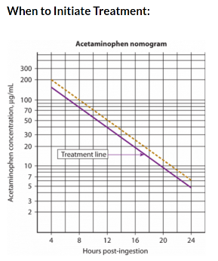
- Stage 3: Occurs on day 3—fulminant hepatic failure—metabolic acidosis, coagulopathy, jaundice, renal failure, encephalopathy, hyperammonemia, bleeding, hypoglycemia, lactic acidosis, and renal failure
- Stage 4: Occurs on day 4+; Liver makes a full recovery or dies

Toxic Level > 150 mg/kg (7.5 g in an adult)
- Need 4 hour level to plot on nomogram - Rumack-Matthew nomogram
  - If patient arrives to ED prior to 4 hours – wait to check level
- If > 8 hours of ingestion – check additional labs à LFTs and level (also Start NAC)

Treatment: IF < 1 hour à can given charcoal
First put them into an ingestion category…
- Acute acetaminophen ingestion within 24 hours:
  - Plot on 4 hour level on Rumack-Matthew nomogram à The treatment line starts at 150 mcg/mL at 4 hours post-ingestion
    - If the level falls below the treatment line à no NAC therapy is needed.
    - If the level falls above the treatment line àNAC is started.
    - If the level will not be available within 8 hours of ingestion à NAC should be started and then discontinued if the level falls below the treatment line when plotted on the nomogram.

- Acute ingestion in which time is unknown or greater than 24 hours:
  - Assume a toxic level à Draw an acetaminophen level and AST/ALT à NAC.
    - If APAP > 10 or increased AST/ALT à continue NAC.
    - Use King’s College Criteria to determine need for transplant referral.
    - The King's College Criteria: identify two groups of patients that have a poor prognosis with acetaminophen induced liver failure:
      - Arterial pH < 7.3 OR
      - An international normalized ratio (INR) of greater than 6.5, serum creatinine of greater than 3.3 and the presence of encephalopathy (of grade III or IV). (need all 3 - markers of coagulopathy, kidney function and mental status.)

- Ingestion of an extended-release acetaminophen:
  - A level is drawn at 4 hours and repeated 4 hours later.
  - The levels are plotted on the nomogram and ff either level falls above the treatment line à NAC

- Ingestion of repeated supratherapeutic doses:
  - Consider this if there is a history of 150mg/kg/day for >2 days or in an adult with 4g/day for >2 days or patient with signs of hepatic dysfunction.
  - Check level, AST/ALT, INR, bilirubin, glucose, lytes, creatinine, lactate, phosphate, ABG.
  - Start NAC if level > 10 or increased LFT’s.
  - If there are repeated ingestions within a 24 hour period, you cannot use the nomogram—instead, total the amount and regard it as a single ingestion, assume toxicity if close, and treat with full NAC protocol.

NAC Protocol:
Loading Dose: 150mg/kg over 1 hour
1st maintenance infusion: 50mg/kg over 4 hours
2nd maintenance infusion: 100mg/kg over 16 hours
- NAC is ideally started within 8 to 12 hours of ingestion
- But has been shown to be effective in most cases if started within 18 to 24 hours of ingestion.

If the patient survives and hepatic function returns, recovery occurs from 4 to 14 days after ingestion.
- Results of laboratory studies may remain abnormal for several weeks.
Complications - Most common complication - anaphylactoid reaction
  - producing flushing, urticaria, angioedema, and bronchospasm.
  - Tx: slow down the infusion rate, treat with Benadryl or Epi.
- Potential for hyponatremia in children under 40 kg
  - due to the amount of free water given in the IV NAC infusion.
  - Concentration should be changed to 40mg/cc in children < 40 kg

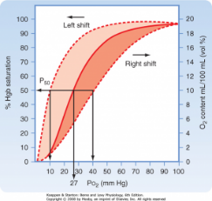
Methemoglobinemia – Blue Baby – Brown Blood – Normal PO2
Pathophysiology - Methemoglobinemia is caused by the conversion of iron molecules in hemoglobin from the ferrous to ferric state. The normal level in kids is <2% of a child’s total hemoglobin.
- Oxyhemoglobin is red and methemoglobin is dark brown creating its characteristic chocolate brown color.
- At least 5g of your hemoglobin must be oxidized to methemoglobin to cause cyanosis.
- Methemoglobin is incapable of transporting oxygen— causing a left-shift in the oxyhemoglobin dissociation curve and resultant tissue hypoxia and metabolic acidosis.
Found in à Teething gels (benzocaine ) – EMLA – Fertilizer - Aniline Dye – liquid gold furnature polish
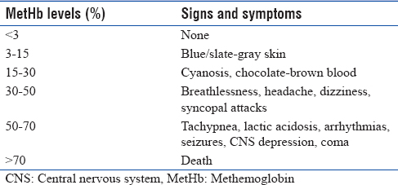
- lidocaine, nitrates, nitrites, nitroglycerin, phenacetin, prilocaine, primaquine
- Well Water (common source of nitrates)
- Acute diarrhea in infants
Clinical findings - Cyanosis unresponsive to supplemental oxygen
- Pulse Ox is unreliable
- Venous blood will turn brown when exposed to room air.
- As levels exceed 10% patients present with unexplained cyanosis
- At levels from 15%-35% à headache, SOB, tachypnea, and tachycardia.
- Higher levels cause CNS effects
- Death occurs with levels over 70%.
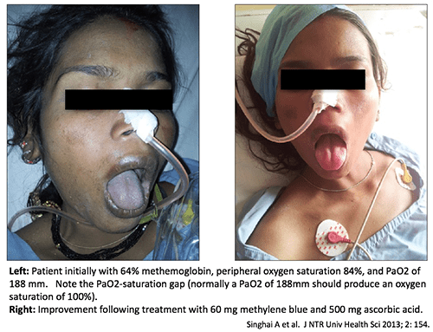
Treatment à supplemental oxygen for all patients
- ensuring oxygen delivery to the fraction of hemoglobin that is functional.
- Patients with levels <30% require no further treatment.
- If level > 30% (and symptomatic) à 1% Methylene blue at 1mg/kg over 5 minutes
  - Most patients resolve their cyanosis within 15 minutes.
  - In refractory cases, repeat doses may be given but should not exceed 6mg/kg during the first 3 hours.
  - Contraindicated in G6PD deficiency because it may cause hemolysis
    - Patients with G6PD deficiency à treat with hyperbaric oxygen or exchange transfusion.

Iron poisoning
Pathophysiology - Iron disrupts oxidative phosphorylation and is a vasodilator—the clinical effects therefore are those of shock and metabolic acidosis.
- Iron is corrosive and can cause hemorrhage, hypovolemia, and GI perforation
Iron poisoning is the leading cause of accidental death from prescription agents in young children.
- Ingestions of >20mg/kg will cause GI symptoms
- Exposures above 50 mg/kg are potentially fatal.
- Flintstones vitamin = 18 mg per pill - prenatal vitamin = 65 mg/pill

Stages:
- Within hours, GI symptoms; significant GI bleeding may occur
- Resolution of GI symptoms and silent absorption of toxic amounts of iron—this may last 36 hours giving a false sense of improvement
- Clinically evident systemic iron poisoning heralds the 3rd stage—causing shock and metabolic acidosis; liver failure may result
- Scarring of the gastric outlet or small bowel (may occur weeks later)

Level - Serum iron concentration usually peak within 6 hours of exposure.
- Normal levels à 50-150
  - Toxic > 350
- Other labs à WBC levels > 15 and serum glucose > 150 predicts severity
- Xray à plain radiographs of the abdomen may demonstrate opacities.

Treatment - Activated charcoal and lavage are ineffective.
- Whole bowel irrigation (WBI) is effective if tablets are seen on plain radiography.
- WBI ONLY IF patient à awake, alert, and without evidence of GI dysfunction (intractable vomiting, ileus, significant bleeding, obstruction, perforation).
  - Give 30 cc/kg/hr of polyethylene glycol by NG tube until effluent clear and radiography no longer shows any iron tablets.

IF à asymptomatic after 6 hours - normal serum iron levels (50-150) - normal gas - normal WBC – glucoseà discharge
IF à Symptomatic – hypovolemic – Level >350 – tablets on xray à chelation with deferoxamine
- Chelation with deferoxamine mesylate à 15mg/kg/hr IV à until symptoms resolved AND iron <100 AND after vin rose urine disappears (color due to chelated Fe-deferoxamine complex in the urine)
  - Side effect chelation à histamine release and hypotension
    - Slow the rate and give benedryl.
    - Deferoxamine for too long (>36hours) risk àARDS and Yersinia sepsis; Dialysis doesn’t work in iron ingestions.
- Chelation should not be delayed in hypotensive patients while waiting for serum iron levels.
- Hypotension is NOT a contraindication for chelation.

**If SR release, check a level 12 hours later

Aspirin (Salicylate) OD – Resp Alk (elevated RR) PLUS metabolic Acidosis – Dec Platelets/vit K (Bleeding)
Aspirin (lethal dose is really low, ~150 mg/kg, i.e. 10-30 grams. That's as few as 30 tablets of 325-mg aspirin.)
Hidden in many OTC products:
- Pepto-Bismol contains aspirin (1cc contains 8 mg of ASA)
- Topical ointments or liniments used in vaporizers contain methyl salicylate (oil of wintergreen; contains 1400mg of ASA per 1 cc. Therefore, a 1-2 cc ingestion of oil of wintergreen can be fatal to a child – also Bengay and wart removers)

Pathophysiology –
Initial phase à ASA stimulates the respiratory center with uncoupling of oxidative phosphorylation in the central nervous system causing early hyperventilation and respiratory alkalosis
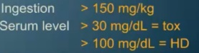
Then à renal response to respiratory alkalosis is to allow excretion of bicarbonate. Adults often present with a mixed respiratory alkalosis and metabolic acidosis.
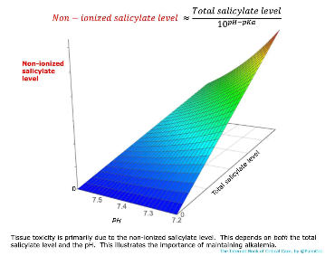
- ASA uncouples oxidative phosphorylation leading to hyperthermia, diaphoresis, and dehydration as well as hypoglycemia (from depleting energy stores due to lack of OP and interfering with glycogen formation). Early on, may have GI symptoms.

Level - Potential ASA toxicity occur at doses of 150mg/kg
- Level > 30 = toxic
- Level > 70 = severe
- Level > 100 = life threatening
- Levels usually peak around six hours after ingestion.
  - Peak may be delayed for >12 hours in patients who have ingested enteric coated tablets.
- Limitations of serum levels: Harm is primarily caused by the non-ionized form of salicylate. The non-ionized salicylate level depends on both the total salicylate level and the pH (non-ionized salicylate level is increased by acidemia).
  - For example, a patient with pH 7.2 and a total salicylate level of 46 mg/dL has the same level of nonionized salicylate as another patient with a pH of 7.55 and a total salicylate level of 100 mg/dL.
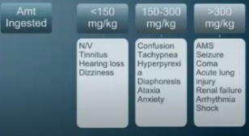
Clinical presentation - earliest symptoms 3 -6 hours later and are GI—then tinnitus, then deafness, then CNS symptoms
- may be indistinguishable from septic shock
- Co-ingestion of depressants may blunt the hyperpneic response leading to respiratory acidosis rather than the expected respiratory alkalosis of a pure ingestion.

Treatment
- Charcoal if < 1 hour
- Avoid intubation
  - Extremely dangerous for patients with combined metabolic acidosis and respiratory alkalosis - hypoventilation may eliminate respiratory compensation - causing the pH to drop.
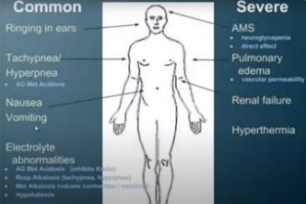
      - This may push patients into the Salicylate Hypercapnia-Acidosis Death Spiral
  - High-flow nasal cannula may help blow off CO2 and reduce the work of breathing.
    - HFNC should be discontinued as the serum bicarbonate levels rise to avoid excessive alkalemia.
  - If intubation is necessary, risk may be reduced by:
    - Giving bicarbonate before intubation (2 mEq/kg bolus of hypertonic bicarbonate).
    - Adjust vent settings to maximize minute ventilation (e.g. 8-10 cc/kg breaths, increase rate as high as possible without causing autoPEEP).
- Monitor glucose - CNS hypoglycemia can occur despite peripheral euglycemia
  - Give to all patients with altered mental status
- Alkalinization of the urine -- NaHCO3 (increases renal clearance)
  - Reduce penetration of salicylate into the tissues (especially the brain).
  - Increase excretion of salicylate in the urine.
  - Indications:
    - Salicylate level >40 mg/dL
    - All symptomatic patients
    - Note: even if pH already alkalemic due to respiratory alkalosis (pH up to 7.55), bicarbonate may still be beneficial to achieve urinary alkalinization.
  - Give 1-2 mEq/kg of NaHCO3 as a bolus
    - followed a maintenance infusion of isotonic bicarbonate at ~200 ml/hr (D5W with three ampules of bicarbonate per liter to create a 150 mEq/L solution of sodium bicarbonate). at 2xmaintenance
    - Stop alkalinization when salicylate levels fall below toxic levels (<40 mg/dL .
  - Check serum pH q2hr, target pH ~7.5-7.55.
  - Target a urine pH of at least 7.5
  - Target potassium level >4.5 mM
    - ** risk of hypoK
- Acetazolamide and other carbonic anhydrase inhibitors are dangerous because they achieve urinary alkalinization at the expense of serum acidification, which promotes salicylate movement into the CNS.
- Dialysis indications:
  - Altered mental status or noncardiogenic pulmonary edema
  - Noncardiogenic pulmonary edema requiring supplemental oxygen
  - Salicylate level
    - >100 mg/dL
    - >90 mg/dL with renal dysfunction
    - >90 mg/dL despite supportive care (e.g. fluid resuscitation)
    - > 80 mg/dL despite supportive care and in context of renal dysfunction
  - pH < 7.2 despite supportive care (e.g. bicarbonate)

Toxic Alcohols
Ethylene Glycol – Antifreeze +AG +OG CaOxylate crystals in urine – Kidney damage
Found in à Sweet-tasting constituent of automobile antifreeze
Clinical symptoms à Inebriating -- vomiting, somnolence, nystagmus, and/or incoordination.
- encephalopathy, and acute renal failure are of most concern.
Labs à
- Osmolal gap
- Metabolic acidosis with AG
- Urine - Calcium oxalate crystals are found in the urine (cause ARF)
  - Urine fluoresces under Wood’s lamp (fluoroscein added to some antifreezes)
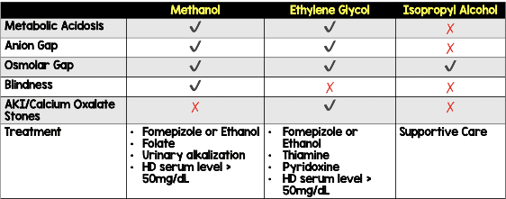
- Hypocalcemia may occur due to calcium and oxalic acid complexes
  - Check level and EKG
- Hypoglycemia, dehydration, and pancreatitis are common
- Blood levels > 50 warrant concern
Treatment:
- IVF
- sodium bicarb as needed to correct the acidosis
- Give Ca as needed
- Fomepizole (4-MP) – blocks alcohol dehydrogenase
  - 15mg/kg IV load, then,
  - 10mg/kg IV Q 12h x 4 doses then 15mg/kg IV q 12h; during dialysis, dose q 4 hours
  - UNTIL level < 20 and metabolic acidosis resolved
- Dialysis is indicated if level >50 and one or more of the following:
  - Visual disturbance or renal failure
  - Acidemia not corrected by bicarbonate therapy
  - Coma
  - Inability to maintain AD inhibition (metabolic acidosis worsening)
  - Long elimination half-life due to a high level portending a long hospital stay

Methanol windshield fluid +AG +OG Blindness
Found in à In windshield washer fluid, dry gas, copy fluids, canned cooking fuels
- Even a single swallow of windshield washer fluid is dangerous
Clinical à Less inebriating than ethanol or ethylene glycol so patients may appear well shortly after ingestion
- Formic acid is directly toxic to the retina, causing blindness
  - patients describe their vision as “standing in a snowfield”; Encephalopathy follows.
- Gastritis and pancreatitis sometimes occur after acute ingestion
Labs à Increased osmolal gap may be initially seen but it disappears as methanol is metabolized.
- Metabolic acidosis à slowly into formaldehyde à further metabolized to formic acid
  - Wide Anion Gap
- Blood levels > 50 warrant concern
Treatment – Fomepizole - Continue until metabolic acidosis corrected and methanol level falls below 20
- IVF and bicarb
- If you intubate, you must match the patient’s physiologic hyperventilation to prevent worsening academia.

Isopropanol (Isopropyl Alcohol) rubbing alcohol + OG NORMAL AG fruity breath
Found in à “rubbing alcohol”, a widely used solvent also used as the cooling ingredient in topical liniments.
- Toxicity can alo occur via dermal or inhalation (such as may result from misguided sponge baths for fever)
Clinical à Twice as potent as ethanol in terms of CNS depression; profound altered mental status, when it occurs, typically manifests within 2 hours of ingestion.
- Hypotension may occur from diuresis, peripheral vasodilation, and myocardial depression. Gastritis may occur
Labs à Increased Osmolal gap
- ketonemia or ketonuria may occur because it is metabolized by AD to acetone
- NO metabolic acidosis NO ANION GAP
- Hypoglycemia
Treatment supportive care; Dialyze – if level > 500 – shock - Coma

Ethanol ABCs – fluids - Benzos
Found in à beverages, mouthwashes, and cleaning products
Clinical à A CNS depressant—loss of inhibition, incoordination, slurred speech, and stupor
- Signs are flushing of face, dysarthria, and/or nystagmus
- aspiration pneumonia is a frequent complication
Labs à As levels approach 300, coma, loss of airway reflexes, and respiratory depression ensue
- Young children with reduced glycogen stores are at higher risk for hypoglycemia
  - Metabolized by AD, requiring the cofactor NAD—the consumption of this cofactor limits gluconeogenesis
- Check – levels – d stick – drug screen – electrolytes
Treatment à ABC’s, IVF
- Intubate if loss of airway reflexes.
- Hypoglycemia à glucose
- Seizure à benzo
- Aggitation à Benzo
- Consider trauma à work up as needed
- Level 450-500 à Consider dialysis

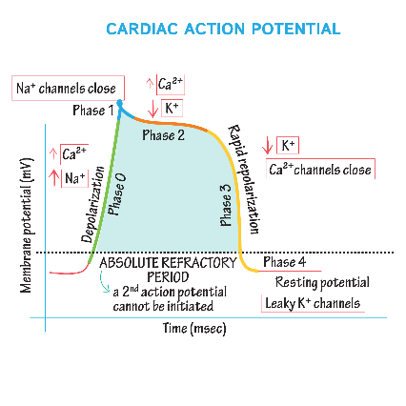
Chronic ETOH – risk withdrawal – seizures
- Treatment benzos
- Also thiamine (can have Wernicke encephalopathy)

Tricyclic Antidepressant (TCA) Overdose *Prolong QRS – prolong QTc – elevated HR – dec BP - +/- seizure
- Think “Three C’s” (Coma, convulsions, cardiac); Effect is on the CNS and cardiovascular systems
- Suspect TCA OD in any patient with ALOC and/or seizure who has prolonged QRS interval
Toxic dose: 10mg/kg is potentially life-threatening
Clinical presentation is the anticholinergic toxidrome
- Anticholinergic effects may retard gastric emptying à resulting in erratic absorption à patients may be initially awake then suddenly apneic or seize.
Cardiovascular effects
- Wide complex tachycardia
- Peripheral alpha-adrenergic blockade causes vasodilation and hypotension
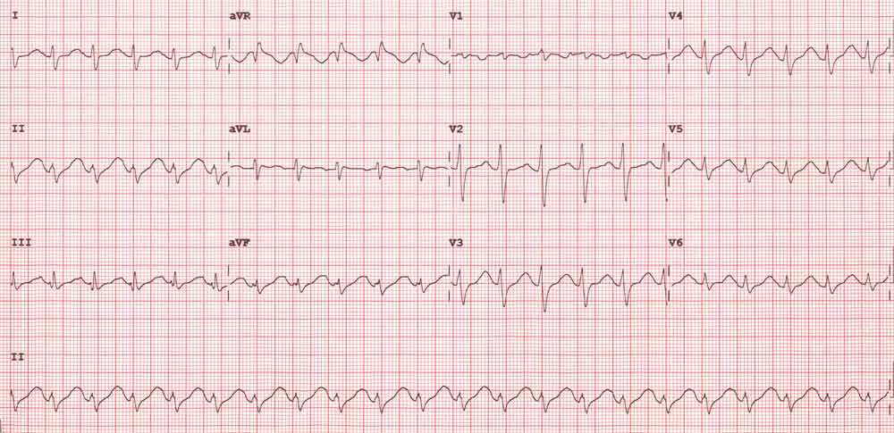
- Membrane-depressant effects (quinidine-like) cause myocardial depression and cardiac conduction disturbances—any acidosis makes this effect on the myocardium worse—that’s why we use bicarb to treat—also alkalinizes the plasma to increase protein binding of free drug.
- Sinus tachy with prolonged QRS interval >100msec; R wave > 3mm in aVR; may have prolonged QTc; may lead to VT
CNS effects: sedation, coma, seizures à result in hyperthermia, rhabdomyolysis, brain damage, MSOF, and death
Treatment: NaHCO3 until until QRS narrow (and pH 7.45 to 7.55)
- ABC’s then…
- Activated charcoal for small to moderate ingestions and gastric lavage for large ingestions (>30mg/kg)
- Consider cardiac pacing for AV block
- Seizures à may not respond to normal treatment
  - Protocol: benzo then benzo then phenobarb then propofol (NO Fosphenytoin!)
  - May need to sedate to prevent the hyperthermia which would lead to further seizures and the lactic acidosis which would lead to further cardiotoxicity
- QRS prolonged or patient hypotensive à give sodium bicarb 1-2 mEq/kg IV
  - repeat as needed to maintain ABG pH between 7.45-7.55
  - what you are really doing is giving bicarb until the QRS narrows—that’s your real end-point

Antipsychotic OD:
Atypical -antipsychotics (Phenothiazine)
Mechanism - through central and peripheral dopaminergic blockade
Clinical – increased tone – decreased BP – elevated HR – prolong QTc
- Muscle rigidity
- Anticholinergic toxidrome
- dystonic reactions (increased tone)
- Generalized seizures
- Akathisia
- Should anticipate rapid changes in mental status including cyclical coma;
Treatment - supportive and AC
- Bicarb for QRS widening
- Benadryl for dystonic reactions or akathisia

Lithium OD:
Suspected in any patient with a known psych history who is confused, ataxic, or tremulous
Pathophysiology - cation that enters cells and substitutes for sodium or potassium—main impact is on the CNS
- Entry into the brain slow à there is a delay between peak blood levels and CNS effects in acute overdose.
- Elimination is virtually entirely by the kidney (normal level range is 0.6 to 1.2)
- *****go by clinical symptoms rather than relying on the level.
The toxic dose depends on whether the overdose is acute or chronic:
- Acute ingestion of 40mg/kg produces a 1.2 level
  - The therapeutic window for lithium is narrow, with 1.2 mmol/L generally being the acceptable upper limit of normal.
- Chronic intoxication may occur in patients on stable therapeutic doses.
  - Meds that interact with lithium to increase levels –
    - AGE, diuretic use, NSAIDS
    - These can cause dehydration, sodium depletion, or excessive sodium reabsorption à which may lead to increased lithium accumulation
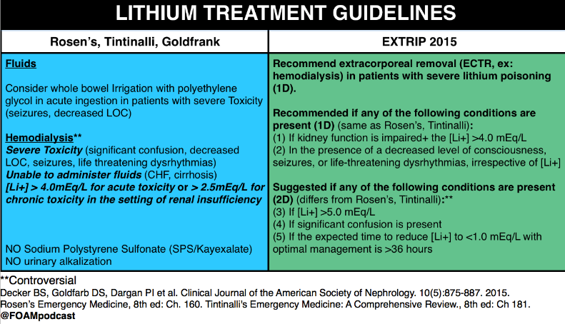
Clinical –
- Acute ingestions present early with GI symptoms of diarrhea, nausea, and vomiting.
- Neurologic symptoms are typically a late finding in acute toxicity, as lithium slowly redistributes to the central nervous system.
  - Confusion, tremors, ataxia, and agitation.
- Chronic toxicity typically demonstrates neurologic symptoms early
  - Progression of an existing tremor, hyperreflexia, clonus, ataxia, altered mental states, seizures, or encephalopathy.
ECG shows T-wave flattening or inversions and depressed ST segments
Labs - Often have elevated BUN/Cr levels
- May have narrowed anion gap due to elevated Cl or HCO3
Treatment –
- ABC’s
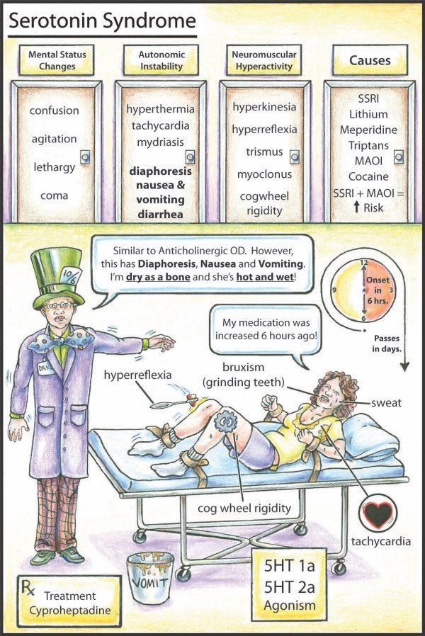
- Consider Gastric Lavage if large recent ingestion - AC does NOT absorb Lithium
  - WBI for SR preparations
- Hemodialysis:
  - Mental status changes
  - Unable to excrete renally (renal failure or anuric patients)
  - Acute ingestion symptomatic with level > 4
  - Chronic ingestions who are symptomatic with levels above 2.5

Serotonin Syndrome ocular clonus – clonus – increased reflexes
- Characterized by confusion, hypomania, restlessness
- Myoclonus (especially of lower extremities)
- Hyperreflexia
- Diaphoresis, shivering, tremor, incoordination, a
- Tachycardia – HTN – Hyperthermia
    - ** Onset is over hours from ingestion
Occurs when patient takes:
- MAO Inhibitor and an SSRI (can have taken a MAO-I 2 weeks prior)
- OD of a single SSRI or multiple SSRI’s
- SSRI and an agent that raises serotonin
  - (dextromethorphan, triptans, MDMA)
Treatment: supportive care
- cyproheptadine (periactin)- a serotonin antagonist.
  - Initial dose is 4-8 mg po and can be repeated q 1-4hours as needed until symptoms resolve or a maximum daily dose of 32 mg is reached.
  - Children’s dose: 0.25mg/kg/day divided q 6hrs with a maximum of 12 mg/day.
- Propranolol: 1mg IV (adult) or in children, 0.1mg/kg/dose over 10 minutes with maximum of 1mg dose every 2-5 minutes until a maximum of 5mg; may repeat q 6-8hr intervals.

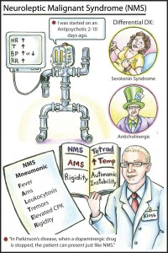
Differential Diagnosis:
Neuroleptic Malignant Syndrome (NMS): lead pipe rigidity – elevated temp – CK
- Days post ingestion or increase in dose of the Neuroleptic (dopamine antagonist/ antipsycotic)
- Sx: “lead-pipe rigidity” and normo/bradyreflexia
- Tx: Bromocriptine (dopamine agonist)

Malignant Hyperthermia (MH): during anesthesia
- Within minutes of halothane or succinylcholine administration
- Sx: mottled skin and “rigor mortis” type rigidity
- Autosomal Dominant transmission (+ family history!)
- hypoventilation and 2-3 x increase in end-tidal CO2 in a patient on a ventilator at a fixed rate (otherwise, they’d become tachypneic and blow it down)
- Tx: Dantrolene (inhibits sarcoplasmic reticulum release of Ca) which inhibits muscle contraction and the resultant hyperthermia

Cardiovascular Agents - Most antihypertensive and antiarrhythmic poisoning is treated with supportive measures.
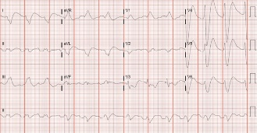
Remember: “Some Block Potassium Channels”
I=S= sodium channel blocker (Quinidine, Procainamide, Lidocaine, Flecanide)
II=B= Beta-blocker (block sympathetic tone to heart)
III=P= potassium channel blocker (Amiodarone)
IV=C= calcium channel blocker

Flecainide –
Class IC anti-arrhythmic – Na Channel blocker
Clinical - Can cause prolong QT/QRS
- risk of developing v.fib – asystole – PEA
- Seizures, CNS depression, hepatotoxicity, pulmonary edema, metabolic acidosis, hypokalemia, hypotension
Treatment – Cardiac life support - gastrointestinal decontamination - aggressive administration of sodium bicarbonate.
- As with tricyclic overdose, sodium bicarbonate probably works to offset the sodium channel blocking effects of the drug, in addition to alkalinizing the serum and thus increasing the protein bound portion of flecainide as well as helping to dissociate the drug from myocytes
- IV lipid emulsion – ILE is thought to work via a twofold mechanism:
  - acting as a "lipid sink," thus sequestering the drug within the emulsion
  - As source of fatty acids for poisoned myocyte
  - Dosing varies – recommend - a loading dose of 1.5 mL/kg pushed over 2-3 minutes
    - Can be repeated, followed by a 0.25 mL/kg/min infusion over an hour.
    - Maximum dosing is approximately 10-12 mL/kg.11
  - The adverse effects of ILE include:
    - Lipid Overload Syndrome -headache, fever, liver toxicity, coagulopathy, and anemia.
    - It also interferes with lab analysis and can cause spurious results on both blood counts and electrolytes
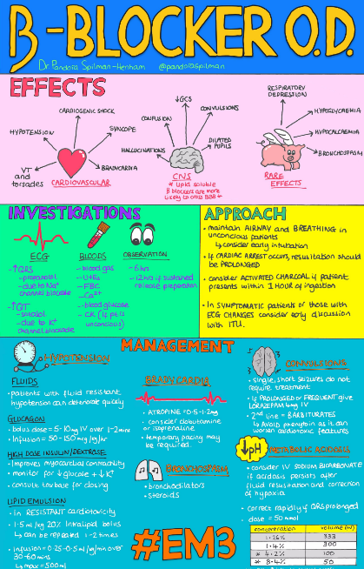
    - Also associated with fat deposition and clotting in ECMO circuits, leading to circulatory machine failure; however, ILE is not an absolute contraindication to ECMO.
- ECMO

Beta Blocker – decreased HR – Decreased BP – Decreased glucose – elevated K (met acidosis)
Class II Drugs:
Clinical OD Effect: decreased cardiac contractility and conduction delay
- Sinus brady; prolonged QRS, profound hypotension
- Depressed level of consciousness and seizures (due to propranolol’s lipophilic nature)
- Respiratory depression and bronchospasm
- Hypoglycemia
Treatment:
- Decontaminate with AC,
- Seizure à benzo, benzo, phenobarb, propofol protocol
- Correct hypoglycemia
- Treat hypotension with Epi (1 mcg/kg/min) or Glucagon 50 mcg/kg x 2 doses then 50 mcg/kg/min drip
  - Glucagon bypasses the beta receptor to activate the cyclic AMP system
- Insulin infusion – can improve cardiac contractility
- Intralipid – consider in severe cases
- If asymptomatic– can monitor for 6 hours

Calcium Channel Blockers – Dec HR – DEC BP – elevated glucose –wide QRS
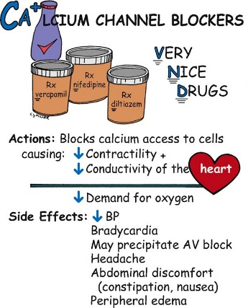
Class IV Drugs: “VD is BAD” - Verapamil and Diltiazem
Clinical –
- Verapamil and diltiazem à Decrease contractilityà myocardial depression AND/OR high-grade AV block à profound brady
  - verapamil and diltiazem cause full cardiovascular collapse
- All others only -- Vasodilate the vasculature à hypotension
  - Others will cause hypotension and you’d still get tachycardia
  - Also have seizures and lethargy.
  - Picture: AV Block, Seizure, Hypotension, lethargy, Brady for “VD”
Metabolism: hepatic, therefore, drugs that inhibit cytochrome P450 may increase toxicity during an overdose
Treatment:
- Decontaminate with MDAC (but with care, since the vagal maneuver may worsen bradycardia)
- IVF - Correct hypovolemia
- Calcium gluconate 20-40 mg/kg IV over 5 min then infuse at 20-40 mg/kg/hr if there is a favorable response (monitor serum calcium)
- Insulin bolus 1 unit/kg followed by infusion of 1 unit/kg/hr until toxicity resolves
  - At the same time, bolus glucose at 0.5g/kg followed by 0.5 g/kg/hr until insulin is discontinued (monitor serum glucose)
- Cardiac pacing
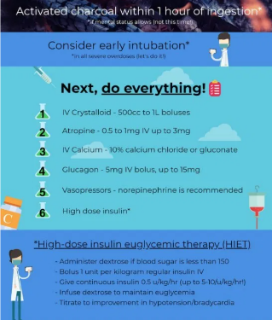
- Dopamine as your first inotrope (if verapamil or diltiazem - will correct all three places that those meds poison)
  - NE if you have any of the other calcium channel blockers because they only cause hypotension
- Glucagon 50 mcg/kg x 2 doses then 5 mcg/kg/min drip (may not work since you still need calcium around for the cyclic amp system to work)
  - Glucagon—it works better in Beta-blocker ingestions rather than in calcium channel blocker ingestions because you need calcium around for the rest of the cyclic AMP system to work and to increase inotropy and chronotropy—in beta blocker OD’s there’s calcium around, in calcium channel blockers, there isn’t.
- Dialysis doesn’t work.

Clonidine:
Stimulates only central alpha 2 adrenergic receptors (an agonist of these) - results in decreased catecholamine release à decreased BP and HR
Clinical - hypotension and bradycardia
- lethargy, coma, and miosis, respiratory depression
- hits the opioid receptors; therefore, you see the opioid toxidrome
Treatment –
- decontaminate with AC
- Fluids for hypotension
- may need pressors
- Narcan à can try
- Admit for obs à drug has a long half-life (at least 24 hours)
- Tolazoline (a central alpha 2 antagonist) has been used in case reports (not standard)

ACE Inhibitors:
Clinical - hypotension (responsive to fluid treatment), hyperkalemia (may need to treat it)
- dry cough
- Acute angioedema
Treatment – AC
- Fluids
- Treat the hyper K
- Treat angioedema à Benadryl and steroids, racemic epi

Oral Nitrates:
- flushing, headache, tachycardia, hypotension
- Methemoglobinemia (cyanosis, acidosis, but normal pulse ox!)

Digoxin:
Glycoside derived from the foxglove plant - found in decorative plants (yellow oleander)
Mechanism - increases cardiac contractility and slows the heart by delaying AV node conduction
Clinical - Acute toxicity presents with vomiting, diarrhea, weakness,
- Bradycardia
- Heart block
- hyperkalemia which may be life-threatening
- bi-directional ventricular tachycardia is characteristic
EKG – T wave and QRS changes
- also frequent PVC’s
Treatment –
- AC
- Give Fab if :
  - Arrhythmia of any kind causing hemodynamic compromise or with a level >10 or K>5.5.
  - Give 5 vials to a child and 10-20 to an adult
- Use atropine for bradycardia; May try Lido
- **DON’T give calcium if the hyperkalemia is from a digoxin overdose as it may precipitate malignant arrhythmias due to elevated calcium levels; kids don’t get into fatal range as long as their level remains below 10.

Amrinone is associated with thrombocytopenia and liver toxicity
Milrinone is associated with hypotension
- Less toxic than amrinone

Adensosine
- Do not give with digoxin, calcium channel blockers, or Class IA drugs à may cause heart block and V Fib
- Don’t use it in de-inervated hearts (post-transplant) à t may cause arrest
- Patients with 2nd degree heart block or on tegertol à may cause 3rd degree heart block

Warfarin – prolongs PT/PTT
- Limits vitamin K- Factors 2,7,9,10 and factor 12 (decreases fastest)
Treatment – FFT – (Vitamin K may take hours to see benefit)

Toxins causing Hypoglycemia “HOBBIES”
H=Hypoglycemics, oral (primarily sulfonylureas and meglitinides)
O=Other (unripe ackee fruit from Jamaica, quinines)
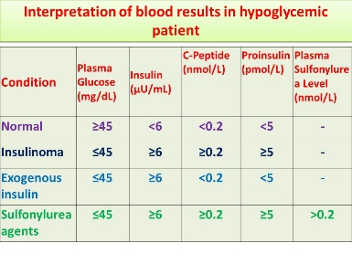
BB=Beta blockers
I=Insulin
- Insulin is secreted as proinsulin which is cleaved to form insulin and C-peptide
- C-peptide can facilitate if exogenous insulin was maliciously administered
- When the plasma glucose is less than 45 à insulin secretion should be almost completely suppressed à plasma insulin levels ZERO
- while insulin is cleared by hepatic transit, C-peptide is not, making it a quantitative marker of endogenous insulin secretion
- commercially available exogenous human insulin does not contain C-peptide fragments.)
E=Ethanol
S=Salicylates (a late finding as the increased metabolic demands will stimulate the peripheral use of glucose and fat with ensuing hypoglycemia)

Diabetic medications
Sulfonylureas
Pathophysiology - Decrease serum glucose concentrations by stimulating insulin release from the pancreas.
- Also augment peripheral insulin receptor sensitivity as well as reduce glycogenolysis.
Clinical – hypoglycemia – VERY LOW GLUCOSE
- May require IV glucose
Treatment
- Stabilize glucose –
- Antidotes à diazoxide or octreotide
  - Somatostatin analog which inhibits glucose-stimulated insulin release; it also inhibits the insulin response to glucagon
  - Will prevent rebound hypoglycemia from IV dex and will decrease overall dextrose requirements

Metformin (biguanide class of oral antidiabetic agents)
Will NOT induce hypoglycemia in nondiabetics
Metformin works by decreasing hepatic glucose production.
- Lactic acidosis is the most serious side effect

Anticonvulsants – treatment mostly supportive
Phenytoin (Dilantin) OD: CNS symptoms - Cardio (dysrhythmias)- Skin affects (extravasation necrosis)
- Caused by phenytoin’s diluent -propylene glycol
Treatment: supportive and AC

Carbamazepine (Tegretol) OD: anticholinergic toxidrome – CNS - cardiac toxicity symptoms
- QRS widening (treat with bicarb)
Treatment: supportive and AC

Valproate (Depakote) OD: Hepatotoxicity, pancreatitis, metabolic acidosis, coma
Treatment: supportive and AC
- May also give Narcan for CNS symptoms
- Carnitine for hepatic dysfunction or hyperammonemia

Chloroquine and quinine (antimalarials) cause GI symptoms followed by CNS stimulation or seizures

Theophylline: GI symptoms, seizures, tachycardia, hypotension, hypokalemia, hyperglycemia, and acidosis
Treatment: WBI along with charcoal
- Manage seizures as per normal

Camphor is in OTC liniments; present with GI symptoms then seizures

Isoniazid (INH) OD:
Classic triad of INH poisoning is “SAC”: seizures, metabolic acidosis, coma
Prevents the conversion of lactate to pyruvate, which is a major mechanism for the metabolic acidosis in an overdose
- Causes seizures by inhibiting conversion of glutamate to GABA
- Does NOT appear on routine toxicology screens
Treatment - Pyridoxine (B6) is the antidote
- serves as the co-factor for GABA synthesis
- Dosed at a 1:1 ratio with the amount of INH ingested

Skeletal Muscle Relaxants
A group of drugs that are simple sedatives, which provide skeletal muscle relaxation indirectly.
Mechanism of toxicity: generalized CNS, respiratory, and cardiac depression
Baclofen: GABA agonist causing profound CNS & respiratory depression as well as paradoxical muscle hypertonicity and seizure-like activity
- causes hypotension and bradycardia; hallucinations, seizures and hyperthermia from abrupt d/c baclofen.
Carisoprodol (Soma) causes spastic encephalopathy, hyperreflexia, opisthotonus
Orphenadrine: causes SVT and VTach, seizures, and arrest
Cyclobenzaprine (Flexeril) causes anticholinergic toxidrome
- despite structural similarity to TCA’s (causing a false positive TCA urine screen)
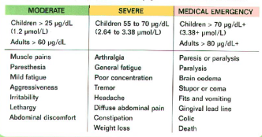
- Cardiotoxicity of TCA’s is not seen.

Lead Ingestion:
Concomitant nutritional deficiency involving iron and calcium is often associated with lead ingestion
Clinical - Vomiting, lethargy, irritability, loss of developmental skills or afebrile convulsions
- Acute lead encephalopathy.
  - Often have high ICP à LP should be avoided due to the risk of herniation
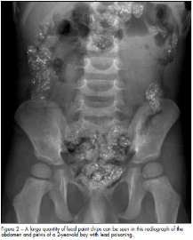
Abdominal xray - may reveal an on-going source of lead -paint chips, plaster, metal charms, or other foreign bodies with high lead content.
Treatment
- If foreign bodies on x-rays à endoscopic removal and/or WBI should be performed before initiating chelation.
- Level – 45 -70 à PO DMSA
- Level > 70 or symptomatic no encephalopathy à Succimer and CaNa2EDTA
- Encephalopathy à dimercaprol (also called British Anti-Lewisite [BAL]) and calcium disodium edetate (CaNa2EDTA)
  - Levels > 70 are associated with encephalopathy
  - CaNa2EDTA - ensure good hydration and monitor renal function
    - Side effect EDTA à elevated BUN and a Fanconi-like urine sediment, with proteinuria and hematuria
  - BAL side effects à elevation on transaminases and is metabolized in the liver before being excreted in the kidneys so there is concern in a patient with hepatic dysfunction.
    - hyperpyrexia and hypertension.
    - forms a toxic chelate if iron is concomitantly administered! Iron may be given, however to the patient if water-soluble succimer (DMSA) is being used as the chelating agent.
  - Both CaNa2EDTA and BAL can cause pain, swelling, and reaction at the injection site.

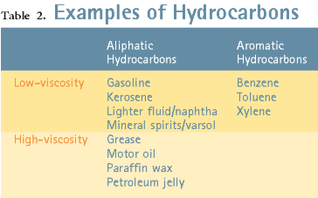
Hydrocarbon ingestion: oils, lamp oil, etc.
Have low viscosity (i.e. furniture polish) and high volatility (enter CNS easily and cause inebriation) move freely around tissue and the airways and pose the greatest risk for aspiration
- if no aspiration – minimal toxicity
Clinical – pneumonitis – cough – elevated RR – dec O2
- CXR infiltrates (CXR findings may lag behind clinical findings)
Treatment – supportive – oxygen
- No lavage - compounds are not absorbed anyway from the GI tract and you will only risk aspiration
- Vasopressin (no beta-adrenergic stimulus) as the vasopressor of choice
- Resolves in days
Dispo – if asymptomatic à monitor 6 hours à CXR at 6 hours à CXR neg and still asymptomatic à DC HOME
- Asymptomatic patients who have abnormal chest radiographic findings should be admitted to the hospital
  - Respiratory status may deteriorate.
- Symptomatic patients also should be admitted for observation and supportive care.

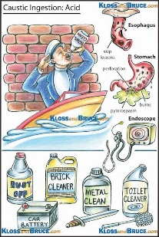
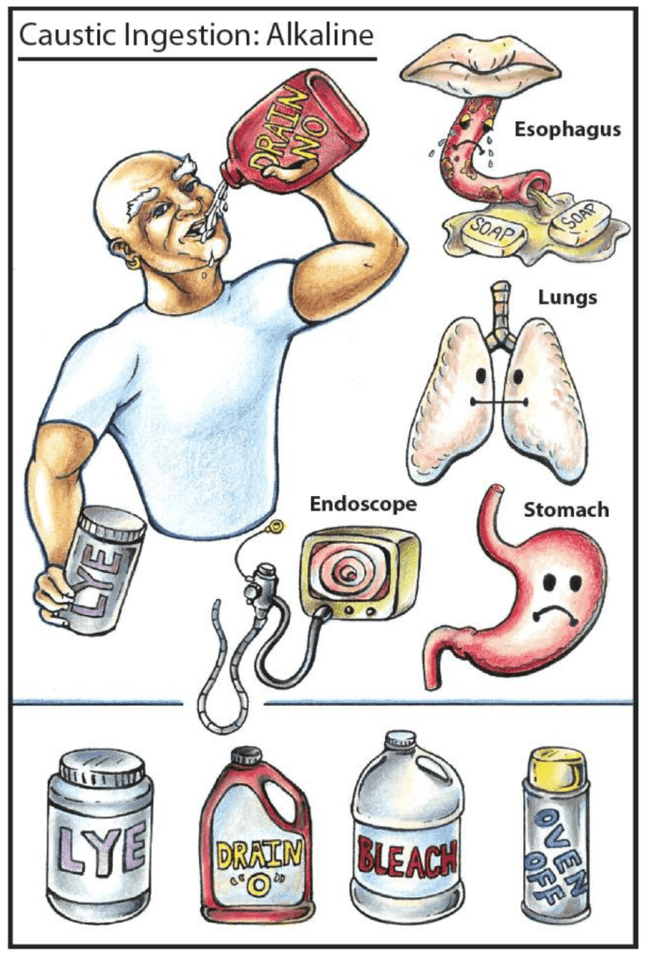
Caustic ingestions:
Caustic substances can be acids, bases, or have neutral pH, as with silver nitrate and concentrated hydrogen peroxide
Strong aCids - Coagulative necrosis
- toilet bowl cleaners, swimming pool cleaners, and rust removers.
ALkali - Liquefaction necrosis
- Household bleach – mild alk – low toxicity
- drain cleaners, various cleaning agents, hair relaxers, dishwasher agents, and disk batteries - Drano
Clinical -Severe damage to the esophagus
- Oral burns do not correlate with esophageal burns.
- Do not place NG tube
Treatment –NPO – monitor airway and endoscopy –
- Not done until 24 hours after ingestion to determine the extent of injury
- IF unknown/possible ingestion – asymptomatic – and tolerating PO after 24 hours à no need scope

Inhalation Exposures
Principles:
- The more volatile the agent, the more subject to inhalation
- Highly water-soluble agents are rapidly absorbed in upper respiratory tract - produce immediate local irritation
- Water-insoluble agents not readily absorbed - produce lower respiratory tract symptoms that are usually delayed
- Aspiration risk is inversely proportional to viscosity (low viscosity agents have the highest aspiration risk)

Smoke:
- The most common fatal gas involved in smoke inhalation is CO
- IF -- facial burns, singed nasal hairs, pharyngeal soot, and carbonaceous sputum—intubate early for airway protection.
  - When inhalation injuries receive mechanical ventilation - permissive hypercapnia may minimize barotraumas
  - Albuterol may help with bronchospasm.
- Symptomatic children à should be admitted for observation
- Asymptomatic à observe for 4-6 hours and admit them if signs or symptoms of inhalation injury develop.

Carbon Monoxide (CO)
- A colorless, odorless, tasteless, and nonirritating gas formed as a by-product of combustion of fossil fuels, wood, or charcoal.
- Most commonly due to smoke inhalation
  - Suspect when multiple family members/victims present with headache or vague flu-like symptoms.
Pathophysiology - CO binds Hb 250x as strongly as oxygen.
- Shifts the oxyhemoglobin dissociation curve to the left à making it more difficult for oxygen to be released to the cells
- Organs most affected are the ones using O2 the most (heart and brain)
Clinical Symptoms –
- Mild CO intoxication may give flulike symptoms of H/A, nausea, and fatigue
- In infants, the only suggestion of toxicity may be irritability or feeding difficulties.
Labs - Pulse ox can be falsely reassuring in patients poisoned by CO
- May do COHb level from ABG or VBG.
- COHb levels do not correlate with clinical signs and symptoms in children.
- A U/A and serum CK are indicated for patients with prolonged unconsciousness or at risk for rhabdomyolysis
- CXR if clinical evidence of pulmonary edema or a concern about related smoke inhalation injury.
Treatment - 100% Oxygen
- The half-life of COHb is 4 hours when breathing room air
- 1 hour while breathing 100% oxygen
- 20 minutes when breathing hyperbaric oxygen (HBO) at 2.5 atmospheres of pressure.
  - It is not clear that HBO treatment is beneficial for patients with CO poisoning.
  - An absolute contraindication for HBO treatment is an untreated pneumothorax
- Criteria for HBO referral
  - pH < 7.1
  - CO >25; CO > 15 in pregnant patient
  - Metabolic acidosis
  - LOC/ALOC; syncope, sz, neuro changes, EKG changes
  - Cerebellar dysfunction, GCS < 15
- Complications of HBO treatment - seizures, vascular gas emboli, and barotraumas to the ears, sinuses, and lungs, as well as the risk involved in transporting the patient to another facility
Dispo:
IF asymptomatic or manifest mild flu-like symptoms and repeat CO <5 after 4 hours à discharge
  - All other exposures should be admitted.

Cyanide no respond to 100% O2 - bright red blood
Gas is formed when wool, silk, synthetic fabrics, and some building materials catch fire.
35% of all house fire victims may have been exposed to CN.
- Acetonitrile is an artificial nail removing compound causing cyanide toxicity.
Pathophysiology - Cellular asphyxiant à CN binds with the ferric ion of mitochondrial cytochrome oxidase enzymes and halts aerobic cellular respiration.
- This shift to anaerobic metabolism results in severe lactic acidosis.
- CN also shifts the O2-Hb dissociation curve to the left, further impairing delivery to tissues.
Clinical Symptoms - The onset of symptoms following exposure to HCN gas is immediate.
- At low concentrations: anxiety, restlessness, palpitations, dyspnea, and headache
- At high concentrations: marked tachypnea, immediately followed by severe respiratory depression, convulsions, respiratory arrest, and death.
- Brightening of blood à CN prevents tissue extraction of oxygen from blood, the oxygen content of venous blood approaches that of arterial blood
- Seriously CN poisoned patient - hyperventilating, hypotensive, and bradycardic without cyanosis.
Labs – Lactic Acidosis!
- High lactate (>10)
- Metabolic acidosis
Treatment – hydroxocobalamin (binds cyanide ions, forming cyanocobalamin (vitamin B12) --> renally excreted)
- Or cyanide antidote kit – in fires sodium thiosulfate should be used (Cannot use nitrate in fires)
  - Dose: 400mg/kg up to 12.5g at rate of 5cc/min = 1.65 cc/kg (up to 50 cc) of 25% sodium thiosulfate
  - few side effects other than burning at the injection site, localized muscle cramping, and N/V
- amyl nitrite and sodium nitrite can cause methemoglobinemia(risk dysrhythmias and seizures and death)
  - Other side effects of nitrites - H/A, blurred vision, N/V, and hypotension

Chlorine Gas
- A pulmonary irritant
- Yellow-green gas that is slightly water-soluble and has a pungent, irritating odor.
- HIGHT DENSITY – (twice that of air) à descends and remains near ground level
  - Therefore, more risk for children
  - Transported on trucks à can have industrial accidents release gas into a surrounding community.

- Chlorine gas is 20 times more irritating than HCl.
- When chlorine gas and mucosal water react à HCl and hypochlorous acid (HOCl) result and are responsible for the caustic effects.
Clinical symptoms – May occur within seconds of exposure
- include upper airway symptoms, irritation of the eyes, nose, and throat, stridor, and upper airway swelling leading to obstruction
- SOB, chest pain, wheezing, pulmonary edema and death
- burns and corneal abrasions result from skin and eye exposures.
Treatment – intubate early
- mild – typically resolve in 6 hours
- Eye and Skin à irrigation with water or saline
- Lungs à Humidified oxygen and albuterol for bronchospasm

Chloramine gas - Household ammonia combined with bleach à reacts with mucosal water to release ammonia and HCl
- Leading to pneumonitis and edema.
- Cough and irritation result but there have never been any deaths from household cleaning agents.

Street Drugs:
Withdrawal both narcotics and sedative-hypnotics - restlessness, hypertension and tachycardia.
- In narcotics, you also have piloerection, N, V, D, myalgias, normal temp, yawning, mydriasis, lacrimation
  - Timing depends on agent used (heroin 4-6 hours; methadone 24-48 hours)
  - Not life threatening
  - Tx: clonidine
- In sedatives, you also have hyperthermia, disorientation, tremors, and seizures
  - Tx: benzo’s

Dextromethorphan
Cough syrups, Robitussin
Clinical - Can cause respiratory depression and apnea
- In abuse – euphoria, hallucinations, inappropriate laughing, psychosis, dissociative features, agitation
- Tachycardia – dilated pupils – diaphoresis – zombie like gait
- Can precipitate serotonin syndrome
Labs -- Risk rhabdo – check CK
- may cause a false positive opioid or PCP screen on urine tox
Treatment – supportive
- AC
- IV naloxone

Marijuana:
Clinical - dreamy intoxication, enhanced color/sound perception
- conjunctival injection
- judgement impaire
- Deep inhalation may cause pneumothorax or pneumomediastinum
- long term use may cause gynecomastia and diminished testosterone levels
Treatment - if very anxious, may give a benzo
- marijuana may be laced with many other drugs so look for other toxidromes in the patient who claims a pure marijuana ingestion.

Cocaine: inc HR – inc BP – inc Temp - agitation
May cause or mimic MI, so you often need monitored observation admission
Clinical - seizures, arrhythmia, myocardial ischemia, and hyperthermia
- Cardiac arrhythmias, hyperthermia, coma, and ultimately, death.
- Headache - could be sign of stroke - imaging if focal neuro deficits, severe headache, or altered mental status
Labs – check CK and renal function
- hyperpyrexia may cause rhabdomyolysis and renal failure
Treatment –
- Body-packers with WBI instead of endoscopic removal
- For elevated BP à no given beta-blockers
  - Unopposed alpha stim – can worsen BP
  - For BP – start with benzo
    - Can give nitroprusside/nitroglycerin
- Benzo – good choice to clam patient down

MDMA decreases thirst, so concurrent activity at a rave party may cause dehydration

Amphetamine
watch for hyperthermia induced rhabdomyolyis
Treatment – benzo if needed for sedation
- For rhabdo à may need to sedate and paralyze, use dantrolene, and alkalinize the urine.

LSD
- Synesthesia (crossed sensory experience) That you can smell a color or see a sound
- Stimulant toxidrome
Treatment - benzo’s may help.

Ketamine or PCP:
Treatment - Benzo; avoid physical restraints.

GHB: a white powder that has a soapy taste when dissolve
Clinical - euphoria, headache, dizziness, ataxia, miosis, and hallucinations
Treatment - benzo

Inhalants - cyanosis, not responsive to oxygen suggests methemoglobinemia secondary to nitrite abuse
- may cause arrhythmias
- Butane, propane, & NO displace alveolar O2 leading to hypoxia and a “high”.
- Chronic toluene inhalation characterized by hippuric acid excretion and Type I RTA with hypokalemia.

Caffeine – energy drinks…
Clinical – n/v, diaphoresis, dilated pupils,
- SVT – wide pulse pressure. Adenosine rarely works, can try esmolol
- Seizures
- Rhabdo
Treatment – Supportive
- Can give charcoal – even if hours later…

In the WILD:
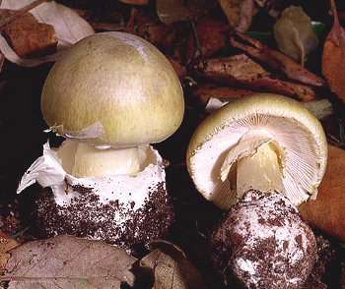
Mushroom Ingestion
Amanita phalloides “the death cap” accounts for > 90% of all mushroom-related fatalities
- Amatoxins cause hepatic and renal toxicity
- Not well absorbed and cause GI symptoms
- A verna and A virosa are closely related species that are more prevalent in the United States
- **the toxins are resistant to heat and are not removed by cooking**
Pathophysiology- binds to RNA polymerase and halt transcription à arrest of protein synthesis and cell death
- Effects metabolically active tissue with high rates of protein synthesis -cells GI tract, hepatocytes and PT of the kidney nephron are most affected.
Clinical - four stages of toxicity.
- Stage I is a latent or asymptomatic stage that typically lasts 6 to 24 hours.
- Stage II begins with the abrupt onset of severe abdominal cramping, nausea, vomiting, and profuse diarrhea
  - Lasts 12 to 24 hours.
- Stage III is a convalescent stage during which symptoms abate and the patient appears to be recovering.
  - Liver enzyme and bilirubin values begin to rise during this stage.
- Stage IV begins 2 to 4 days after ingestion and is characterized by dramatic increases in liver enzyme values and deterioration of hepatic and renal function.
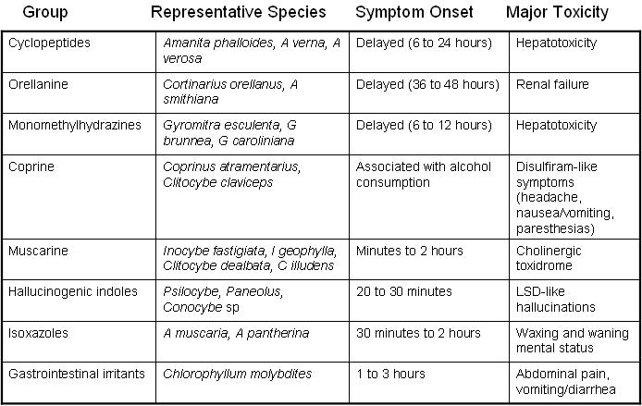
  - Multiorgan failure and disseminated intravascular coagulation occur in some cases.
Treatment – supportive intravenous fluids, maintenance of normal electrolyte and glucose concentrations, and monitoring and support of hepatic and renal function
- AC (repeat-dose AC for first 48 hours due to enterohepatic recirculation of toxin)
- Silibinin (extract of milk thistle) – NAC - high dose PCN (may inhibit toxin uptake)
- Antidotes are available for very few of the toxic mushroom species.
  - Pyridoxine may reduce toxicity after monomethylhydrazine ingestion
  - Atropine may reverse some of the toxicity of muscarine-containing mushrooms.
- Liver transplantation is necessary in refractory cases that progress to severe hepatic failure.
- Overall mortality rates 10% to 30%, with an additional 20% of patients developing chronic active hepatitis.
- Mortality rates are highest in young children.


Morning glory – like LSD
- Hallucinations – increase awareness – anxiety – aggressive
Treatment – supportive +/- benzo for agitation

Jimsonweed – anticholinergic
- Inc temp – miosis – flushed skin – agitated (hot, blind, red, mad…)


Pokeweed – GI – n/v/d
- Hemorrhagic gastritis
- Deep purple berry
Treatment – supportive

Foxglove or Oleander – Dig toxicity
- Inhibits Na K pump
- Arrhythmia – GI symptoms – visual symptoms
Treatment – DigFab


Philodendron – oral and pharyngeal burn
- House plant

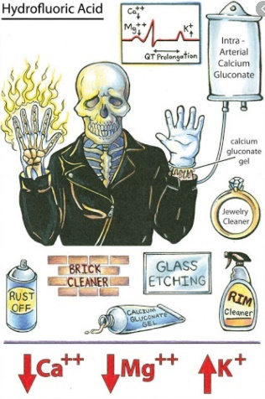

Hydrogen Fluoride (HF) - produces hydrofluoric acid – treatment calcium
Irritant gas used in chemical manufacturing; in an aqueous solution produces hydrofluoric acid
- Used as a rust remover and in the manufacture of silicon semiconductor chips
- Exposure is usually by dermal or ingestion routes.
Mechanism of Toxicity: Dermal and respiratory irritant
- Penetrates tissues deeply where the highly cytotoxic fluoride ion is released and cellular destruction occurs
- Also fluoride rapidly precipitates with cations causing systemic hypocalcemia and hypomagnesemia.
Clinical presentation: depends on type of exposure (gas or liquid), concentration, duration, and extent of exposure:
- Inhalation: - immediate ocular and NP irritation
  - Cough, and bronchospasm
  - after several hours, chemical pneumonitis and noncardiogenic pulmonary edema occur.
- Dermal exposure: exposure to weak solutions is potentially more worrisome since pain will not be immediate;
  - Concentrated solutions (>50%) have better warning properties because of immediate pain
  - After a delay of 1-12 hours, progressive redness, swelling, skin blanching, and pain occur owing to penetration to deeper tissues by the fluoride ion.
  - The exposure is usually through a pinhole-size defect in a rubber glove and the fingertip is the most common site of injury
  - Pain is progressive and unrelenting and you may have severe deep-tissue destruction, full thickness skin loss and bony destruction
- Ingestion: corrosive injury to mouth, esophagus, and stomach
- Systemic: hypocalcemia, hypomagnesemia, hyperkalemia after concentrated solution exposure to >2.5% BSA
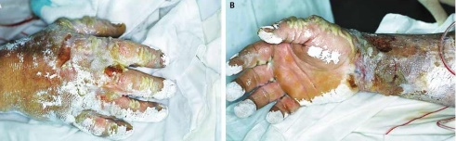
  - leads to cardiac dysrhythmias, the primary cause of death in HF injuries
  - Prolonged QT interval may be the initial manifestation of hypocalcemia or hypomagnesemia
Treatment: Calcium gluconate rapidly precipiatates fluoride ions and is an effective antidote for dermal exposures and systemic hypocalcemia
  - May also need to monitor and replace serum magnesium.
- Topical: apply a gel containing calcium gluconate or carbonate using an occlusive dressing to enhance skin penetration, if pain is not improved after 30 minutes, consider subcutaneous injection
- Systemic: Calcium gluconate 10% 0.2-0.4 cc/kg IV
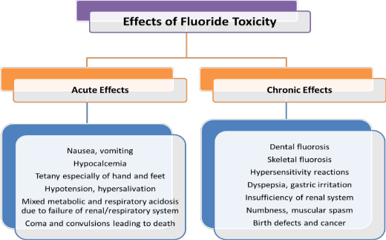
Prehospital medical direction: give any available calcium containing (calcium carbonate or milk) or magnesium containing (Epsom salts, MgOH) substance by mouth
- Soak extremity in Epsom salt solution or Benzalkonium (Zephiran) solution

Fluoride OD: In 1 tsp of toothpaste, there is 5mg elemental Fluoride
- It takes 3-5mg/kg to cause GI effects and 5-10mg/kg to cause electrolyte effects.

Oral lidocaine – (magic mouth wash – typically not used in toddlers
- 1 mk/kg ingested can result in convulsions.

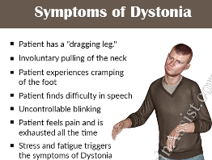
Dystonia – s/p Reglan – neck twisting and odd posture
- Due to dopamine imbalance
Treatment – Benadryl – can reoccur
- May need prescription to be taken at home

Smells

Moth ball à campfer
Pears à Chloroal hydrate
Glue à Toluene
Carrots à Water hemlock
Garlic à Arsenic, organophos, selenium

