PEM|BRS: Research Methods and Epidemiology

Prevalence: the number of existing cases of a disease per a total population at a given point in time (in cases per 1,000)

Incidence: a measurement of the instantaneous rate of developing a disease in a population and equals the number of new cases of disease in a given time period over the total person-time of observation.

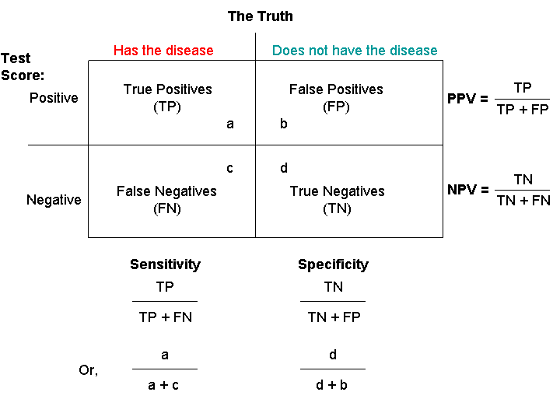
The performance characteristics of tests for infectious diseases can be illustrated by placing the population into four mutually exclusive cells on a 2x2 table
- Disease is the top heading of the table because this is the priority
- Test is placed on the left border.

Sensitivity - sometimes termed detection rate
- The ability of a test to identify persons who have the disease.
- Calculated by dividing those correctly identified with the disease (a) by all who have the disease (a+c): a/(a+c).
- Of all those with the disease, sensitivity is the proportion with a positive test.

Specificity The ability of the test to identify those who do not have the disease.
- Calculated by dividing those correctly identified as disease-free (d) by all those who do not have the disease (b+d): d/(b+d).
- Of all those who do NOT have the disease, specificity is the proportion with a negative test.

Sensitivity and specificity are inherent characteristics of a test
- Are independent of prior probability of disease.
- A major limitation of these two measures is that they do not allow the clinician to estimate the chance (probability) of disease in the presence of a given test result—which is what is truly clinically relevant.

One approach to describing the probability of disease is by use of the predictive value of the test.
The PPV - Defined as the proportion of people with a positive test who actually have the disease
- [a/(a+b)].
- The PPV is the probability of disease given a positive test result.
- Thus, of all those who have a positive test, PPV is the proportion who actually have the disease.
The NPV - proportion of people with a negative test who do not have the disease
- [d/(c+d)].
- The NPV is the probability of NO disease given a negative test result.
- Of all those who have a negative test, NPV is the proportion who did not have the disease.
Predictive values vary with the prevalence of the disease in the population
- Are not inherent characteristics of the test.
- As prevalence increases the PPV increases while NPV decreases.
- As prevalence decreases the PPV decreases while the NPV increases.

Sensitivity and specificity are inherent characteristics of the assay and are independent of the prevalence of the disease
Positive and negative predictive values vary, depending on the prevalence of the disease in the study population.

Another example can help to illustrate this issue:
A review article on rapid diagnostic tests for influenza reports a sensitivity of 60% and specificity of 90% for one test. Consider the use of this test in two different populations: one that has an influenza prevalence of 30% and one that has a prevalence of 1%. Based on these prevalence rates, the numbers in the “totals” row can be entered as illustrated in Tables 2 and 3.
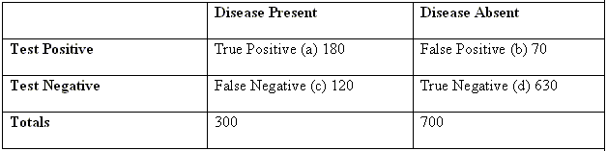
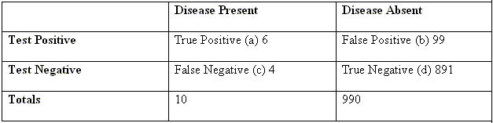
Table 2: 2X2 Table for Population A (n = 1,000), Prevalence 30% Table 3: 2X2 Table for Population B (n = 1,000), Prevalence 1%
PPV = [a/(a+b)] = 180/250 = 72% PPV = [a/(a+b)] = 6/105 = 6%
NPV = [d/(c+d)] = 630/750 = 84% NPV = [d/(c+d)] = 891/895 = 99.5%

***Most important element of a screening tool sensitivity
- Best screen to capture true positive

Practical consequence (variability in predictive values)
- Seasonal illnesses such as influenza are interpreted differently at different times of the year.
  - During periods of low influenza prevalence (summer) most positive test results are false-positives
    - so more specific diagnostic techniques such as cell culture should be used for diagnosis
  - During a period of high prevalence (winter) a positive result on a rapid test is likely to represent a true positive.
- Predictive values should be considered when interpreting the result of any diagnostic test that has less than perfect sensitivity and specificity.
- Diagnostic tests should be ordered only after careful consideration of the clinical evidence supporting or refuting the diagnosis.
- If a test is ordered in a situation where disease is unlikely (low prevalence), a positive result likely will be in error (false-positive).
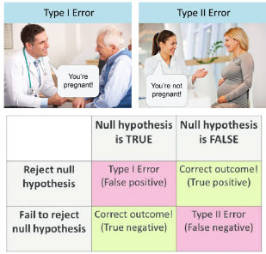
False Positive rate FP divided by (FP + TN). b/(b+d)
- It can be considered the reverse of the specificity (1-specificity).
- It is the probability of a positive test even if an individual does NOT have the disease.

False Negative rate FN / (FN + TP). c/(a+c)
- It can be considered the reverse of the sensitivity (1-sensitivity).
- It is the probability of a negative test even if the individual has the disease.

Type I Error = Alpha Error
- Error of rejecting the null hypothesis when it is actually true.
- In other words, it occurs when we believe we are observing a difference, when in truth there is no difference.

Type II Error = Beta Error
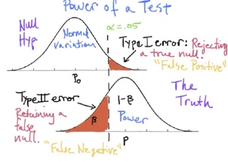
- Error of failing to reject the null hypothesis.
- In other words, it occurs when we fail to observe a difference when there is one.

Power –Probability of correctly rejecting the null hypothesis when the true effect is greater than or equal to the effect size
- likelihood that a particular study will be able to detect a variation from the null hypothesis if that variation exists.
- 1 -Beta (Not making Type II error)
- As power increases decreased risk of type II error
- Power of 80% is standard
- May be done priori or post hoc: Most recommend that the power analysis be done a priori
Goal of study – reject null hypothesis
Power - reject null when null is false
Therefore – want high power…

Sampling Error = when the observer chooses a sample that is not representative of the population.

Margin of Error = the amount of random sampling error that occurs with the results.
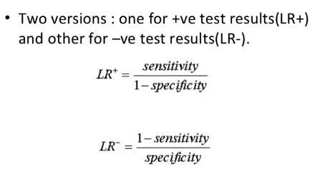
Likelihood ratio (LR)
- An alternative and more intuitive summary metric that incorporates sensitivity and specificity
- The LR is independent of the pretest probability and easy to use in paperless calculations that can be performed at the bedside.
Positive LR ratio of probability of obtaining a positive test in the presence of disease divided by the probability of obtaining a positive test in the absence of disease
- [positive test/presence of disease] ÷ [positive test/absence of disease].
- Another method of expressing this is to divide sensitivity by (1-specificity) or true positive rate/false positive rate.
Negative LR ratio of probability of [negative test/presence of disease] ÷ [negative test/absence of disease] or (1- sensitivity)/specificity.
Strength of LRs permit the user to multiply the LR by the pretest odds of the disease to yield the posttest odds of having the disease if the test result is positive.
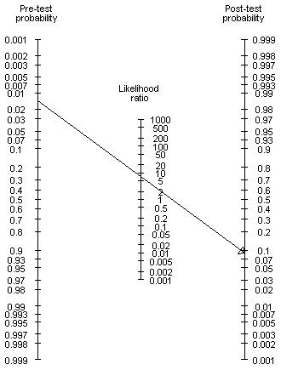
The odds of the disease are slightly different from the probability of disease.

Example: What is the probability a negative rapid strep has a positive culture Sensitivity of a rapid strep screen is 83% and specificity is 95%; assume throat culture sensitivity is 100% for this scenario:
- LR of a Negative OIA Test = (1-0.83)/0.95 = 0.17
- Pretest Odds of the Disease = pretest probability÷(1 - pretest probability)=0.5/(1-0.5) = 1
- Posttest Odds of the Disease = LR x pretest odds = 0.17x1 = 0.17
- Posttest Probability of the Disease=posttest odds÷(1+posttest odds)=0.17/(1+0.17)= 0.15
- Therefore, the chance that the patient still will have a positive culture for GABHS in the presence of a negative screening OIA test is 0.15 or 15%.

Once the LR is known for the screening test, use of the nomogram developed by Fagan is the simplest method for calculating the posttest probability, in this case, the chance of a positive throat culture. After drawing a line from the pretest probability (.5) through the LR (.17) of interest, the continuation of the line intercepts the adjusted posttest probability (.15 =15%)

A positive LR should be greater than 10 and a negative LR should be less than 0.1
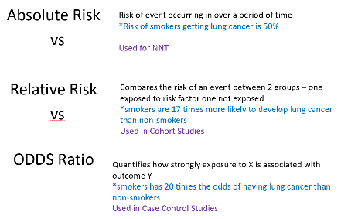
Absolute Risk - Risk of event occurring over a period of time
- Example 1 in 2 people born after 1960 in the US will be diagnosed with some form of cancer in their lifetime
- Used to calculate NNT
- The amount by which your therapy reduces the risk of the bad outcome.
- Where ARR = CER (Control Event Rate) - EER (Experimental Event Rate).
- NNTs are always rounded up to the nearest whole number.
Example
- If your drug reduces the risk of a bad outcome from 50 per cent to 30 per cent, the ARR is:
- ARR = CER - EER = 0.5 - 0.3 = 0.2 (20 per cent) therefore

Number Needed to Treat (NNT)
- The Number Needed to Treat (NNT) is the number of patients you need to treat to prevent one additional bad outcome (death, stroke, etc.).
- For example, if a drug has an NNT of 5, it means you have to treat 5 people with the drug to prevent one additional bad outcome.
Calculation
To calculate the NNT, you need to know the Absolute Risk Reduction (ARR); the NNT is the inverse of the ARR:
- If your drug reduces the risk of a bad outcome from 50 per cent to 30 per cent, the ARR is:
- ARR = CER - EER = 0.5 - 0.3 = 0.2 (20 per cent) therefore
- NNT = 1/ARR = 1/0.2 = 5

Relative Risk Incidence of disease among those exposed
- Compares the risk of an event between 2 groups –
- one exposed to risk factor one not exposed X times more likely
- Relative risk is a ratio of the probability of an event occurring in the exposed group versus the probability of the event occurring in the non-exposed group.
- Probability of event in exposed group / Probability of event in not exposed group
- RR of 1.8 = elevated risk 1.8 times higher in one group
- IF CI crosses 1 = not significant
  - Association likely resulted from chance
- An example is a relative risk of developing lung cancer (event) in smokers (exposed group) versus non-smokers (non-exposed group).
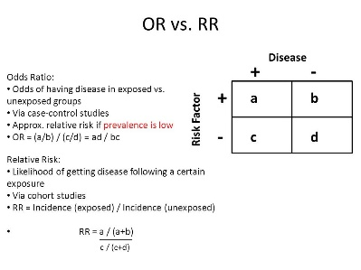
  - If we hypothetically find that 17% of smokers develop lung cancer and 1% of non-smokers develop lung cancer
Relative Risk = 17% / 1% = 17
Thus, smokers are 17 times more likely to develop lung cancer than non-smokers.
- Used in Cohort Studies

ODDS Ratio Odds of people with disease being exposed
- Quantifies how strongly exposure to X is associated with outcome Y - relative odds given risk factors
- The odds ratio (OR) is a measure of how strongly an event is associated with exposure.
- The odds ratio helps identify how likely an exposure is to lead to a specific event.
- OR 7.75 = odds of having disease is 7.75 times greater in patients with those risk factors
- If CI includes 1 Not statistically significant
  - More narrow CI more precise
- If the data is set up in a 2 x 2 table as shown in the figure then the odds ratio is (a/b) / (c/d) = ad/bc.
- Example –
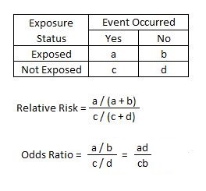
  - If 17 smokers have lung cancer, 83 smokers do not have lung cancer, one non-smoker has lung cancer, and 99 non-smokers do not have lung cancer
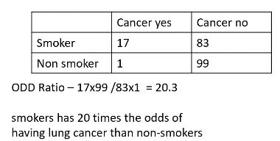
  - What is the odds ratio?

- Used in case control studies

Study Design:
Randomized Control Trial: Two groups are compared
- Study subjects are randomized into either a treatment group or a control/placebo group
  - one group is given an intervention and the other group is not
- Then the groups are followed prospectively for a time period to determine differences in outcome.
- Primary disadvantage: Study Enrollment is time intensive

Cohort:
- Observational investigations used to examine outcomes of exposures or risk factors over time
  - Identification of persons who have the exposure or risk factor of interest - these individuals are monitored for development of one or more outcomes
- Can be retrospective or prospective
  - Retrospectively Examines two groups with different exposures and compares their outcomes
    - Exposure and outcome have already occurred at the time of the study and data is collected after the fact.
  - Prospective Study
    - Study group(s) (cohorts) are followed over time – to see if develop disease
- Compares a group with exposure to a risk factor vs a group without that risk factor
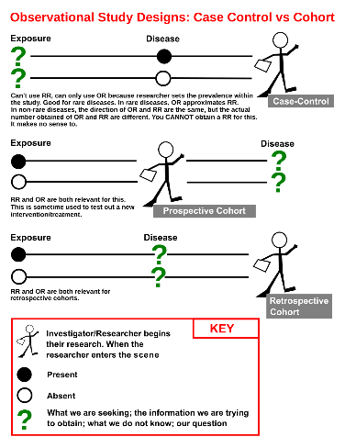
  - Follows over time to evaluate whether exposure changed the likelihood of a disease
- Example Group with exposure to soda at school vs group without to compare obesity rates
- Primary disadvantage: Accuracy of data cannot be guaranteed
  - Other disadvantages Observer bias (no blinding), Do not provide quick answers, Follow up bias
  - Can take years – more expensive that case control
- Advantage No recall bias - Easier and cheaper than RCT
- OUTCOME Relative Risk

Case-control:
- Standard initial approach to identifying the source of outbreaks of disease
  - Such outbreaks often are caused by exposures to food, water, or other environmental “point-sources” contaminated with a microbe
- Retrospective study
- Examines all patients in the study group at a given point in time.
  - Compares one group who have the disease – the CASES
  - With another who do not have the disease – the CONTROLS
- Look back in time to see how often each group was exposed to a risk factor
- Example Compare obese and non-obese patients to assess soda at school
- Primary disadvantage: It is most efficient for rare outcomes
  - Other disadvantage Recall bias - Selection bias
- Advantage Quick and inexpensive - frequently used for outbreaks – good for rare disease
- Because of relative ease to conduct & lower costs often first types of causation assessments to be conducted.
- OUTCOME ODDS RATIO (with a 95% confidence interval)

Nested-Case Control Study: A case-control study “nested” within an ongoing cohort study.
- Often a specific subset of patients emerges during a larger cohort study; and therefore, this is studied.
- Primary disadvantage: Controls may not be representative of the cohort

Cross-sectional Survey: Capture information about risk factor and clinical features at one point in time
- Essentially a “snapshot” in time.
- Data for various diseases and various exposures are collected at the same point in time
  - Relationships between timing of exposures (risk factors) and onsets of disease generally cannot be captured in this type of study.
- Example - Survey all high schoolers determine how much soda they drink and if obese
- Disease prevalence can be estimated, but incidence generally cannot be inferred.
- Associations can be elucidated, but causation cannot be inferred.

Longitudinal study: an observational study over time.
- Primary Disadvantage: Biases may affect the implications of the study.

Correlational study: a descriptive study, which examines disease in relation to some characteristic of a population.

Case Series: A descriptive study, which describes a group of patients with the same disease process.

Ecologic Study: measures the exposure and disease in a group of people considered as 1 unit, rather than in an individual.

A disease registry - Capture information about risk factors or clinical features of a particular disease.
- Data for individuals who do not have the disease generally are not captured for comparison.
- Registries are particularly useful for descriptive and pathophysiologic analyses of diseases that have relatively low incidences.
- Standardized data collection from multiple centers can facilitate more rapid accrual of data
- A disease registry is, in essence, a more formal version of a single cohort study or case series.
Surveillance systems
- Communicable disease reporting system of the Centers for Disease Control and Prevention (CDC)
  - can be considered a type of registry.
- Data can be combined with population data to determine disease incidence and then relative incidences.
- Surveillance efforts such as the CDC FoodNet can be helpful in determining sources of national outbreaks
  - Less effective for local outbreaks, where answers are needed within a few days.
Hierarchy of validity in determining causation among observational studies –
- Cross-sectional studies provide the lowest level of insight.
- Case-control studies provide more substantial evidence that a particular disease is caused by a particular agent or risk factor, but such findings generally require confirmation with cohort studies
- Cohort studies provide the most convincing evidence of cause and effect.
- Case series and disease registries/surveillance systems typically do not include control groups without disease and, therefore, do not address causation.
The absence of an observed association and favorable outcomes DOES NOT mean there is no causal effect
We can never prove causation Strongest study is Random Control
Most studies we cannot measure causality directly only associate between variables

Other Types of analysis:
- Mean: numerical average of all the data set values
- Mode: most common value in the data set
- Median: “middle” item in the data set

- Intention to Treat Analysis: based on the initial treatment or intervention intent, and not on the treatment or intervention actually received.
  - Thought to simulate the real life effects of an intervention in reality, few interventions are performed 100% of the time.

- Bonferroni’s correction is applied to a statistical analysis when multiple repeated analyses are performed on the same data set.

Data mining – sorting through large amounts of data and picking out relevant data
- Used if risk factors are unknown

Confidence Intervals: The 95% confidence interval represents the concept that one is 95% confident that the interval will cover the true mean value.
- As the sample size increases, a narrower confidence interval results.
  - Narrow CI’s are more precise than broad CI’s.
- If the CI includes 1 – NO statistically significant relationship between the variables
  - Since an odds ratio of 1 would imply there is no increased risk for one group over the other.

Types of data: The Normal Distribution Curve:
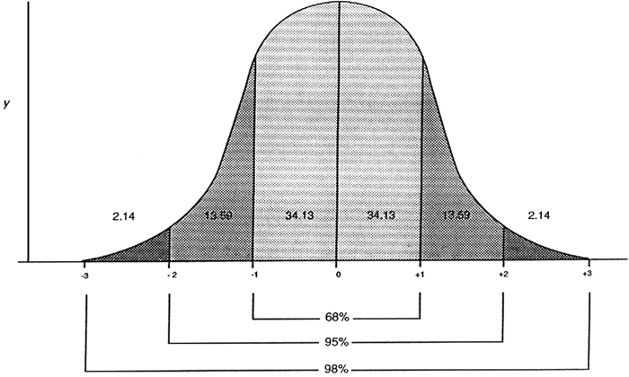
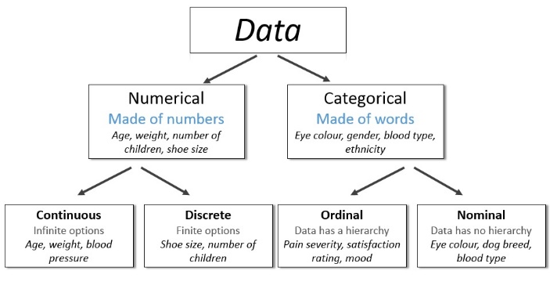
Types of Data and Types of analyses:
- Categorical (Nominal) Data: yes, no, male, female, etc.
- Continuous Data: numerical
  - Parametric data: data with a normal distribution
    - Mean and the median should be the same. When data has a normal distribution, the curve is unimodal and symmetric about its mean.
  - Non-parametric data: If continuous data does NOT have a normal distribution

 | Low | middle | High
Male | 15 | 31 | 29
Female | 47 | 45 | 30

Tests –
- Categorical
  - Chi Square More than 2 groups (low – med – high)
    - If >5 measurements are made in each comparison group
  - Fisher’s Exact test Comparing 2 groups
    - Or if there are small counts = one or more cells have a value of <5 then can be for more than 2 groups
 | Low | middle | High
Male | 2 | 16 | 2
Female | 3 | 17 | 1
 | Low | High
Male | 2 | 2
Female | 3 | 1

- Continuous parametric –
  - Student t 2 groups -- continuous data with a normal distribution
    - Paired T test – for comparison of 2 groups when the differences in the measurements within a paired sample (i.e. a before and after measurement)
  - ANOVA 3 or more sets of continuous data with a normal distribution
- Continuous non-parametric
  - Wilcoxan rank Sum Test (aka Mann-Whitney U test) 2 groups
  - Kruskal-Wallis test 3 or more groups

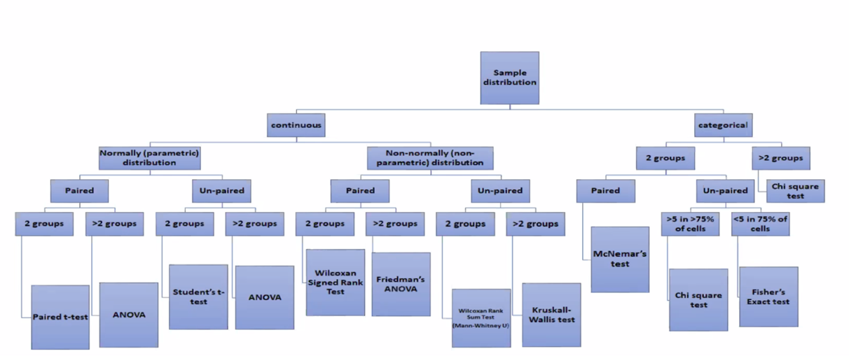
Kolmogorov-Smirnov and Shapiro-Wilk tests are used to determine whether data have a normal distribution.

Logistic Regression=used to predict the relationship between a discrete dichotomous outcome (i.e. pneumonia vs. no pneumonia) and a set of variables to determine the significance of a single variable while controlling for the other variables in the analysis.

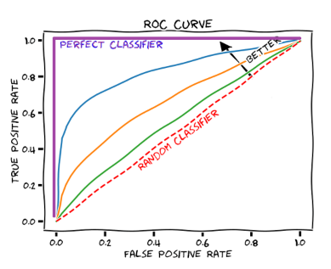
Kappa Statistic – measure of intra-observer agreement
- >0.6 is acceptable agreement

Receiver Operator Characteristic (ROC) Curves: areas under the ROC curves (AUROCs)
- Best one is the highest one (closest to the upper left-hand corner of the graph)
- Represents the relationship between the sensitivity and specificity of a test for a range of cutoff points by plotting the probability of a true positive result (sensitivity) against the probability of a false positive result (1-specificity).
- The accuracy of the test is represented by the area under the ROC curve.
- A straight line at 45 degrees represents the points at which the test is not helpful
- A curve under that line represents a test which suggests the opposite (when the test is negative, it predicts the disease).
ROC - Although it is easy to understand and often convenient to categorize states of health as disease and non-disease, based on one cutoff value of the test result, this approach is not practical. For example, using a cutoff value of 15.0x10³/mcL (15.0x10⁹/L) for a white blood cell (WBC) count is convenient in a clinical setting to help discriminate between febrile infants at risk for developing serious bacterial infections. However, tests such as the WBC count are continuous variables that have a spectrum of sensitivities, specificities, predictive values, and likelihood ratios. Therefore, reporting only one value of a test’s sensitivity or specificity is misleading and a hazardous oversimplification of accuracy.

In fact, when the cutoff value is increased (assuming larger values indicate a higher chance of positive outcome), the proportion of true-positives (sensitivity) and false-positives (1-specificity) decreases. ROC plots provide a graphic view of the entire spectrum of this proportion (sensitivity/1-specificity) and demonstrate the tradeoff between sensitivity and specificity.
- A perfect test would have sensitivity and specificity both equal to 1.
- Thus, the ROC curve for a perfect test would start at origin (0,0) and proceed vertically up the y axis to (0,1) and then horizontally to (1,1).
- A good test is close to this ideal. The closer the curve follows the left and top borders of the ROC space, the more accurate is the test.
- The closer the curve comes to the 45-degree diagonal, the less accurate is the test.

AUROC - the percentage of times the test correctly classifies two patients in a random pair (one from the disease group and one from the nondisease group).
The traditionally used cutoffs for test accuracy are:
For example, a recent article compared test characteristics of serum procalcitonin (PCT), C-reactive protein (CRP), absolute neutrophil count (ANC), and WBC count in the emergency department evaluation of febrile children and found the following AUROC results:
- PCT: 0.82 (95% confidence interval [CI]: 0.78–0.86
- CRP: 0.85 (95% CI: 0.81–0.88)
- ANC : 0.74 (95% CI: 0.70–0.78)
- WBC count: 0.71 (95% CI: 0.66–0.75)

- AUROCs of 0.9 to 1 (excellent) - 0.8 to 0.9 (good) - 0.7 to 0.8 (fair) - 0.6 to 0.7 (poor) - 0.5 to 0.6 (fail).
The advantages of using ROC plots are:
- Graphs are easy to compare and comprehend
- Plots are comprehensive representations of pure accuracy (ie, discriminatory ability over the entire range of the test)
- They can provide an optimal cutoff for the tradeoff between sensitivity and specificity (along with confidence intervals around the cutoff) to compare between tests
- The results are independent of disease prevalence
Disadvantage - The need for cumbersome calculations and statistical software .

Meta-analysis –
- Benefit – economical use of time – generalizes studies – controls between variables of studies
- Does not increase Power
- May have personal bias – studies chosen by researcher

Institutional Review Board (IRB):All research on humans is subject to IRB review and cannot be conducted unless the entire protocol has been submitted and approved.
- An IRB (also known as ethical review board) is a group that has been formally designated to approve, monitor, and review biomedical and behavioral research involving humans, with the aim of protecting the rights and welfare of the human subjects.
- The IRB has the authority under federal regulation and institutional policy to approve, require the modification of, or disapprove research activities being conducted at an individual institution.
- It also has the authority to suspend or terminate previously approved research in which unforeseen harm to participants occurs or that is not being conducted as approved by the IRB.
- The IRB must be informed of proposed changes in an investigation and approve such changes.
A human subject - any individual, living or deceased, about whom the investigator collects data through direct intervention or interaction or from sources such as medical records, clinical databases, billing records, and pathologic or diagnostic tissue specimens.
- Human subjects are patients, families, or other individuals who are asked to participate in a project.
There are three categories of IRB review: based on federal regulations relate to the degree of risk to research participants.
- Full board – most studies
- Expedited – non-invasive and minimal risk
  - involve the use of confidential records, data, or specimens that exist (are on the shelf) at the time of IRB approval
    - ie – retrospective chart reviews
    - collecting blood when venipuncture already being done
    - modifications of previous research
    - collection of hair
- Exempt - involve the use of anonymous existing data or specimens.
  - Anonymous means that the study information never can be linked to identifiers

Research subjects are not to be approached until the IRB has given final approval to the application
- IRB approval must be obtained before implementing any changes to an approved study.
- Example: Neither an EMS director, an ED director, nor a research coordinator can alter a study protocol without the approval of the IRB.
- Minor changes to a study not involving greater-than-minimal risk usually undergo an expedited review by a subcommittee of the IRB.
- Major changes to a study require full IRB review.

Bias: Bias is defined as any process that leads to the systematic deviation of study results or inferences from the truth.
- It does not refer to a conscious or unconscious bias on the part of investigators to steer the results in 1 direction
- Rather, it denotes errors caused by suboptimal study design, reporting, or analysis.

Selection bias: When individuals who participate in a study differ in some way from the population to whom the results of the study are applied
- Differences may be due to how subjects are recruited or selected by the investigators or how subjects choose whether to enroll in a study.
- In case-control studies - occurs when the control group selected differs by some systematic factor from the subjects classified as cases.

Publication bias: is related to the tendency of both investigators (authors) and editors to publish studies that have positive results and to reject studies that do not.

Confounding: occurs when a factor is associated with both an exposure and an outcome and that factor is identified mistakenly as being linked to the development of the outcome.

Misclassification: when subjects are misclassified erroneously as either having the exposure or the outcome of interest.

Recall bias: Subjects who are cases are more likely to “remember” past exposures than controls who have not suffered the outcome of interest.
- It is the bias of inaccuracy that may result from study subjects remembering events of the past.
- Seen more frequently in case-control or retrospective studies

Reporting bias: may be seen when different groups selectively report information based on concerns about how that information may be used or what it reveals about them (eg, information about substance abuse or sexual practices).
- May be a problem in unblinded clinical studies, where either the investigators or subjects are aware of a treatment that has been administered and this influences how either group reports the presence of the outcome

Interviewer Bias: when the study interviewer obtains or interprets the information differently.

Haddon’s Matrix – develop or evaluation of injury prevention
- Host – person being injured
For each factor –
- Pre-event – highway design
- Event – airbags, seatbelts
- Post event – treatment of injuries

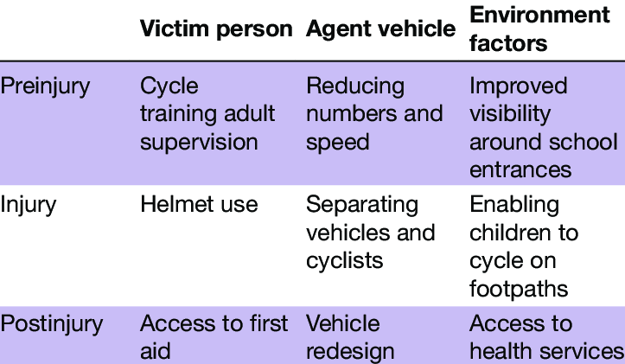
- Agent – that which cases injury
- Environment –

Trial Phases

Phase I- small group, safety, dose range, common side effects
Phase II- larger group, effectiveness, safety
Phase III- large group, confirm effectiveness, compare to other common therapies, safety
Phase IV- to market

